Mineral Titles Act
NOTICE OF GRANT OF A MINERAL TITLE
Title Type and Number: | Exploration Licence 31608
Granted: | 22 May 2018, for a period of 6 Years
Area: | 22 Blocks, 36.39 km²
Locality: | SHORT RANGE
Name of Holder/s: | 100% CGM (WA) PTY LTD [ACN. 610 789 252]
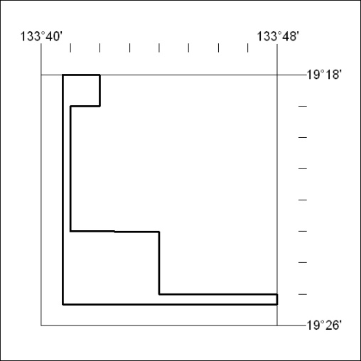
Area granted is indicated above. The titleholder is not permitted to exercise occupational rights on any land that is subject to a development title, or an application for a development title. Any land the subject of a Reserved Land gazettal under the Mineral Titles Act and all land vested in the Commonwealth of Australia is also excluded by description but not excised from the grant area.

195/18

Mineral Titles Act
NOTICE OF GRANT OF A MINERAL TITLE
Title Type and Number: | Exploration Licence 31610
Granted: | 22 May 2018, for a period of 6 Years
Area: | 25 Blocks, 70.69 km²
Locality: | SHORT RANGE
Name of Holder/s: | 100% CGM (WA) PTY LTD [ACN. 610 789 252]
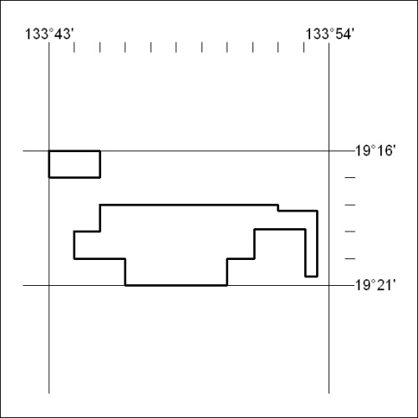
Area granted is indicated above. The titleholder is not permitted to exercise occupational rights on any land that is subject to a development title, or an application for a development title. Any land the subject of a Reserved Land gazettal under the Mineral Titles Act and all land vested in the Commonwealth of Australia is also excluded by description but not excised from the grant area.

196/18

