Mineral Titles Act
NOTICE OF LAND CEASING TO BE A MINERAL TITLE
Title Type and Number: | Extractive Mineral Permit 27679
Area ceased on: | 04 May 2018
Area: | 2.00 Hectare
Locality: | NOONAMAH
Name of Applicants(s)Holder(s): | 100% BIRCH Alan James
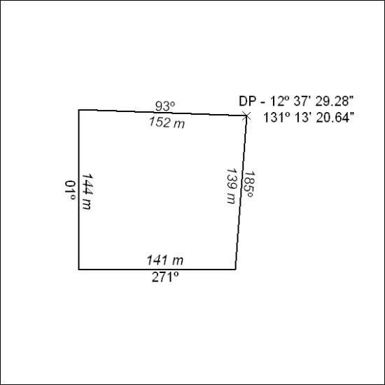

187/18

Mineral Titles Act
NOTICE OF LAND CEASING TO BE A MINERAL TITLE
Title Type and Number: | Extractive Mineral Permit 27680
Area ceased on: | 04 May 2018
Area: | 20.00 Hectare
Locality: | NOONAMAH
Name of Applicants(s)Holder(s): | 100% BIRCH Alan James
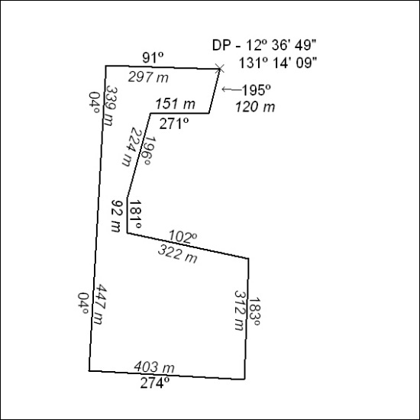

188/18

Mineral Titles Act
NOTICE OF LAND CEASING TO BE A MINERAL TITLE
Title Type and Number: | Extractive Mineral Permit 29250
Area ceased on: | 04 May 2018
Area: | 9.00 Hectare
Locality: | ADAM
Name of Applicants(s)Holder(s): | 100% BIRCH Alan James
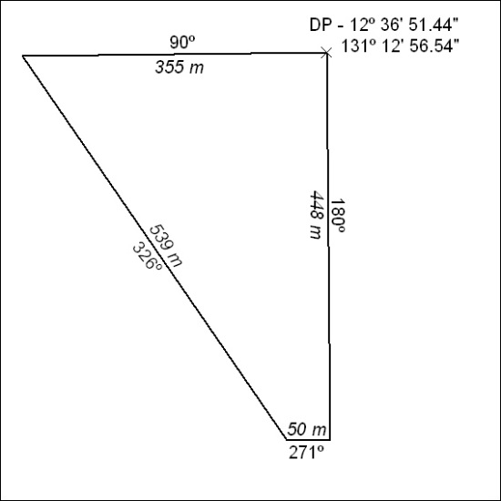

189/18

