Mineral Titles Act
NOTICE OF LAND CEASING TO BE A MINERAL TITLE AREA
Title Type and Number: | Exploration Licence 28434
Area Ceased on: | 26 April 2018
Area: | 31 Blocks, 96.99 km²
Locality: | MACDONNELL RANGES
Name of Applicant(s)/Holder(s): | 56.28% CROSSLAND NICKEL PTY LTD* [ACN. 099 477 915], 43.72% ESSENTIAL MINING RESOURCES PTY LTD [ACN. 601 655 725]
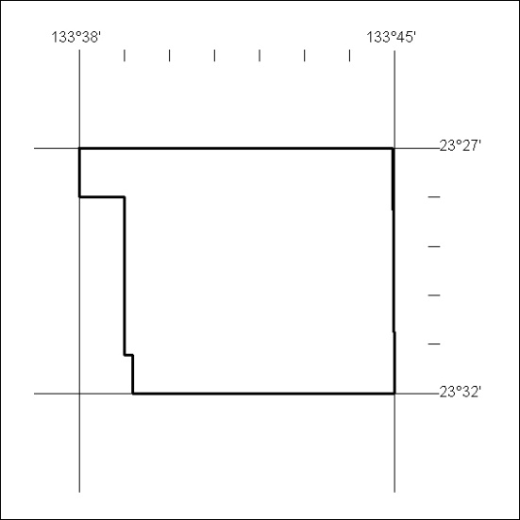

148/18

Mineral Titles Act
NOTICE OF LAND CEASING TO BE A MINERAL TITLE AREA
Title Type and Number: | Exploration Licence 29789
Area Ceased on: | 27 April 2018
Area: | 6 Blocks, 18.92 km²
Locality: | NARWIETOOMA
Name of Applicant(s)/Holder(s): | 56.28% CROSSLAND NICKEL PTY LTD* [ACN. 099 477 915], 43.72% ESSENTIAL MINING RESOURCES PTY LTD [ACN. 601 655 725]
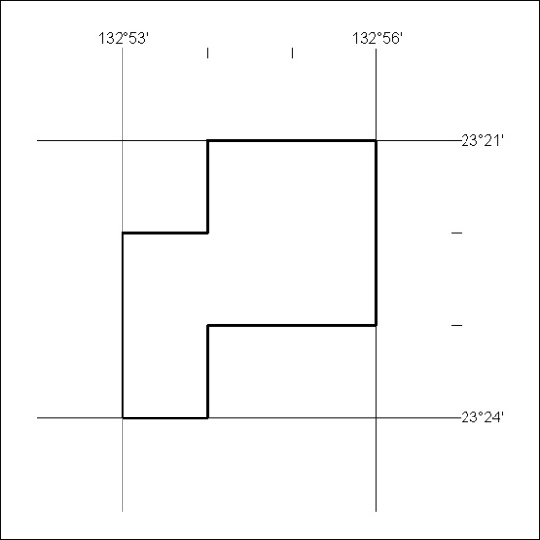

149/18

Mineral Titles Act
NOTICE OF LAND CEASING TO BE A MINERAL TITLE AREA
Title Type and Number: | Exploration Licence 29853
Area Ceased on: | 27 April 2018
Area: | 19 Blocks, 59.89 km²
Locality: | BURT
Name of Applicant(s)/Holder(s): | 100% CROSSLAND NICKEL PTY LTD* [ACN. 099 477 915]
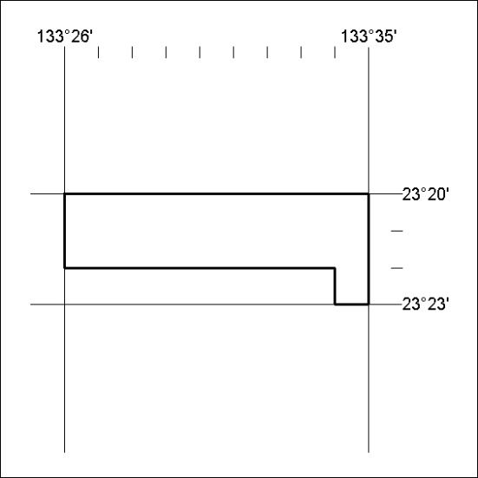

150/18

Mineral Titles Act
NOTICE OF LAND CEASING TO BE A MINERAL TITLE AREA
Title Type and Number: | Exploration Licence 30837
Area Ceased on: | 27 April 2018
Area: | 65 Blocks, 205.16 km²
Locality: | QUARTZ
Name of Applicant(s)/Holder(s): | 100% PINNACLE EXPLORATION PTY LTD [ACN. 605 748 196]
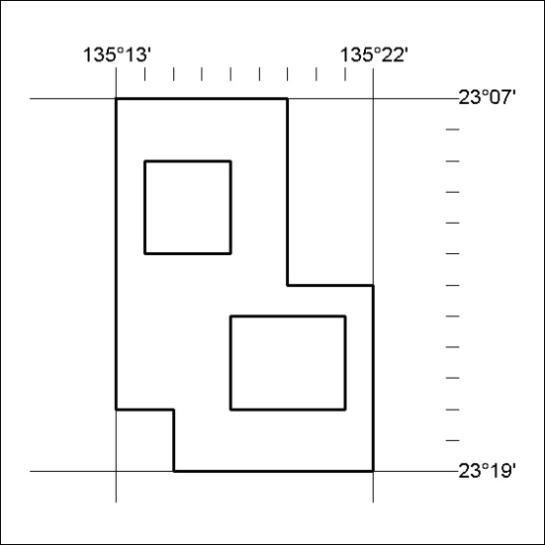

151/18

Mineral Titles Act
NOTICE OF GRANT OF A MINERAL TITLE
Title Type and Number: | Exploration Licence 31545
Granted: | 26 April 2018, for a period of 6 Years
Area: | 111 Blocks, 365.68 km²
Locality: | KILLARNEY
Name of Holder/s: | 100% WRIGHT Anthony
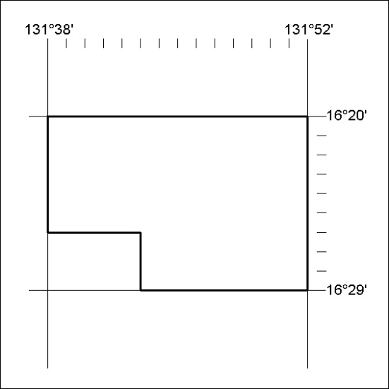
Area granted is indicated above. The titleholder is not permitted to exercise occupational rights on any land that is subject to a development title, or an application for a development title. Any land the subject of a Reserved Land gazettal under the Mineral Titles Act and all land vested in the Commonwealth of Australia is also excluded by description but not excised from the grant area.

152/18

