Mineral Titles Act
NOTICE OF GRANT OF A MINERAL TITLE
Title Type and Number: | Exploration Licence 31698
Granted: | 18 April 2018, for a period of 6 Years
Area: | 143 Blocks, 471.58 km²
Locality: | VICTORIA RIVER DOWNS
Name of Holder/s: | 51% HOLDFAST EXPLORATION PTY LTD [ACN. 104 155 795], 49% HALL Richard Charles Blake
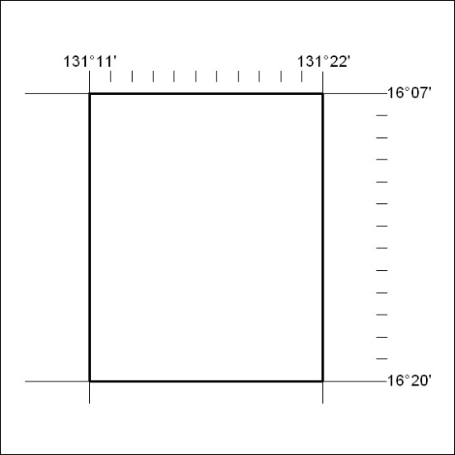
Area granted is indicated above. The titleholder is not permitted to exercise occupational rights on any land that is subject to a development title, or an application for a development title. Any land the subject of a Reserved Land gazettal under the Mineral Titles Act and all land vested in the Commonwealth of Australia is also excluded by description but not excised from the grant area.

141/18

