Mineral Titles Act
NOTICE OF LAND CEASING TO BE A MINERAL TITLE
Title Type and Number: | Mineral Lease 25075
Area ceased on: | 21 February 2018
Area: | 114.00 Hectares
Locality: | BYNOE
Name of Applicants(s)Holder(s): | 100% NORTHERN TERRITORIES RESOURCES PTY LTD* [ACN. 124 647 829]
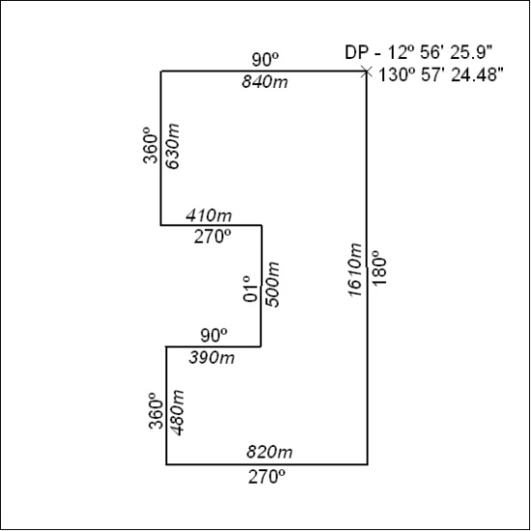

78/18

