NT Pastoral Feed Outlook - September 2017
The purpose of this quarterly outlook is to summarise information relevant to the pastoral industry such as current feed supplies, seasonal conditions, the development of drought conditions in central Australia and fire risk.
You can see the entire document and all districts by continuing to scroll through this file. If you are interested in selected sections, you can click on the links below.
Summary of current situation & trends - all districts
Northern Territory Seasonal Outlook – as at September 2017
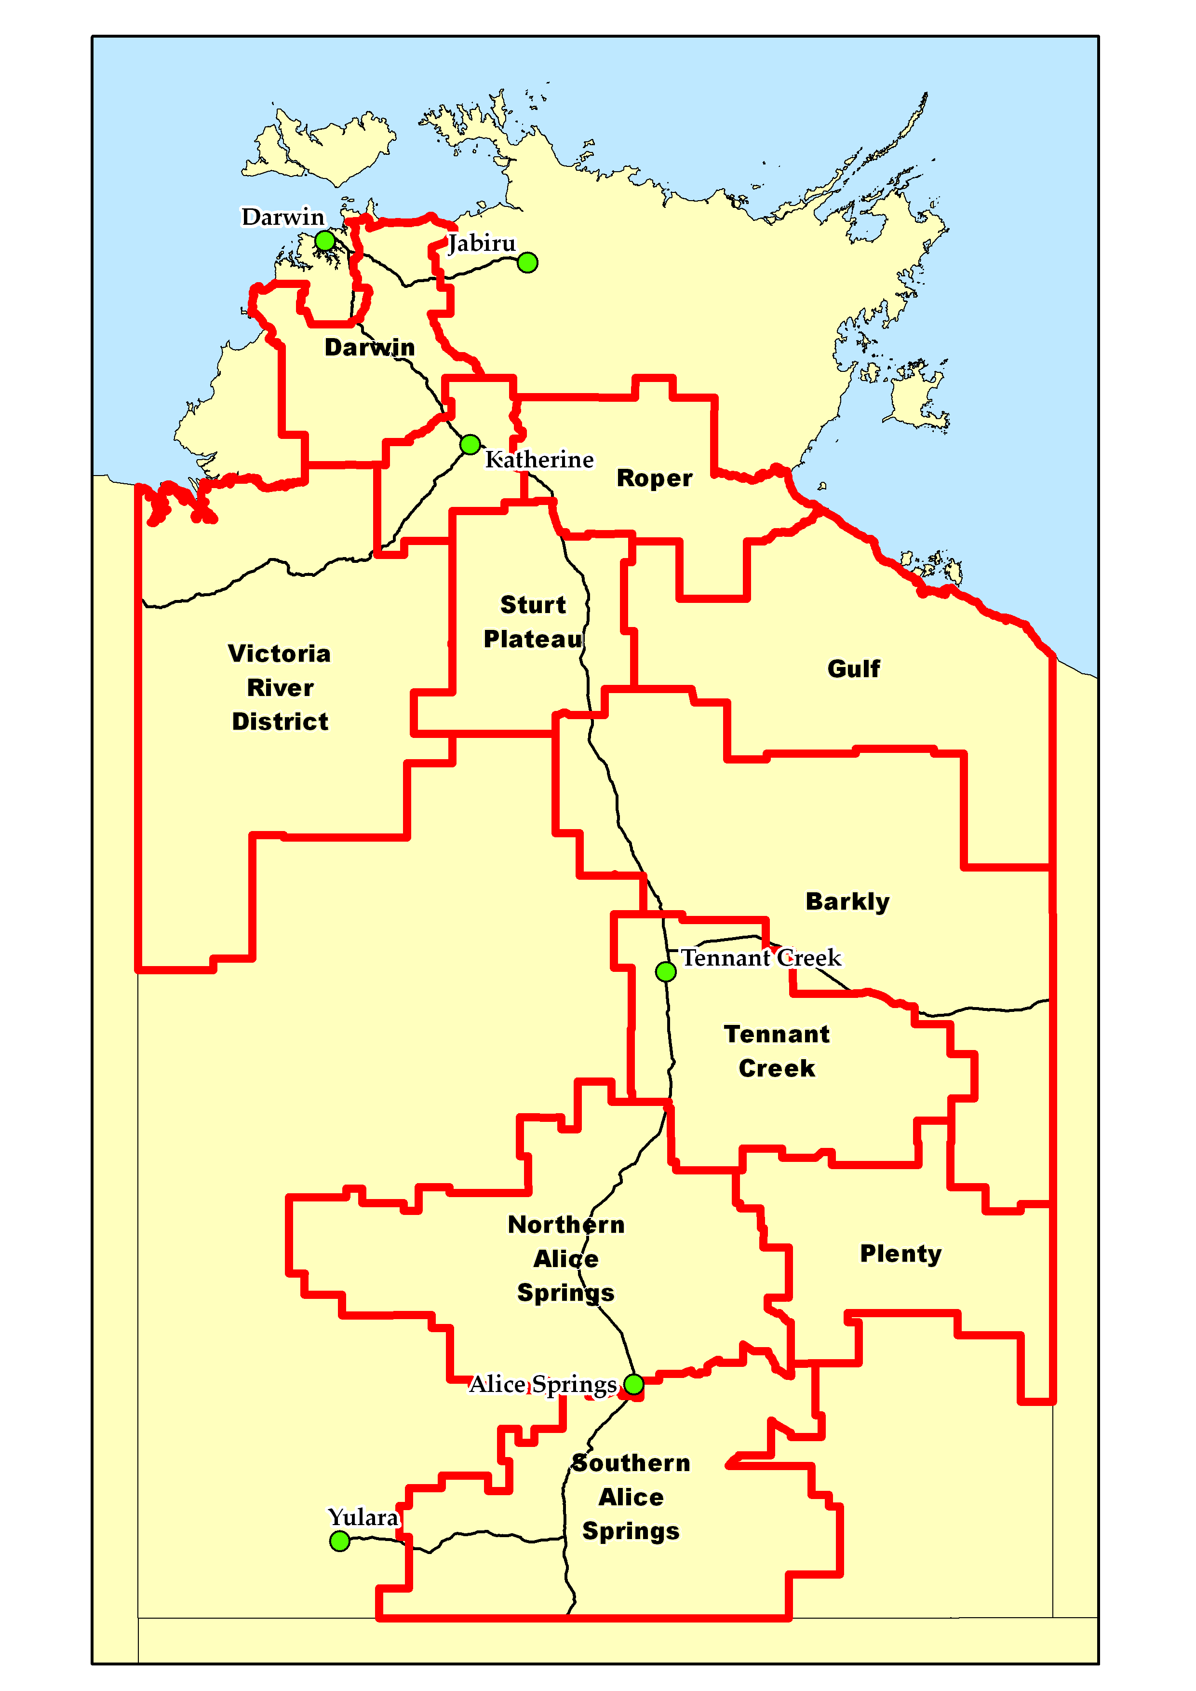
Individual District Summaries:
- Darwin District
- Katherine District
- Victoria River District
- Sturt Plateau District
- Roper District
- Gulf District
- Barkly District
- Tennant Creek District
- Northern Alice Springs District
- Plenty District
- Southern Alice Springs District

Summary of current situation & trends - all districts – September 2017

KEY | Green = low risk | Orange = watch | Red = high risk

KEY | ↑ = increasing trend | ↓ = decreasing trend | ↔ = steady

 | Northern Territory Pastoral Districts
Indicator | Darwin | Katherine | VRD | Sturt Plateau | Roper | Gulf | Barkly | Tennant Creek | Northern Alice Springs | Plenty | Southern Alice Springs | Comments
2016/17 total pasture growth | ↔ | ↔ | ↑ | ↔ | ↑ | ↑ | ↑ | ↑ | ↑ | ↑ | ↑ | Arrows indicate trend compared to the long-term median.
Current estimated standing biomass | ↓ | ↓ | ↓ | ↓ | ↓ | ↓ | ↓ | ↓ | ↔ | ↔ | ↓ | Arrows indicate trend since previous quarter.
Current fire risk | ↑ | ↑ | ↑ | ↔ | ↑ | ↔ | ↑ | ↓ | ↔ | ↔ | ↔ | Arrows indicate the trend since previous quarter.
Current seasonal outlook | ↑ | ↑ | ↑ | ↑ | ↑ | ↑ | ↑ | ↑ | ↑ | ↑ | ↔ | Arrows indicate the trend since previous quarter and taking into account the forecasted model predictions.

For further information about this Outlook, please contact Chris Materne on 8951 8135 or Dionne Walsh on 8999 2178

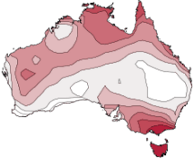
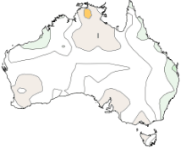
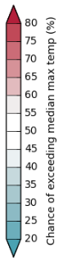
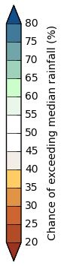
Northern Territory Seasonal Outlook
as at September 2017

Sourced from the Australian Bureau of Meteorology
http://www.bom.gov.au/climate/outlooks/
The national outlook for October to December 2017 indicates that:
- Drier than average conditions are expected across much of the NT.
- Warmer than average days and nights are more likely across the entire NT.
Climate influences from the Indian and Pacific oceans are likely to be competing, with a weak drying influence from the Indian Ocean potentially cancelling out a slightly wet influence from the Pacific Ocean. In addition to the natural drivers such as the El Niño–Southern Oscillation and the IOD, Australian climate patterns are being influenced by the long-term increasing trend in global air and ocean temperatures.
Chance of exceeding the median max. temp.
October to December 2017

Chance of exceeding the median rainfall
October to December 2017

Seasonal Indicators | Comments (sourced from the Australian Bureau of Meteorology)
El Niño Southern Oscillation (ENSO)  http://www.bom.gov.au/climate/enso/  Current outlook: Neutral  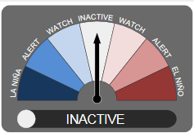  ENSO status  Current status: INACTIVE | ENSO remains neutral, but tropical Pacific continues to cool.  Sea surface temperatures (SSTs) have steadily cooled over the central and eastern tropical Pacific for the past two months, but remain well within the neutral ENSO range. Temperatures at and below the surface are now slightly cooler than average. Other indicators of ENSO, such as the Southern Oscillation Index (SOI), cloudiness near the Date Line and trade winds also remain at neutral levels.  Most international climate models surveyed suggest the tropical Pacific Ocean may cool further, but persist at ENSO-neutral levels for the rest of 2017. | 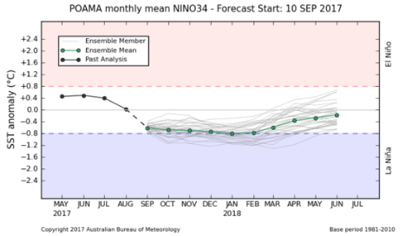  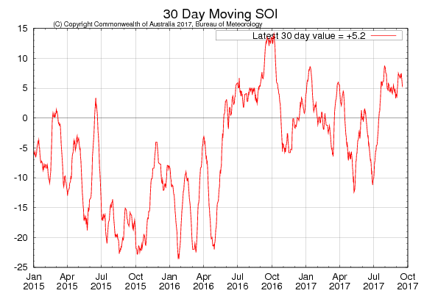
Indian Ocean Dipole (IOD)  http://www.bom.gov.au/climate/enso/#tabs=Indian-Ocean  Current outlook:  Neutral | IOD also neutral.  Most of the climate models surveyed indicate that the IOD will remain neutral during Spring. However, two out of the six models suggest a positive IOD may develop during Spring. A positive IOD is typically associated with below average Spring rainfall over southern and central Australia.  If a positive IOD eventuated it would likely be short-lived as IOD events typically break down by December as the monsoon trough moves south towards Australia. | 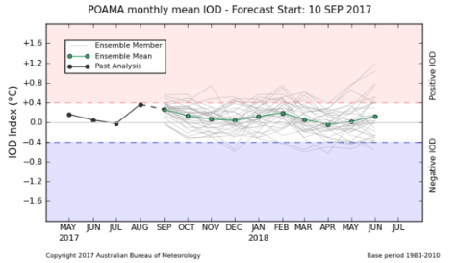  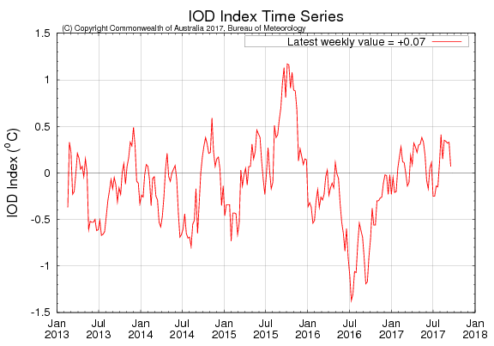

Darwin District
Risks:
- As at the 1st September 2017, 97% of the district had a high fire risk.

Note: In a typical wet season pasture growth in the Darwin region is limited by available soil nitrogen, not water. Therefore a poor wet season may not generally affect the quantity of pasture growth on upland.

Currently (as at 1st September 2017)
(% of district) | <1,000kg/ha | 1,000 - 2,000kg/ha | 2,000 - 3,000kg/ha | >3,000kg/ha
2016/17  Pasture Growth | 0% | 49% | 47% | 4%
Total Standing Dry Matter | 40% | 50% | 7% | 3%

(% of district) | Below Average | Average | Above Average
2016/17  Pasture Growth | 51% | 29% | 20%
Total Standing Dry Matter | 49% | 48% | 3%
Fire Risk | High  97% | Moderate  3% | Low  0%
Area Burnt | 39% (since 1st January 2017)  10% (since 1st July 2017)

2017/18 Median Pasture Growth (kg/ha)  (Running Total) |  | Chance of exceeding  Median Pasture Growth  (September – December 2017)
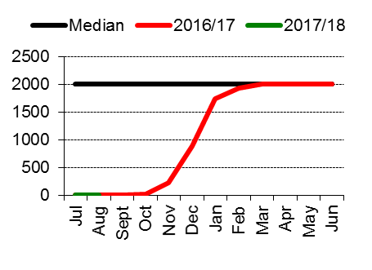 | 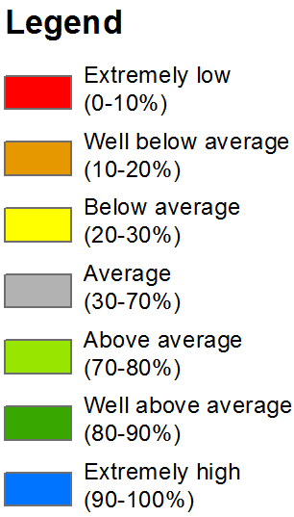 | 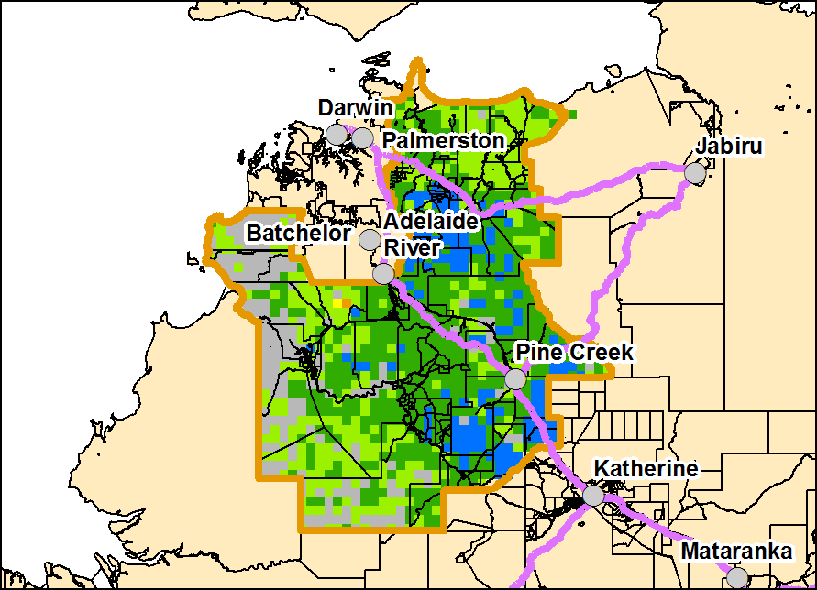
Total 2017/18 Pasture Growth  (July – August 2017) |  | Current Estimated  Total Standing Dry Matter
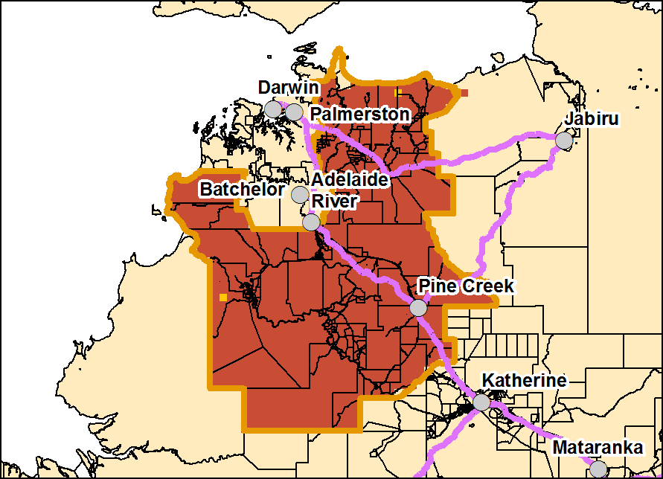 | 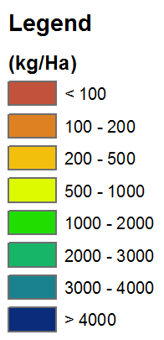 | 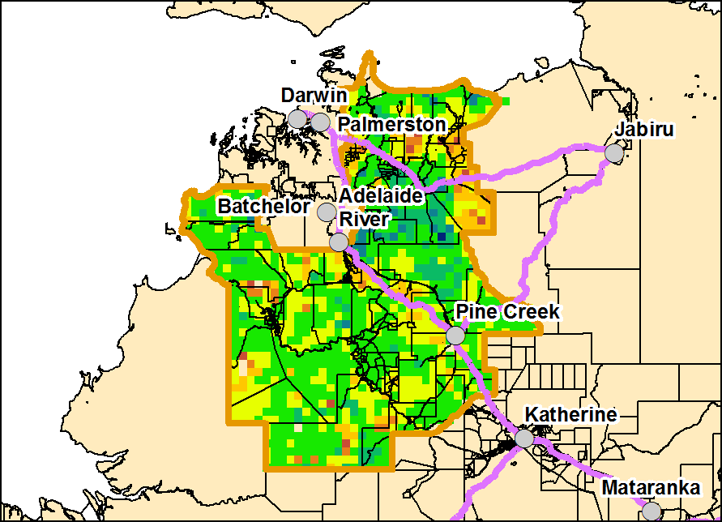

Katherine District
Risks:
- As at the 1st September 2017, 100% of the district had a high fire risk.

Currently (as at 1st September 2017)
(% of district) | <1,000kg/ha | 1,000 - 2,000kg/ha | 2,000 - 3,000kg/ha | >3,000kg/ha
2016/17  Pasture Growth | 0% | 35% | 64% | 1%
Total Standing Dry Matter | 21% | 56% | 21% | 2%

(% of district) | Below Average | Average | Above Average
2016/17  Pasture Growth | 53% | 26% | 21%
Total Standing Dry Matter | 50% | 47% | 3%
Fire Risk | High  100% | Moderate  0% | Low  0%
Area Burnt | 19% (since 1st January 2017)  2% (since 1st July 2017)

2017/18 Median Pasture Growth (kg/ha)  (Running Total) |  | Chance of exceeding  Median Pasture Growth  (September – December 2017)
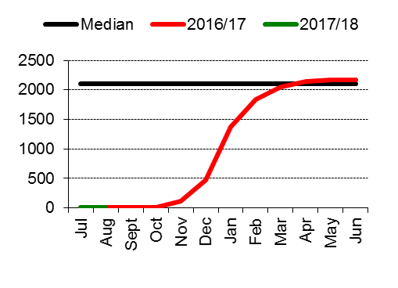 |  | 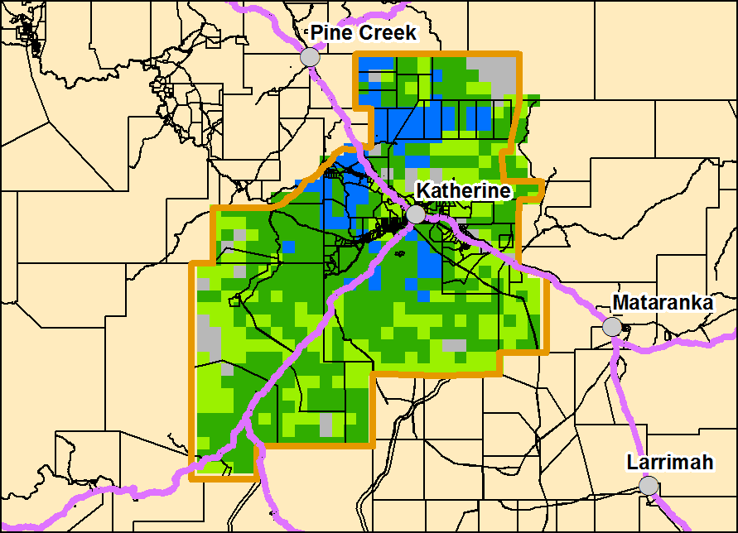
Total 2017/18 Pasture Growth  (July – August 2017) |  | Current Estimated  Total Standing Dry Matter
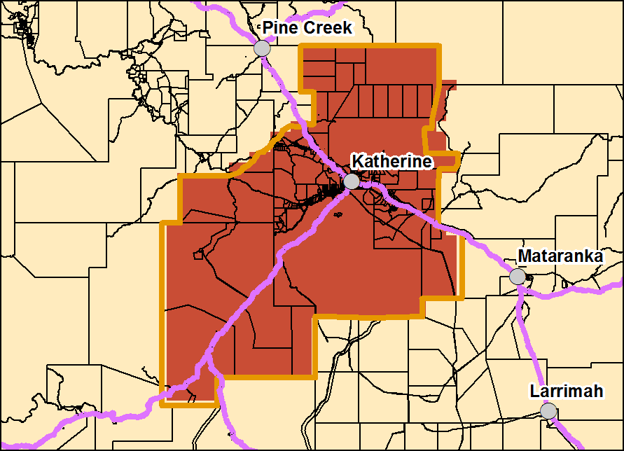 |  | 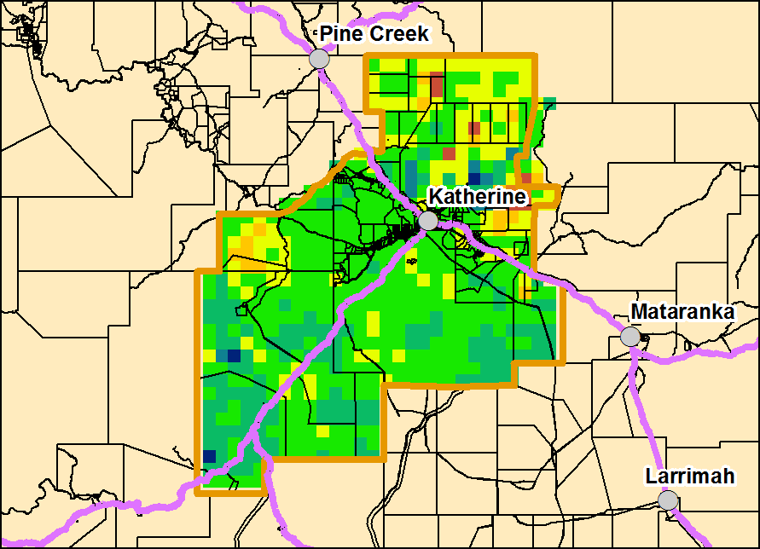

Victoria River District
Risks:
- As at the 1st September 2017, 99% of the district had a high fire risk.

Currently (as at 1st September 2017)
(% of district) | <1,000kg/ha | 1,000 - 2,000kg/ha | 2,000 - 3,000kg/ha | >3,000kg/ha
2016/17  Pasture Growth | 1% | 29% | 60% | 10%
Total Standing Dry Matter | 6% | 40% | 28% | 26%

(% of district) | Below Average | Average | Above Average
2016/17  Pasture Growth | 10% | 31% | 59%
Total Standing Dry Matter | 30% | 44% | 26%
Fire Risk | High  99% | Moderate  1% | Low  0%
Area Burnt | 10% (since 1st January 2017)  3% (since 1st July 2017)

2017/18 Median Pasture Growth (kg/ha)  (Running Total) |  | Chance of exceeding  Median Pasture Growth  (September – December 2017)
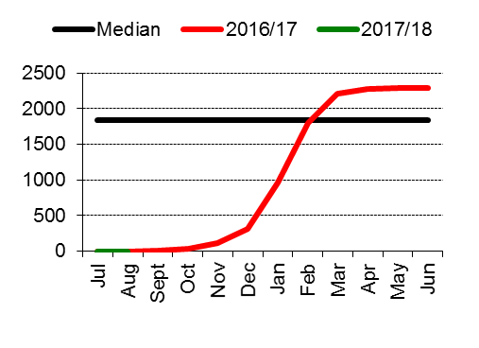 |  | 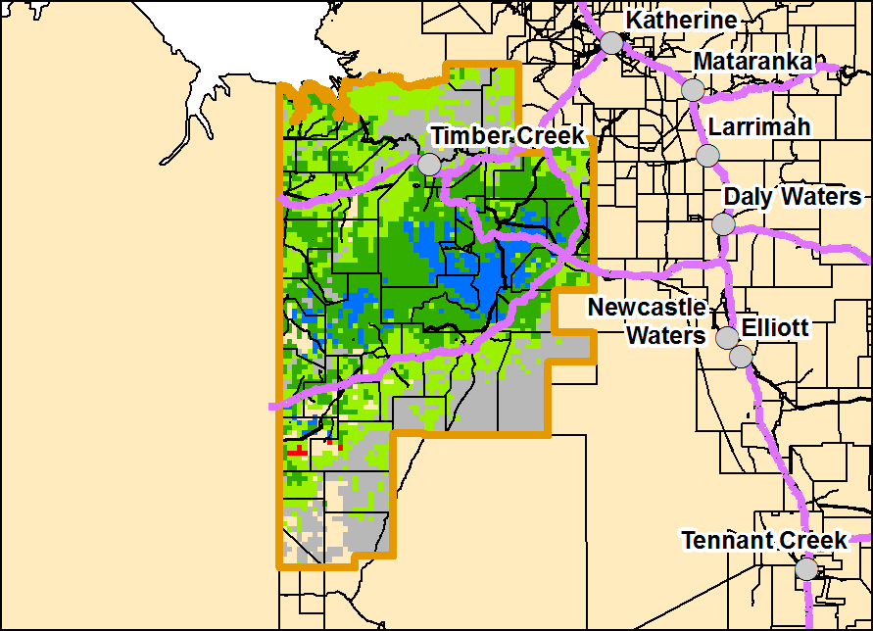
Total 2017/18 Pasture Growth  (July – August 2017) |  | Current Estimated  Total Standing Dry Matter
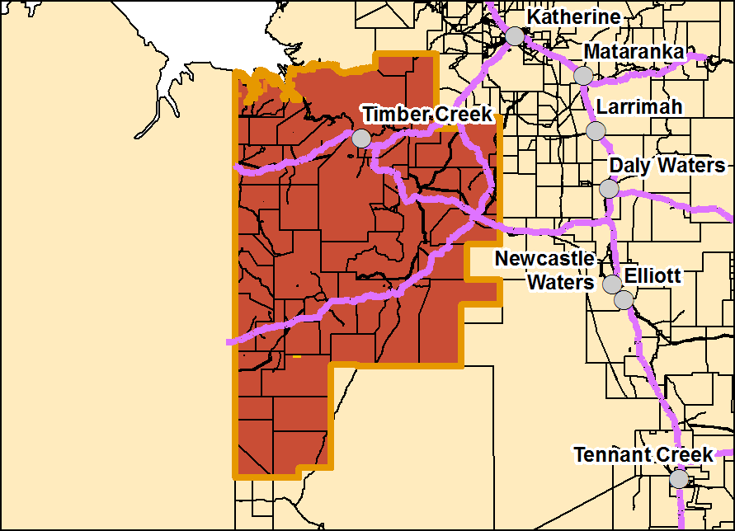 |  | 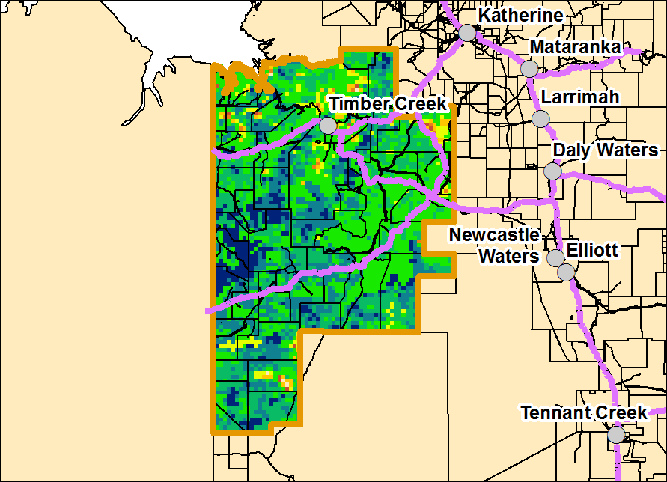

Sturt Plateau District
Risks:
- As at the 1st September 2017, 99% of the district had a high fire risk.

Currently (as at 1st September 2017)
(% of district) | <1,000kg/ha | 1,000 - 2,000kg/ha | 2,000 - 3,000kg/ha | >3,000kg/ha
2016/17  Pasture Growth | 1% | 35% | 63% | 1%
Total Standing Dry Matter  (kg/ha) | 7% | 79% | 11% | 3%

(% of district) | Below Average | Average | Above Average
2016/17  Pasture Growth | 6% | 68% | 26%
Total Standing Dry Matter | 25% | 72% | 3%
Fire Risk | High  99% | Moderate  1% | Low  0%
Area Burnt  (% of district) | 4% (since 1st January 2017)  <1% (since 1st July 2017)

2017/18 Median Pasture Growth (kg/ha)  (Running Total) |  | Chance of exceeding  Median Pasture Growth  (September – December 2017)
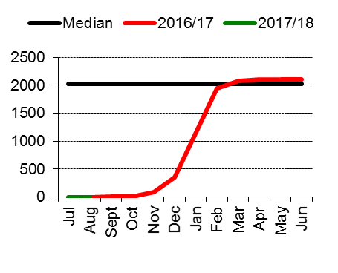 |  | 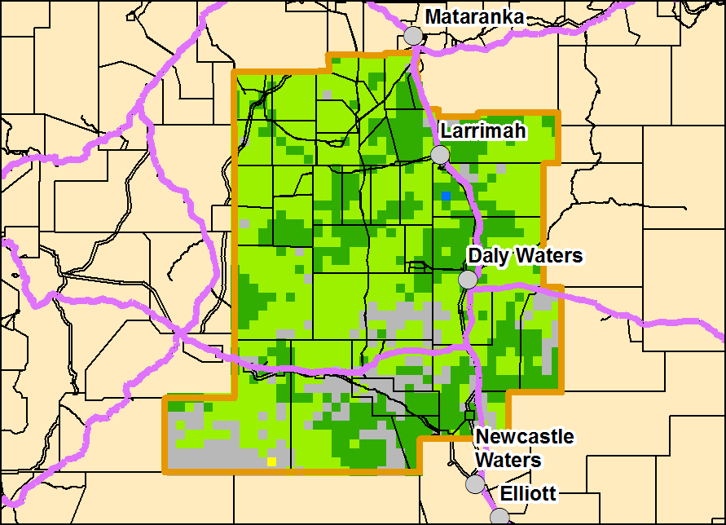
Total 2017/18 Pasture Growth  (July – August 2017) |  | Current Estimated  Total Standing Dry Matter
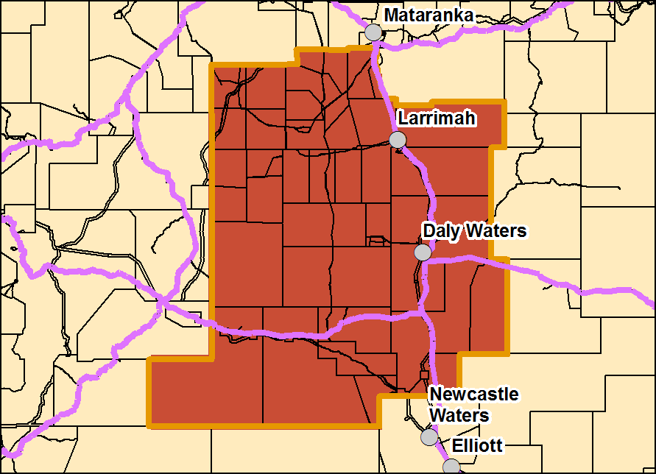 |  | 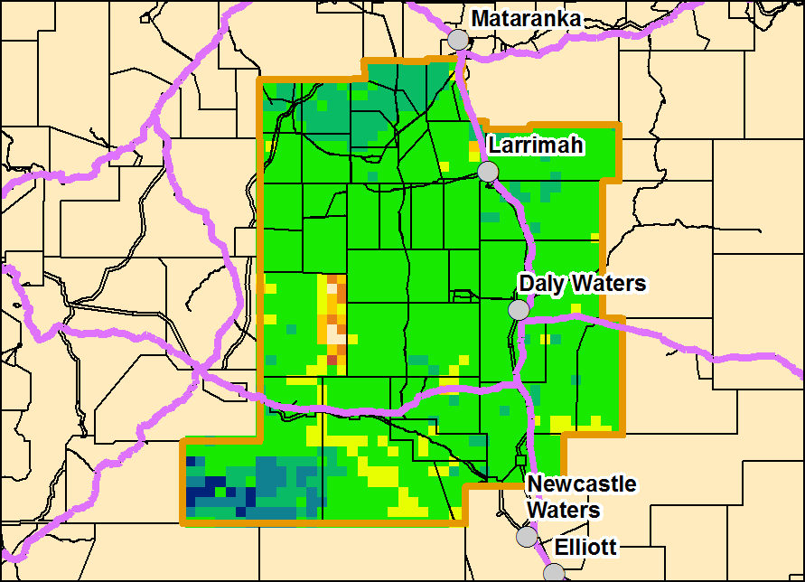

Roper District
Risks:
- As at the 1st September 2017, 99% of the district had a high fire risk.

Currently (as at 1st September 2017)
(% of district) | <1,000kg/ha | 1,000 - 2,000kg/ha | 2,000 - 3,000kg/ha | >3,000kg/ha
2016/17  Pasture Growth | 0% | 18% | 69% | 13%
Total Standing Dry Matter | 10% | 41% | 33% | 16%

(% of district) | Below Average | Average | Above Average
2016/17  Pasture Growth | 15% | 24% | 61%
Total Standing Dry Matter | 35% | 53% | 12%
Fire Risk | High  99% | Moderate  1% | Low  0%
Area Burnt | 17% (since 1st January 2017)  6% (since 1st July 2017)

2017/18 Median Pasture Growth (kg/ha)  (Running Total) |  | Chance of exceeding  Median Pasture Growth  (September – December 2017)
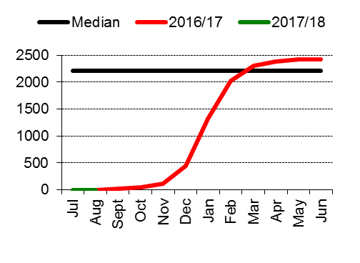 |  | 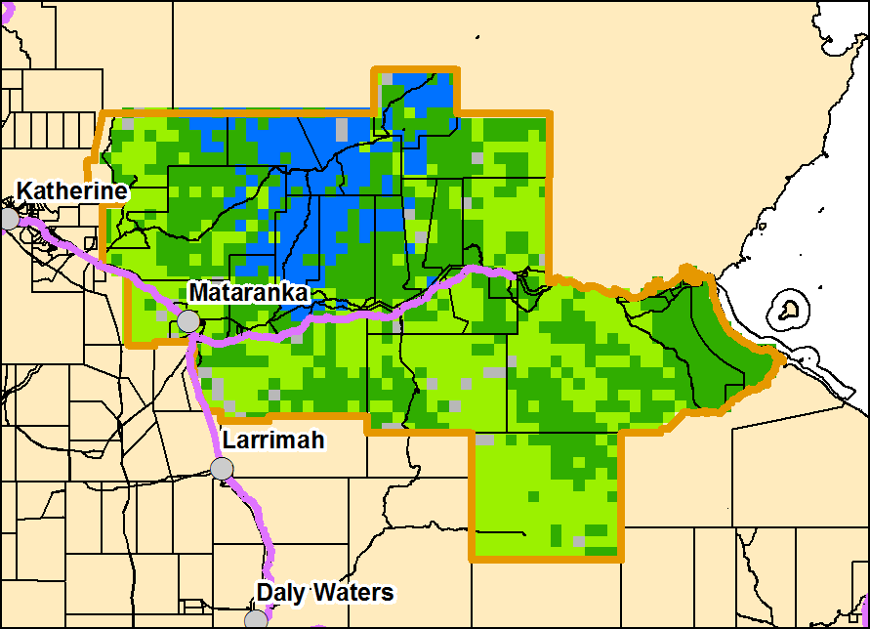
Total 2017/18 Pasture Growth  (July – August 2017) |  | Current Estimated  Total Standing Dry Matter
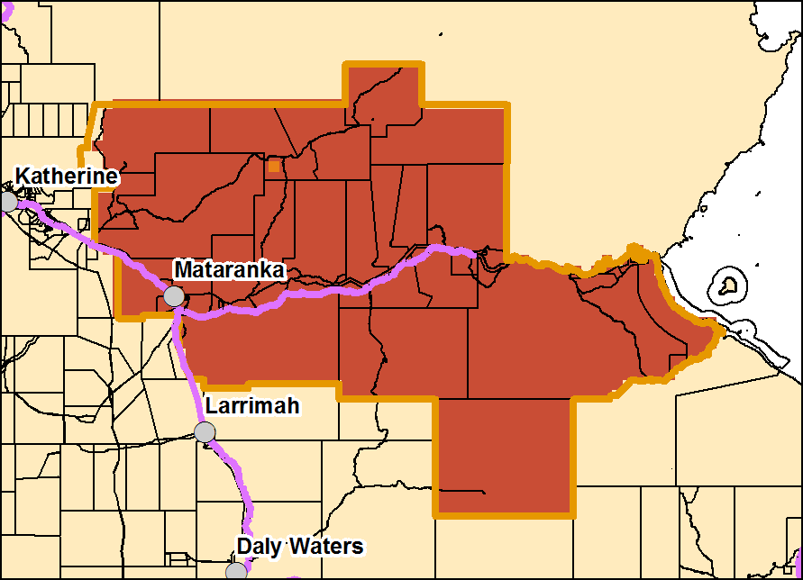 |  | 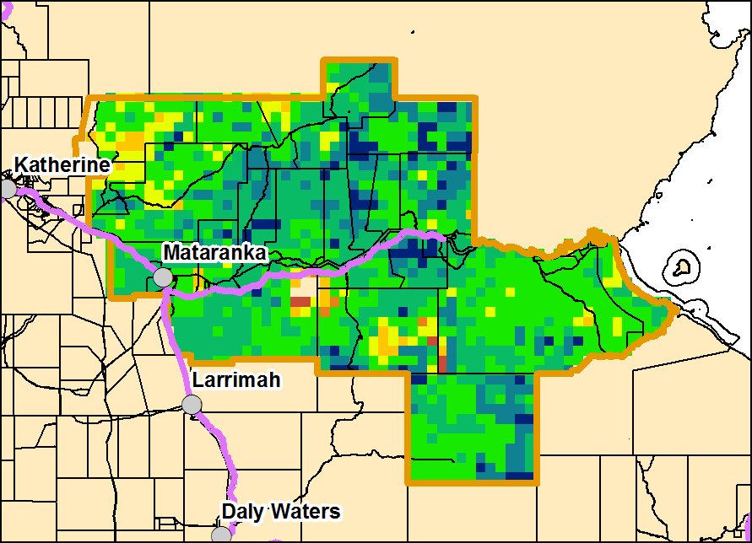

Gulf District
Risks:
- As at the 1st September 2017, 99% of the district had a high fire risk.

Currently (as at 1st September 2017)
(% of district) | <1,000kg/ha | 1,000 - 2,000kg/ha | 2,000 - 3,000kg/ha | >3,000kg/ha
2016/17  Pasture Growth | 0% | 27% | 63% | 10%
Total Standing Dry Matter | 8% | 50% | 20% | 22%

(% of district) | Below Average | Average | Above Average
2016/17  Pasture Growth | 11% | 35% | 54%
Total Standing Dry Matter | 32% | 57% | 11%
Fire Risk | High  99% | Moderate  1% | Low  0%
Area Burnt | 8% (since 1st January 2017)  5% (since 1st July 2017)

2017/18 Median Pasture Growth (kg/ha)  (Running Total) |  | Chance of exceeding  Median Pasture Growth  (September – December 2017)
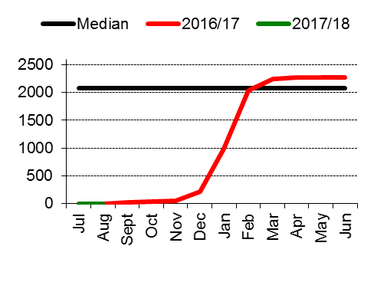 |  | 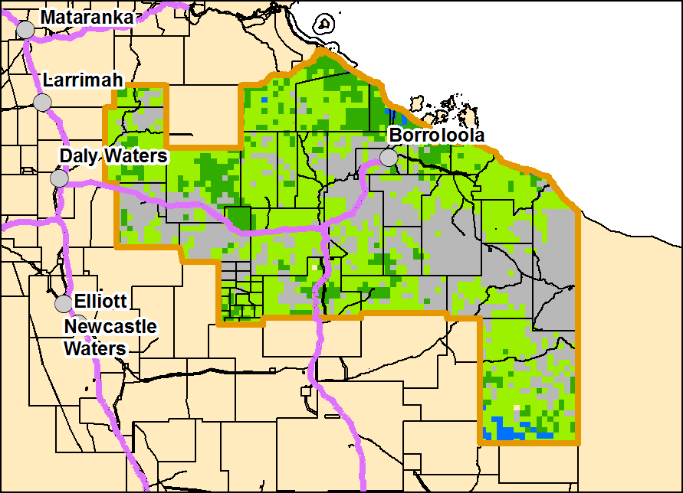
Total 2017/18 Pasture Growth  (July – August 2017) |  | Current Estimated  Total Standing Dry Matter
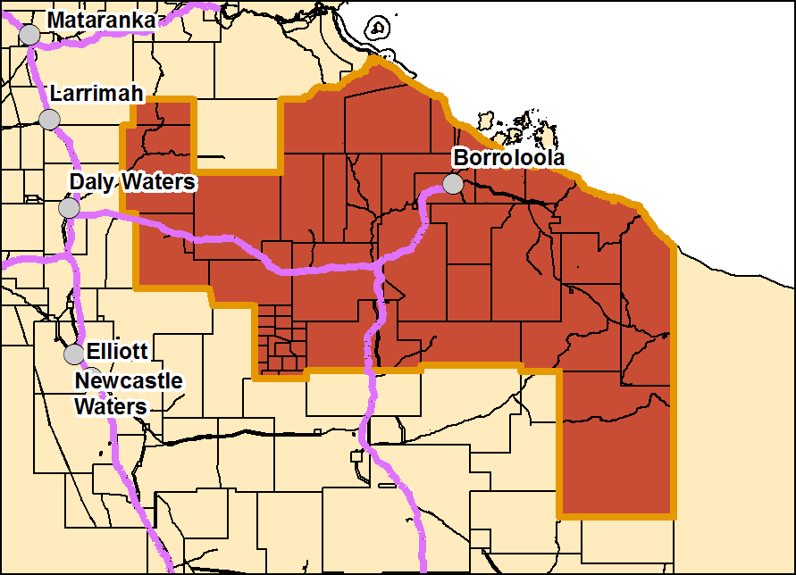 |  | 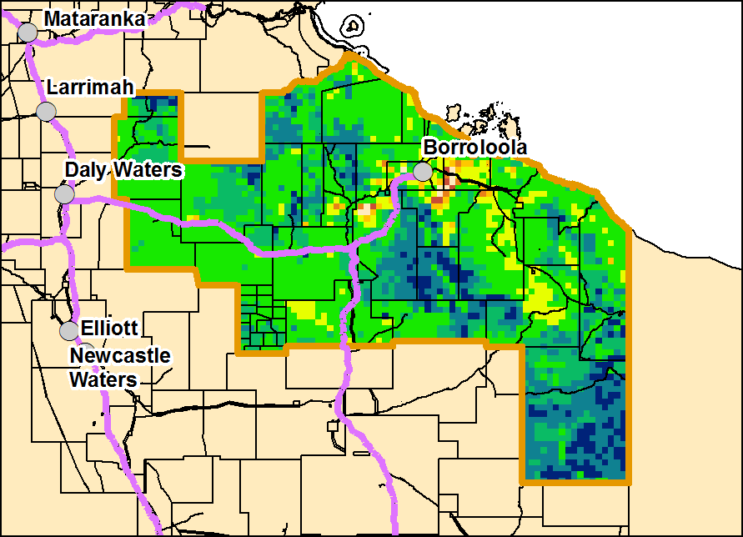

Barkly District
Risks:
- As at the 1st September 2017, 95% of the district had a high fire risk.

Currently (as at 1st September 2017)
(% of district) | <250kg/ha | 250 - 500kg/ha | 500 - 1,000kg/ha | >1,000kg/ha
2016/17  Pasture Growth | 100% | 0% | 0% | 0%
Total Standing Dry Matter | 1% | 5% | 26% | 68%

(% of district) | Below Average | Average | Above Average
2016/17  Pasture Growth | <1% | 4% | 96%
Total Standing Dry Matter | 3% | 21% | 76%
Fire Risk | High  95% | Moderate  5% | Low  0%
Area Burnt | 2% (since 1st January 2017)  2% (since 1st July 2017)

2017/18 Median Pasture Growth (kg/ha)  (Running Total) |  | Chance of exceeding  Median Pasture Growth  (September – December 2017)
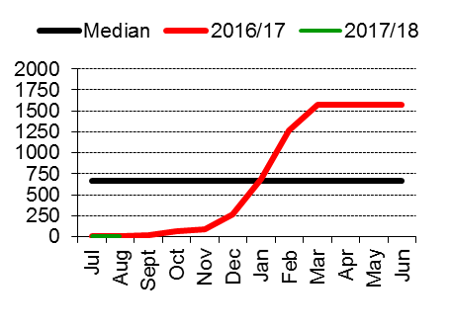 |  | 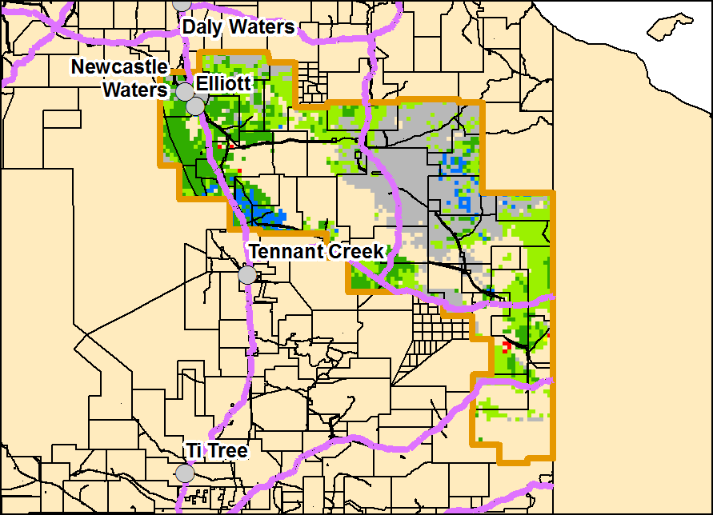
Total 2017/18 Pasture Growth  (July – August 2017) |  | Current Estimated  Total Standing Dry Matter
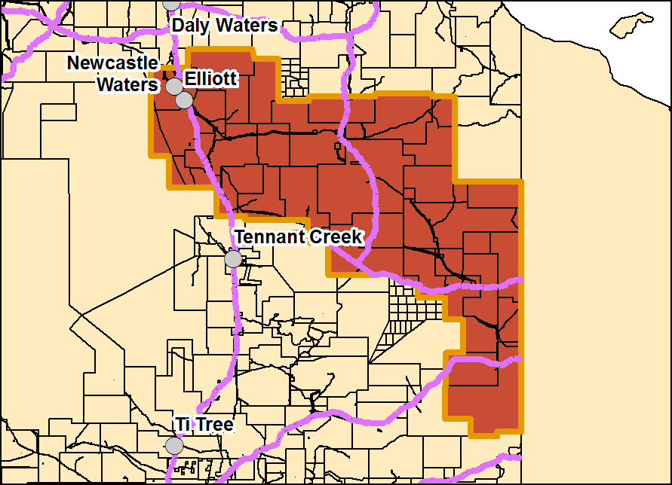 |  | 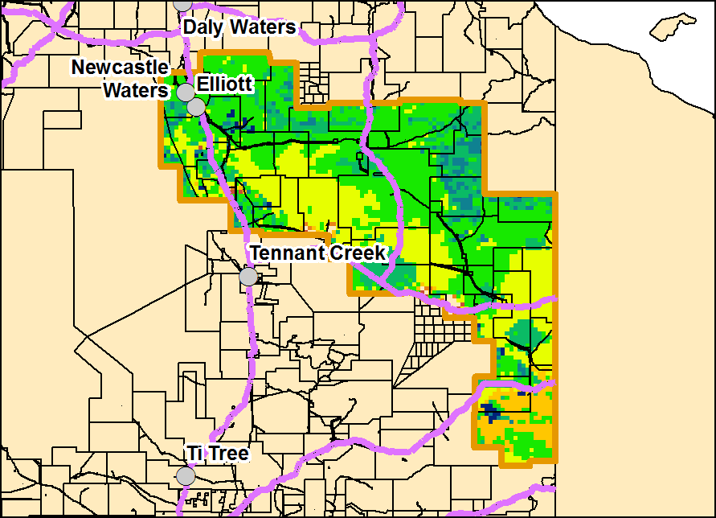

Tennant Creek District
Risks:
- As at the 1st September 2017, 94% of the district had a high fire risk.

Currently (as at 1st September 2017)
(% of district) | <250kg/ha | 250 - 500kg/ha | 500 - 1,000kg/ha | >1,000kg/ha
2016/17  Pasture Growth | 0% | 0% | 12% | 88%
Total Standing Dry Matter | 7% | 1% | 4% | 88%

(% of district) | Below Average | Average | Above Average
2016/17  Pasture Growth | 0% | 1% | 99%
Total Standing Dry Matter | 11% | 21% | 68%
Fire Risk | High  94% | Moderate  6% | Low  0%
Area Burnt | 12% (since 1st January 2017)  11% (since 1st July 2017)

2017/18 Median Pasture Growth (kg/ha)  (Running Total) |  | Chance of exceeding  Median Pasture Growth  (September – December 2017)
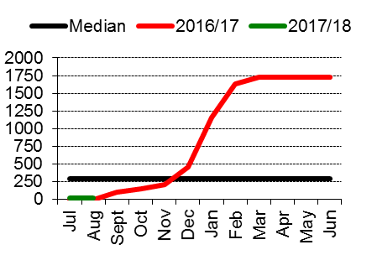 |  | 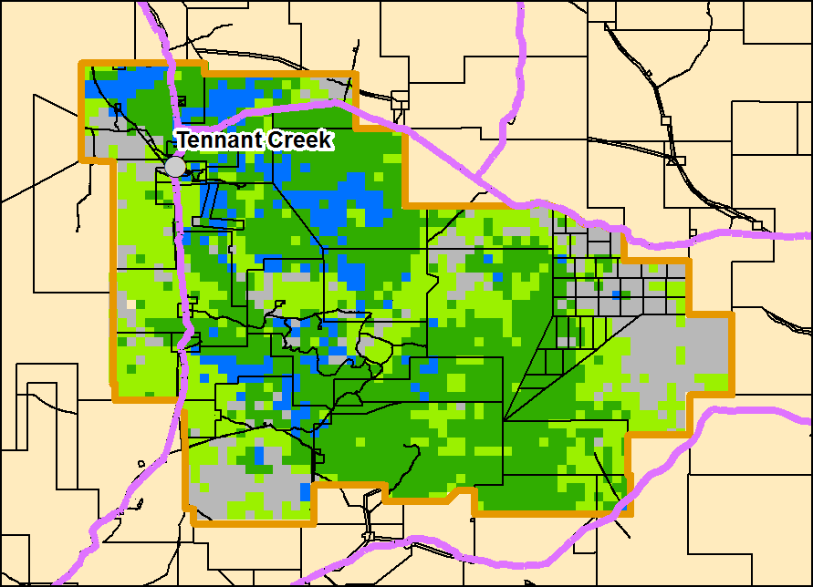
Total 2017/18 Pasture Growth  (July – August 2017) |  | Current Estimated  Total Standing Dry Matter
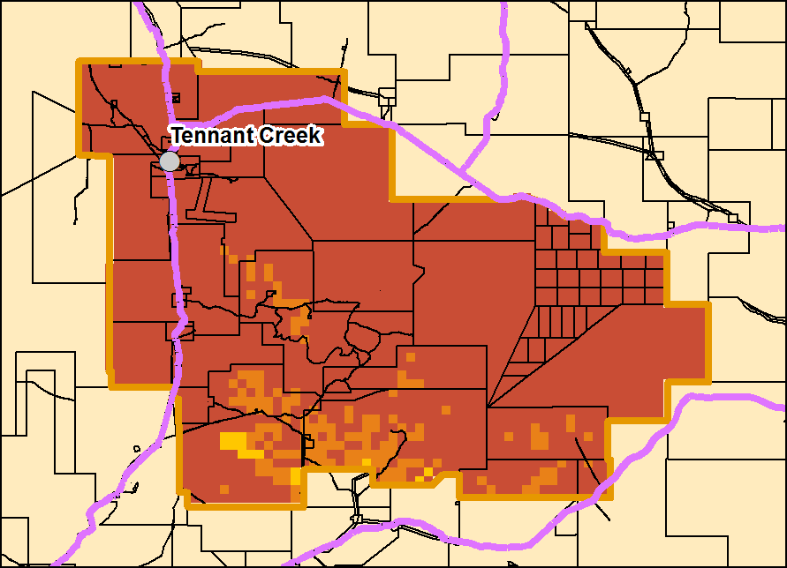 |  | 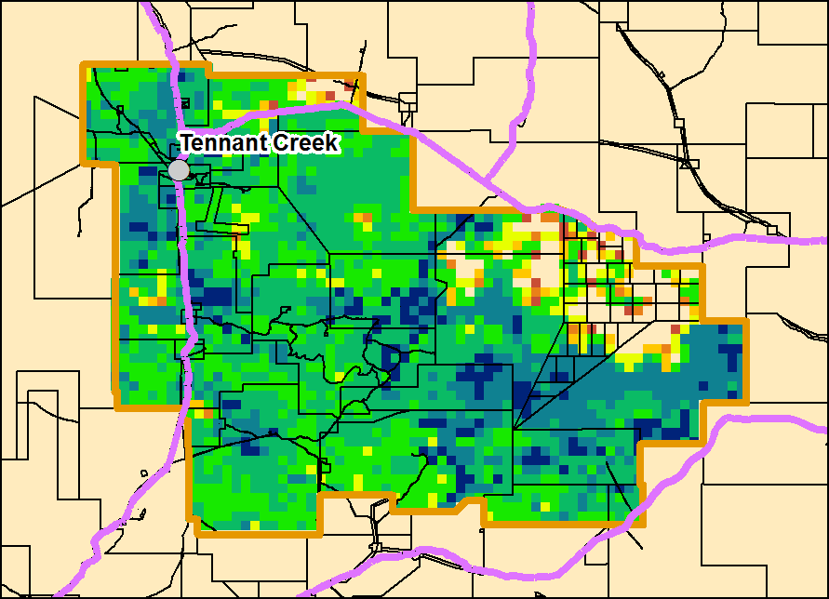

Northern Alice Springs District
Risks:
- As at the 1st September 2017, 100% of the district had a high fire risk.

Currently (as at 1st September 2017)
(% of district) | <250kg/ha | 250 - 500kg/ha | 500 - 1,000kg/ha | >1,000kg/ha
2016/17  Pasture Growth | 0% | 3% | 17% | 80%
Total Standing Dry Matter | 1% | 2% | 6% | 91%

(% of district) | Below Average | Average | Above Average
2016/17  Pasture Growth | 0% | 4% | 96%
Total Standing Dry Matter | 4% | 34% | 62%
Fire Risk | High  100% | Moderate  0% | Low  0%
Area Burnt | 3% (since 1st January 2017)  2% (since 1st July 2017)

2017/18 Median Pasture Growth (kg/ha)  (Running Total) |  | Chance of exceeding  Median Pasture Growth  (September – December 2017)
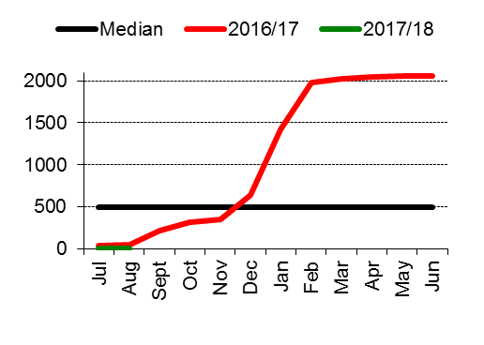 |  | 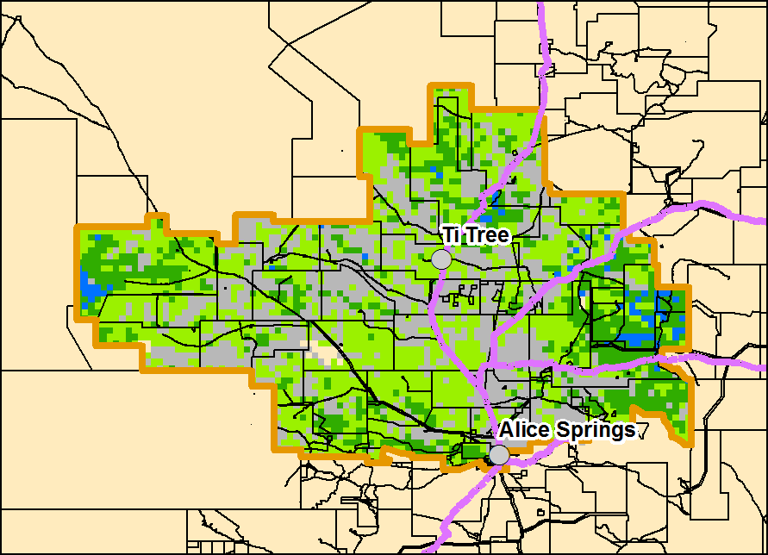
Total 2017/18 Pasture Growth  (July – August 2017) |  | Current Estimated  Total Standing Dry Matter
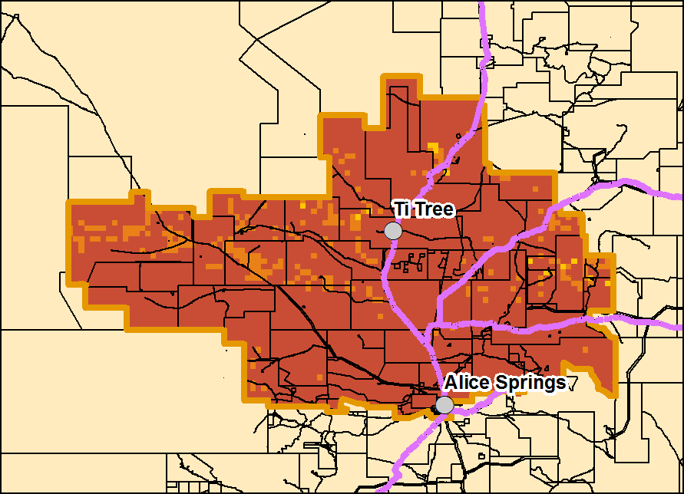 |  | 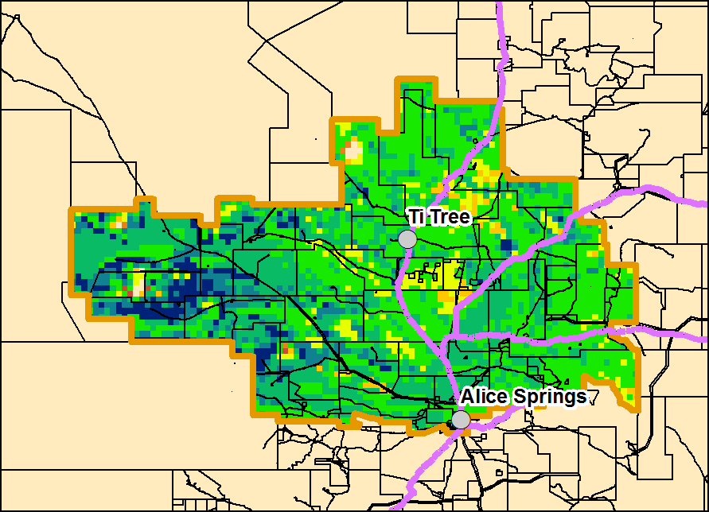

Plenty District
Risks:
- As at the 1st September 2017, 100% of the district had a high fire risk.

Currently (as at 1st September 2017)
(% of district) | <250kg/ha | 250 - 500kg/ha | 500 - 1,000kg/ha | >1,000kg/ha
2016/17  Pasture Growth | 0% | 8% | 26% | 66%
Total Standing Dry Matter  (kg/ha) | <1% | 3% | 29% | 68%

(% of district) | Below Average | Average | Above Average
2016/17  Pasture Growth | 0% | 0% | 100%
Total Standing Dry Matter | <1% | 27% | 73%
Fire Risk | High  100% | Moderate  0% | Low  0%
Area Burnt | 0% (since 1st January 2017)  0% (since 1st July 2017)

2017/18 Median Pasture Growth (kg/ha)  (Running Total) |  | Chance of exceeding  Median Pasture Growth  (September – December 2017)
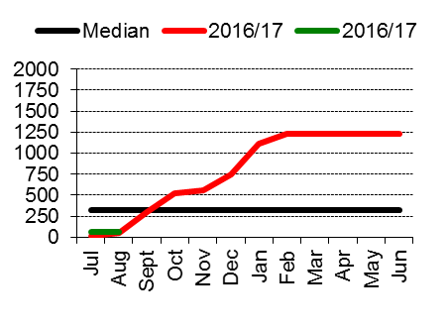 |  | 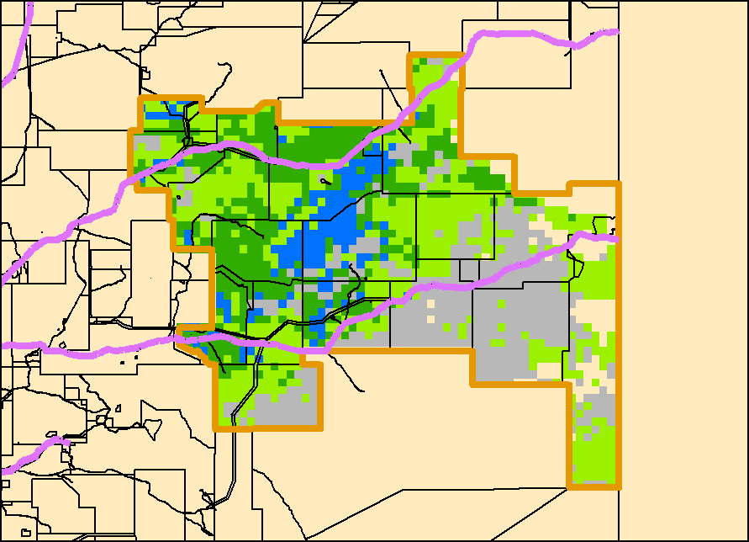
Total 2017/18 Pasture Growth  (July – August 2017) |  | Current Estimated  Total Standing Dry Matter
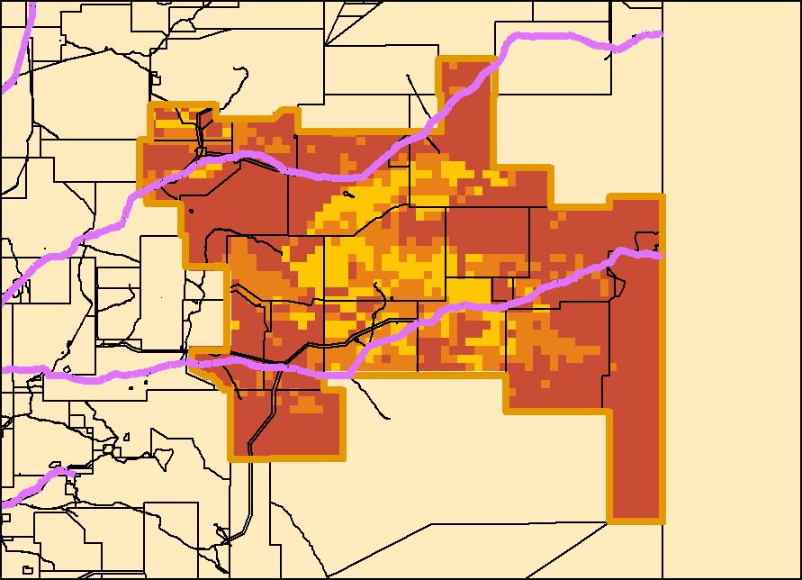 |  | 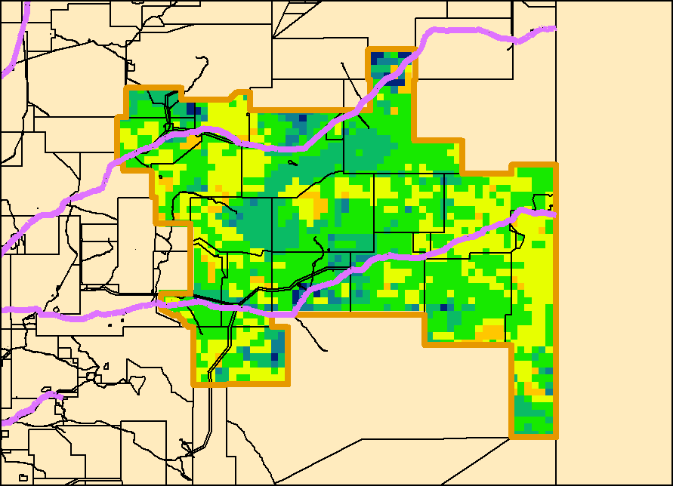

Southern Alice Springs District
Risks:
- As at the 1st September 2017, 99% of the district had a high fire risk.

Currently (as at 1st September 2017)
(% of district) | <250kg/ha | 250 - 500kg/ha | 500 - 1,000kg/ha | >1,000kg/ha
2016/17  Pasture Growth | 4% | 11% | 39% | 46%
Total Standing Dry Matter  (kg/ha) | 1% | 7% | 31% | 61%

(% of district) | Below Average | Average | Above Average
2016/17  Pasture Growth | 0% | 1% | 99%
Total Standing Dry Matter | 3% | 72% | 25%
Fire Risk | High  99% | Moderate  1% | Low  0%
Area Burnt | 0% (since 1st January 2017)  0% (since 1st July 2017)

2017/18 Median Pasture Growth (kg/ha)  (Running Total) |  | Chance of exceeding  Median Pasture Growth  (September – December 2017)
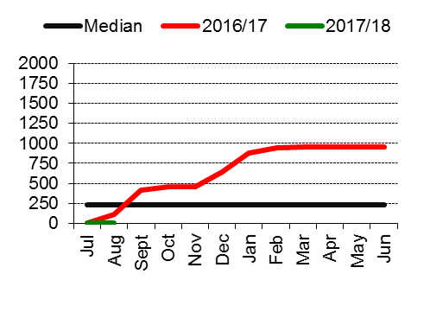 |  | 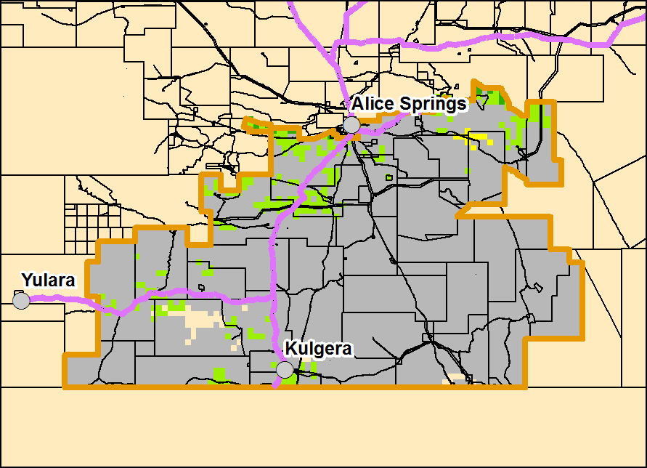
Total 2017/18 Pasture Growth  (July – August 2017) |  | Current Estimated  Total Standing Dry Matter
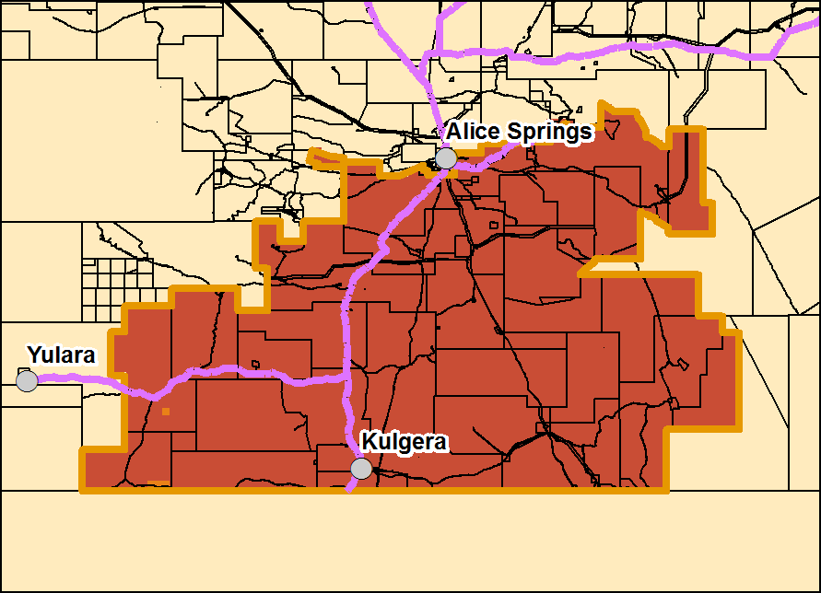 |  | 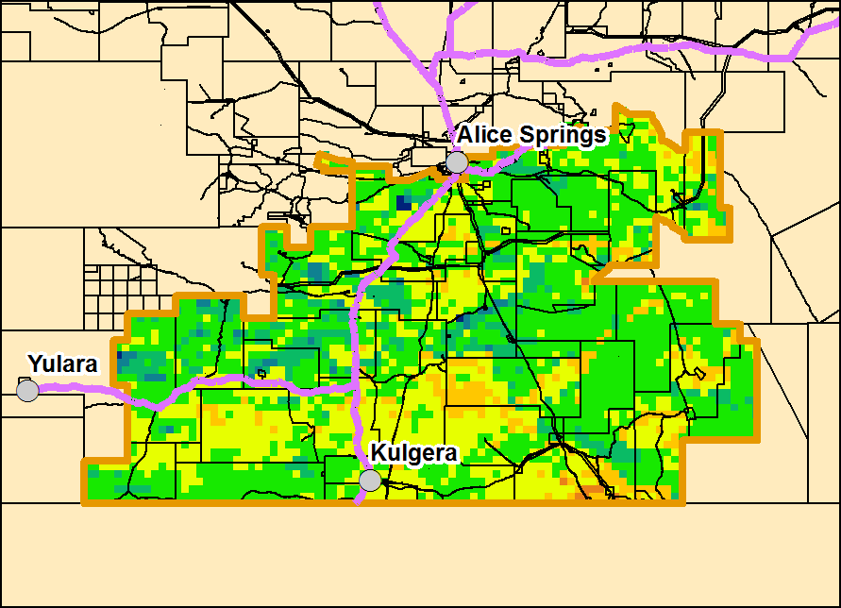

Pasture Information
The pasture and fire risk information in this document is derived from AussieGRASS. AussieGRASS is a model that simulates pasture growth and standing biomass using climate data, vegetation mapping, fire history and regional estimates of grazing pressure. The model can be used to track simulated pasture growth and total standing pasture biomass at the landscape scale.
Note that the model does not use stocking rate data for individual properties. Where stock numbers are significantly higher or lower than typical for a district, model estimates of total standing dry matter may be erroneous.

Disclaimer
While all care has been taken to ensure that information contained in this document is true and correct at the time of production, changes in circumstances after the time of distribution may impact on the accuracy of its information. The Northern Territory of Australia gives no warranty or assurance, and makes no representation as to the accuracy of any information or advice contained herein, or that it is suitable for your intended use.
You should not rely upon information in this document for the purpose of making any business or investment decisions without obtaining independent and/or professional advice in relation to your particular situation.
The Northern Territory of Australia disclaims any liability or responsibility or duty of care towards any person for loss of damage caused by any use of or reliance on this information.

