Key points
- Territory-wide business confidence was positive at +54% in the March quarter 2024. This was down from +62% in the December quarter 2023 and from +66% in the March quarter 2023.
- The fall in the quarter was driven by weaker confidence in Alice Springs, following an increase in the December quarter 2023.
- Commonly cited reasons for confidence in the quarter were ‘strong customer relations’, ‘business opportunity’ and ‘strong market position’.
- The most commonly cited reasons for concern were ‘security & anti-social behaviour’, ‘lack of suitably skilled workers’ and ‘decrease in business/sales’.

Territory business confidence is positive but declining
Territory-wide business confidence was positive at +54% for the March quarter 2024, in response to the question ‘How confident are you about your business prospects over the next 12 months?’ However, this was lower both over the quarter and year by 9 percentage points (ppt) and 12 ppt, respectively (Table 1).
Increased concern about security and anti-social behaviour contributed to the quarterly and annual deterioration. More businesses also reported weaker sales and increased business cost, reflecting weaker real household finances and the high inflation environment. That said, Territory businesses expect growth in revenue through stronger sales in the next 12 months.
Table 1: Business confidence index
 | Mar qtr 2024 | Quarterly change | Annual change*
Confident | 68% | -3ppt |  | -6ppt
Worried | 14% | +5ppt |  | +6ppt
Net Balance | 54% | -9ppt |  | -12ppt
*Current quarter compared with the same quarter in the previous year.
Figure 1: Responses to the business confidence question & change from previous quarter
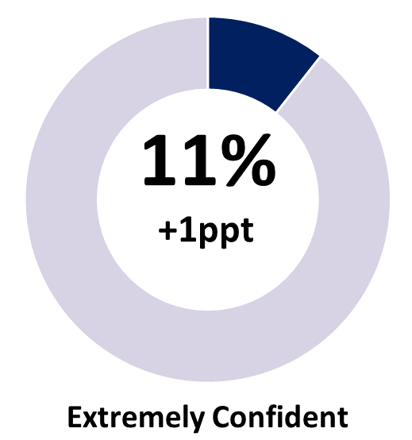 | 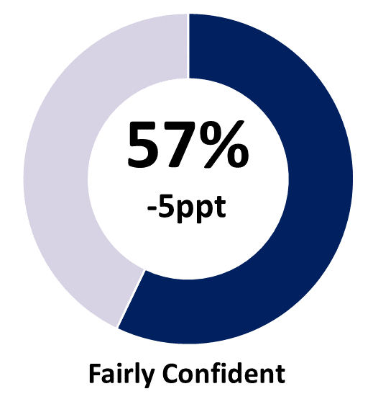 | 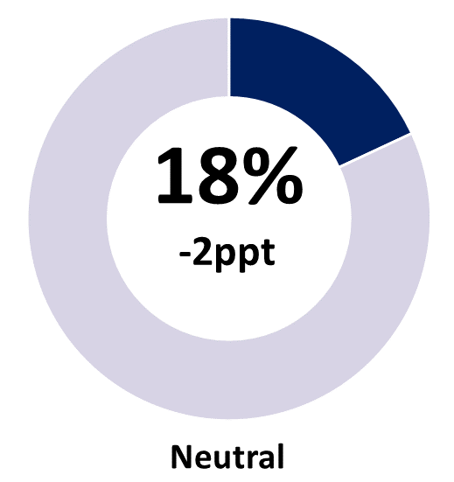
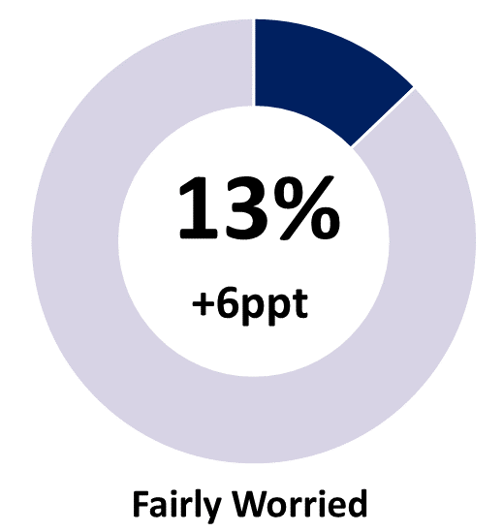 | 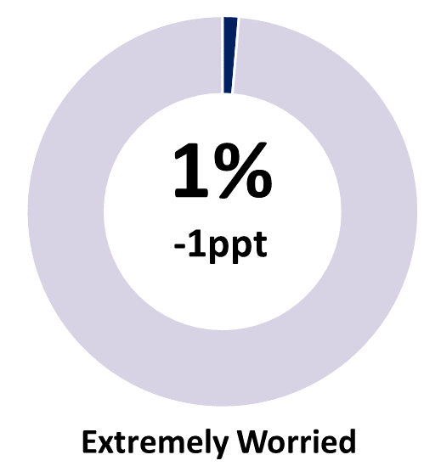 | 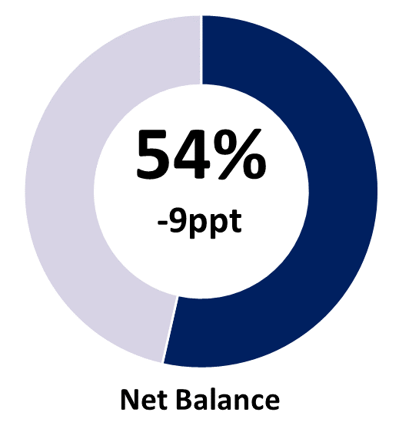
Note: Individual categories may not add to the net balance figure due to rounding.

Business confidence remains above pre-pandemic levels
Compared to previous March quarter results, business confidence in the March quarter 2024 fell to its lowest since 2020 (Chart 1). The proportion of worried businesses increased by 5 ppt in the quarter, picking up shares from confident (down by 3 ppt) and neutral (down by 2 ppt) businesses. Notwithstanding the drop in business confidence in the quarter, confidence level remains above the pre-pandemic average (49%) (Chart 2).
Chart 1 | Chart 2
Business confidence by quarter (%) | Average business confidence by calendar year (%)
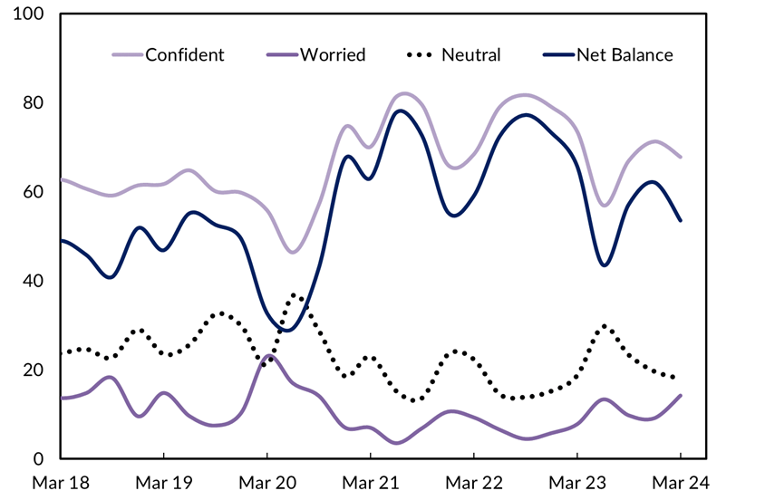 | 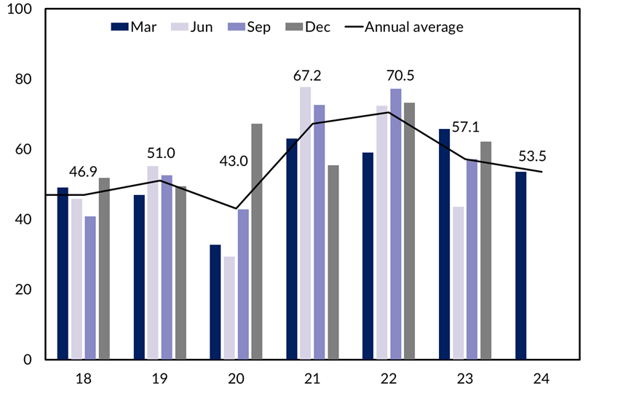

Business performance remained flat in the quarter
When asked ‘How is your business performing this year compared to last year?’, 47% of businesses reported improved performance. This is unchanged from the previous quarter, but is 5 ppt lower than the March quarter 2023 (Table 2).
Table 2: Business performance compared to last year
 | March qtr 2024 | Quarterly change | Annual change*
Better | 47% | 0ppt | -5ppt
Same | 35% | 0ppt | +1ppt
Worse | 18% | 0ppt | +4ppt
*Current quarter compared with the same quarter in the previous year.
Figure 2: Responses to the business performance question & quarterly change
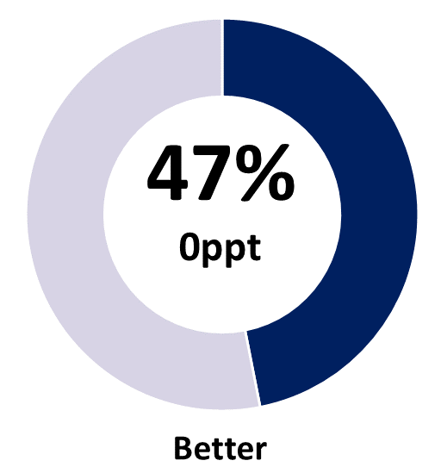 | 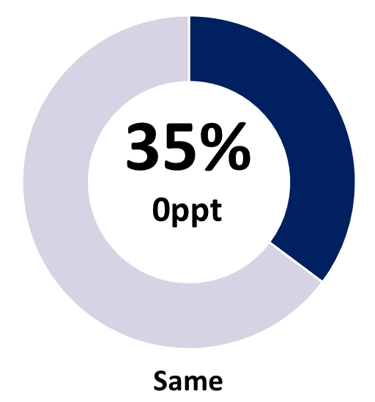 | 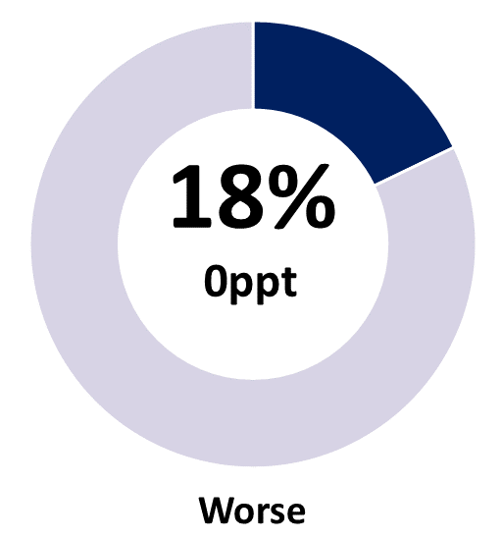
Note: Individual categories may not sum to 100 due to rounding.
The proportion of businesses stating performance this year worsened from last year was unchanged in the quarter, but increased by 4 ppt to 18% in annual terms (Chart 3).
Chart 3
Business performance – comparing this year to last – by quarter (%)
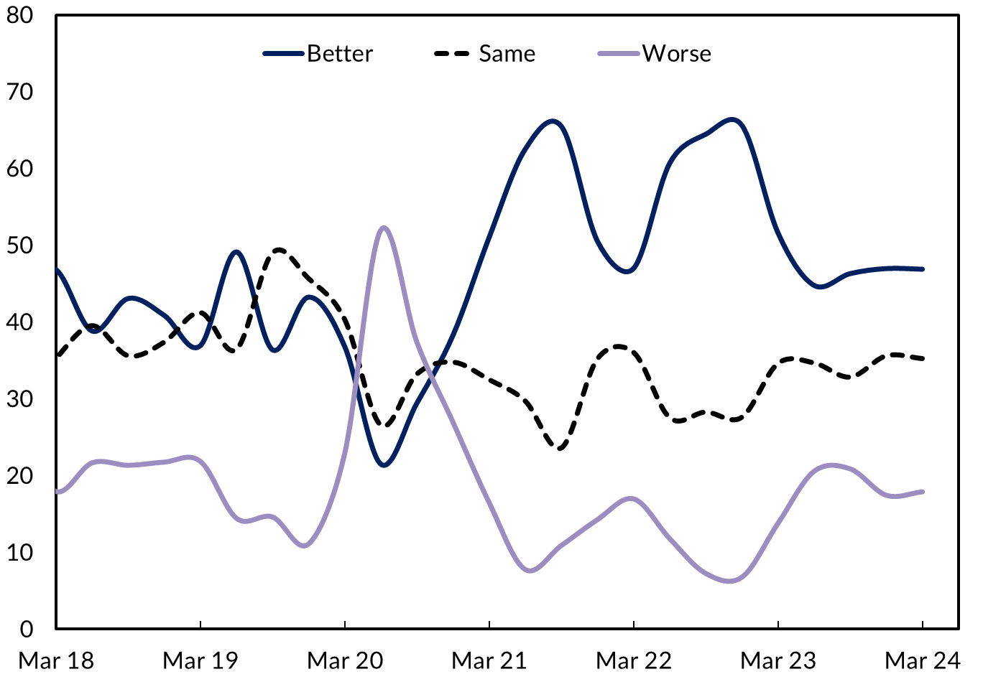

Customer relations & business opportunity drove confidence
Similar to previous quarters, the main reasons for positive business confidence in the Territory were strong customer relations and continued business opportunities. In addition, strong market position and the benefits accruing from being in business for a long time have also been cited as important sources of confidence (Chart 4).
Solid growth in private investment in the second half of 2023 is likely to have supported business sentiment in the quarter, with investment increasing by 15.0% in the December quarter 2023 (Chart 5), led by mining-related construction (30%) and machinery & equipment investments (14%).
Chart 4
Reasons for confidence, share of businesses (%)
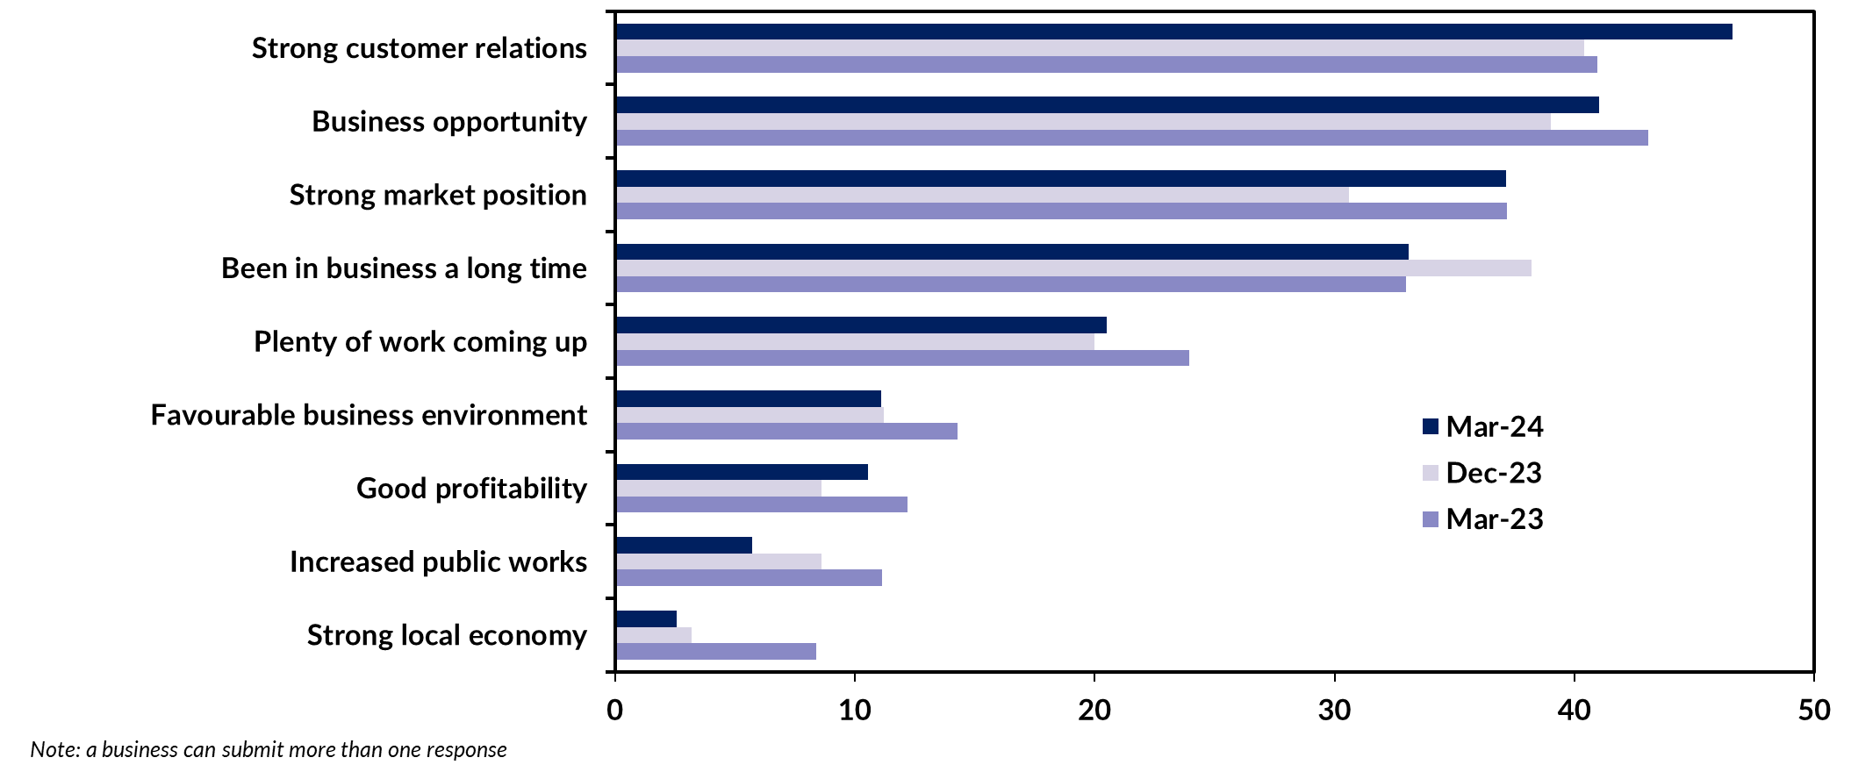

The Federal Court’s decision to permit construction of the Barossa subsea gas pipeline (January) and the Australian Government’s $840 million funding commitment to the Arafura rare earths project in Central Australia (March) were positive news for business confidence in the quarter, while Core Lithium’s decision to suspend mining at its Finniss project (January) due to weak market conditions was not.
Sectors reporting solid growth over the past few years, including international education, mining exploration and building construction (notably non-residential construction), are likely to also have supported the overall positive sentiments (Chart 6).
Chart 5 | Chart 6
Territory state final demand component  Quarterly growth (%), seasonally adjusted | Education, mining and construction activities  Index: December 2016 = 100
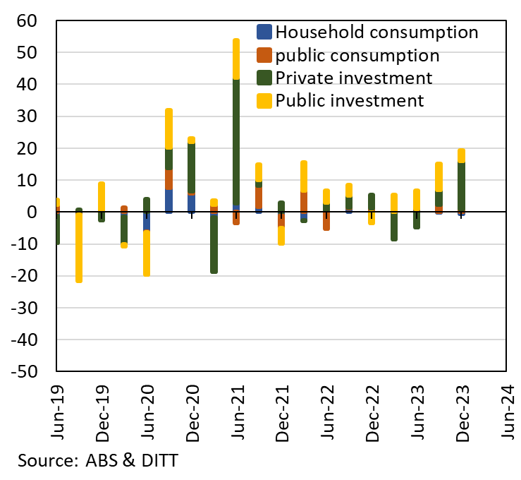 | 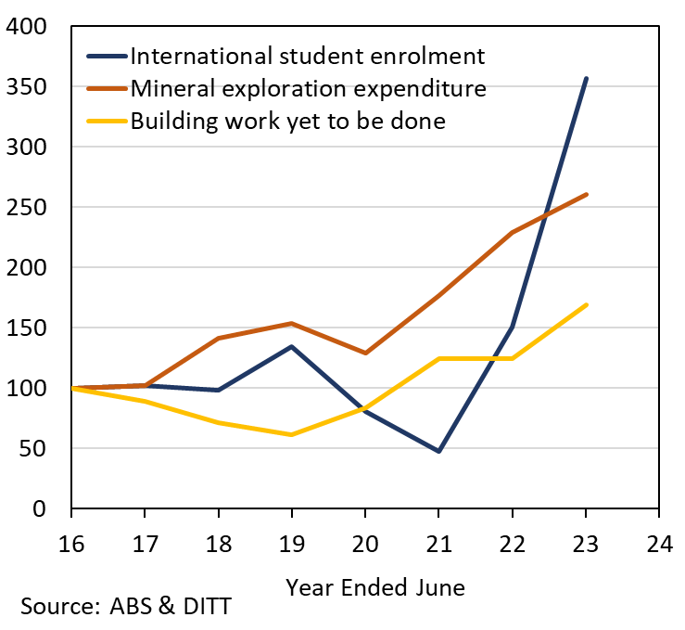

Security & anti-social behaviour and labour shortages are the main concerns
For the past four quarters the survey has included a free text option for respondents to identify concerns beyond the pre-defined options and, for two consecutive quarters, ‘security & anti-social behaviour’ has been identified as a major issue by the Territory businesses (Chart 7).
Compared with the previous quarter, the proportion of businesses reporting this as their major concern increased by 6 ppt to 20%, notably in Katherine region (up 41 ppt). Flooding in the Gulf region and temporary transfer of community residents to Katherine is likely to have contributed to the reported results.
Chart 7
Reasons for worry, share of businesses (%)
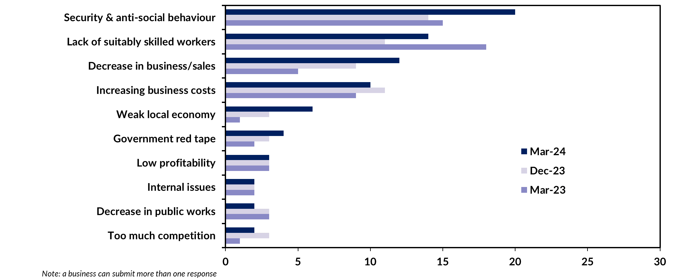
Chart 8 | Chart 9
Number of vacancies by sector  Annual , Original (‘000) | Wage price Index  Annual growth (%), Private and Public
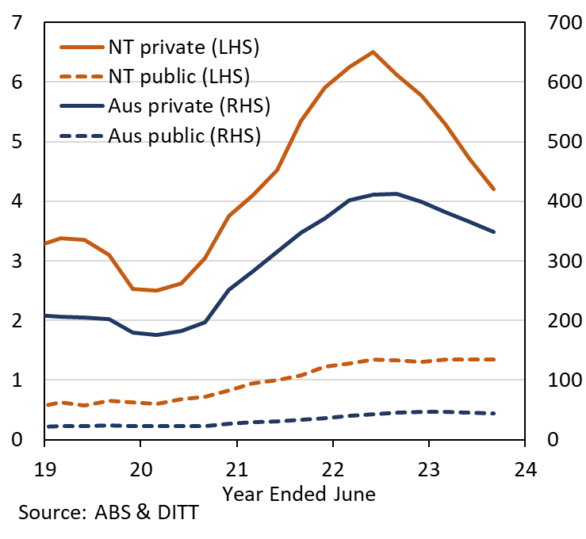 | 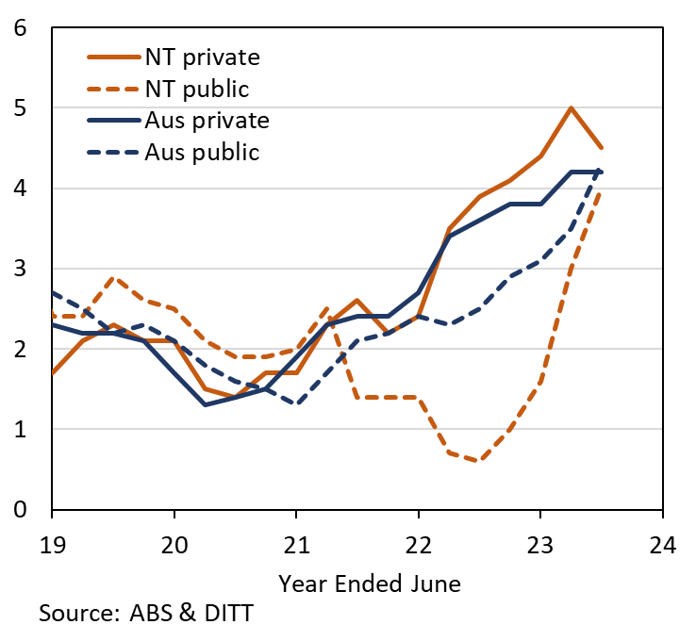
‘Lack of suitably skilled workers’ has been in the Top 2 of concerns since mid-2020, and increased in the quarter (+3ppt) but decreased annually (-4ppt). The Territory’s private sector had an average of 5.8 additional vacancies per 1000 population than nationally in 2023, and the highest proportion of businesses (21.4%) reporting vacancies amongst the jurisdictions and nationally (18.3%) in February 2024. While the Territory as a whole continues to have challenges attracting and retaining labour, this is being exacerbated in the Alice Springs region due to security and anti-social behaviour issues and the associated media reporting.
Other cited reasons for concern relate to domestic demand, and included decrease in sales, rising costs and weak local economy. These sentiments are corroborated by the December 2023 State Final Demand (SFD) data which reported a decline in household consumption (-0.7%), as consumers respond to persistently high inflation (3.3% in March quarter 2024) and interest rate hikes by the RBA since May 2022.
Businesses were also concerned about rising costs. Looking at wage costs specifically, private sector wages in the Territory continue to grow at a faster rate than nationally, although there has been a slight reduction in the recent quarter (Chart 9).

Business confidence was lowest in Alice Springs
Business confidence and performance varied by region in the quarter (Table 3), with Daly-Tiwi-West Arnhem reporting the highest net balance of (+94%), for the second consecutive quarter. Confidence in Greater Darwin decreased by 6 ppt in the quarter to a net balance of +54%, but sits well above its pre-pandemic level.
Alice Springs recorded the lowest confidence of the regions with a net balance of 30%. This represents a significant fall in the quarter (-32 ppt) and compared with the March quarter 2023 (-42 ppt). Reports suggest the recent curfew has been effective in reducing anti-social behaviour, but the impacts on the regionally significant tourism industry are likely to be felt for some time.
Katherine recorded a net balance of +66%, a decrease of 5 ppt in the quarter. The Katherine region also recorded the weakest result for business performance with only 24% of businesses feeling better about their performance this year relative to last year.
Table 3: Business confidence & performance by region
Business Confidence |  |  |  |  | Business Performance
 | Mar qtr 2024 | Quarterly change | Annual change |  |  | Mar qtr 2024 | Quarterly change | Annual change
Territory-wide (n=541) |  |  |  |  | Territory-wide (n=541)
Confident | 68% | -3ppt | -6ppt |  | Better | 47% | 0ppt | -5ppt
Worried | 14% | +5ppt | +6ppt |  | Same | 35% | 0ppt | +1ppt
Net Balance | 54% | -9ppt | -12ppt |  | Worse | 18% | 0ppt | +4ppt
Greater Darwin (n=226) |  |  |  |  | Greater Darwin (n=226)
Confident | 67% | -3ppt | -5ppt |  | Better | 50% | 0ppt | -1ppt
Worried | 10% | +3ppt | +5ppt |  | Same | 33% | 0ppt | -2ppt
Net Balance | 54% | -6ppt | -10ppt |  | Worse | 17% | 0ppt | +3ppt
Daly-Tiwi-West Arnhem (n=35) |  |  |  |  | Daly-Tiwi-West Arnhem (n=35)
Confident | 94% | +13ppt | +11ppt |  | Better | 63% | +21ppt | +5ppt
Worried | 0% | 0ppt | -7ppt |  | Same | 31% | -15ppt | -1ppt
Net Balance | 94% | +13ppt | +18ppt |  | Worse | 6% | -6ppt | -3ppt
East Arnhem (n=11) |  |  |  |  | East Arnhem (n=11)
Confident | 82% | +2ppt | +17ppt |  | Better | 55% | +11ppt | -4ppt
Worried | 18% | +13ppt | +6ppt |  | Same | 18% | -18ppt | -11ppt
Net Balance | 64% | -11ppt | +11ppt |  | Worse | 27% | +7ppt | +16ppt
Katherine (n=104) |  |  |  |  | Katherine (n=104)
Confident | 80% | +6ppt | +4ppt |  | Better | 24% | -19ppt | -38ppt
Worried | 14% | +11ppt | +5ppt |  | Same | 45% | +13ppt | +26ppt
Net Balance | 66% | -5ppt | 0ppt |  | Worse | 31% | +5ppt | +12ppt
Barkly (n=35) |  |  |  |  | Barkly (n=35)
Confident | 88% | +11ppt | -1ppt |  | Better | 35% | -6ppt | -20ppt
Worried | 6% | +2ppt | +6ppt |  | Same | 50% | +14ppt | +6ppt
Net Balance | 82% | +9ppt | -7ppt |  | Worse | 15% | -8ppt | +15ppt
Alice Springs (n=130) |  |  |  |  | Alice Springs (n=130)
Confident | 55% | -15ppt | -24ppt |  | Better | 37% | +2ppt | -13ppt
Worried | 25% | +17ppt | +18ppt |  | Same | 44% | -7ppt | +7ppt
Net Balance | 30% | -32ppt | -42ppt |  | Worse | 19% | +4ppt | +6ppt
Note: Caution should be taken when interpreting these results as the sample size in some regions may be relatively small.

Business confidence was weakest in the retail trade sector
Business confidence varied among the 10 industries with the largest number of respondents, ranging from Education & Training reporting a net balance of +81% to Retail Trade at +21% (Chart 10).
Business confidence deteriorated across many industries in the March quarter 2024, most notably in the customer-facing sectors with Retail Trade reporting a fall of 31 ppt in the quarter and 38 ppt annually. This aligns with the businesses concerns on weak demand and economy, as reported above. Latest data reports that Territory retail trade turnover saw a drop of 1.2% in the year to December 2023, driven by a 2.3% fall in retail of household goods. This is consistent with the SFD data which reported a 3.9% fall in household expenditure on furnishings and household equipment.
Confidence in the Territory’s Accommodation & Food Services industry also decreased in the quarter (-9 ppt) and annually (-34 ppt) to 43%. This aligns with Tourism NT reporting $2.6 billion in tourism revenue for the Territory in 2023, down by 5% compared to 2022. The Territory Government has implemented several programs to support the tourism and hospitality sectors, including the Territory Tourism Discount Scheme which aims to increase economic activity during the off-peak season.
Chart 10
Business confidence responses by industry (%)
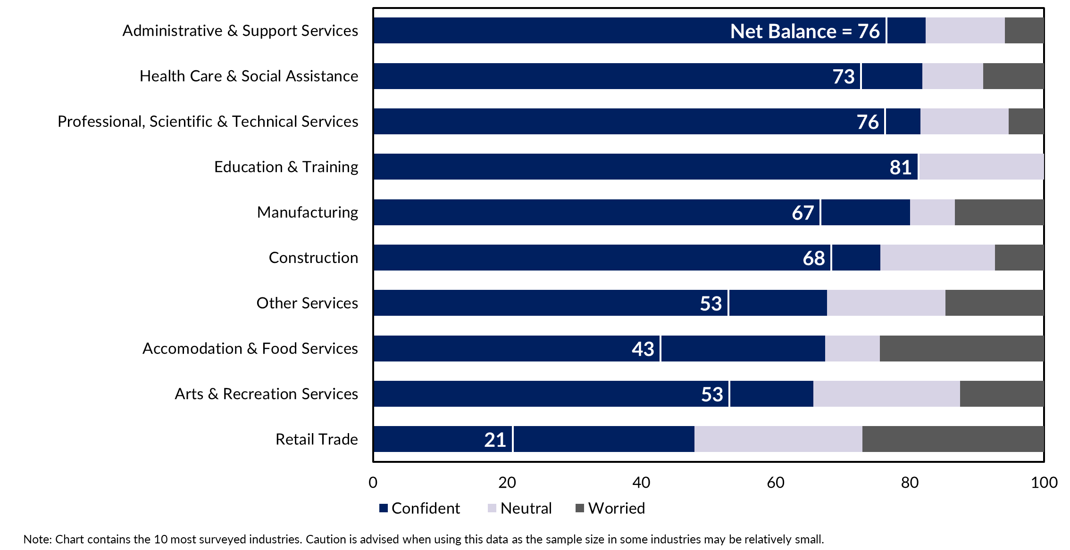

Businesses are confident of revenue growth …
Notwithstanding current uncertainties, the survey reports Territory businesses are optimistic about future growth prospects, with 66% expecting revenue growth in the next 12 months, and 55% expecting increased profitability (Chart 10). In addition, 22% of Territory businesses report they intend to upgrade capital & equipment stocks, and 14% of businesses intend to invest in new technology in the next 12 months.
Chart 10
Business indicators (%)
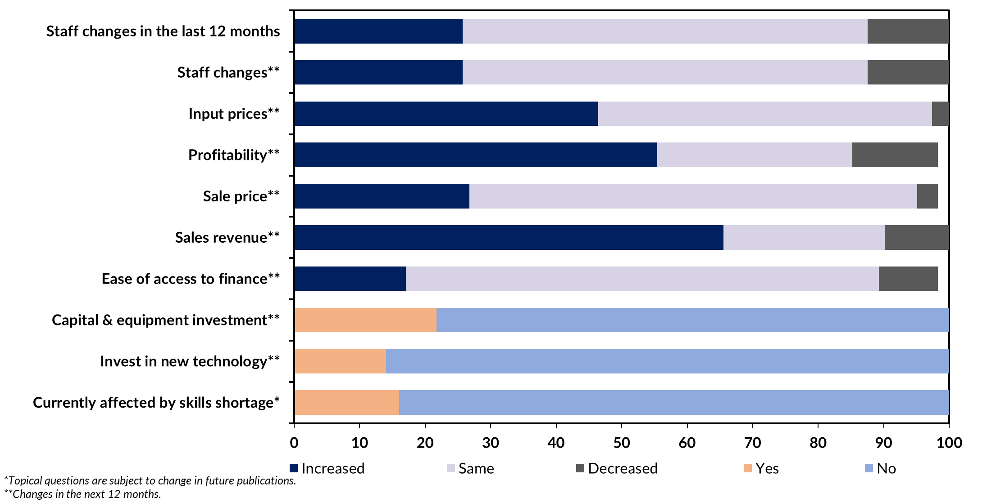

… and attracting staff from interstate and investing in training
Responding to the question on managing labour shortages, 11% of businesses state they are actively looking to attract staff from interstate and are investing in training and upskilling (Chart 11). The proportion of businesses reporting ‘lack of suitably skilled workers’ has been volatile, but has been trending down since the peak in mid-2022. Increased net overseas migration (which is up by 38% annually to September 2023) is also helping businesses to meet labour requirements.
Chart 11
Responses to skill shortages (%)
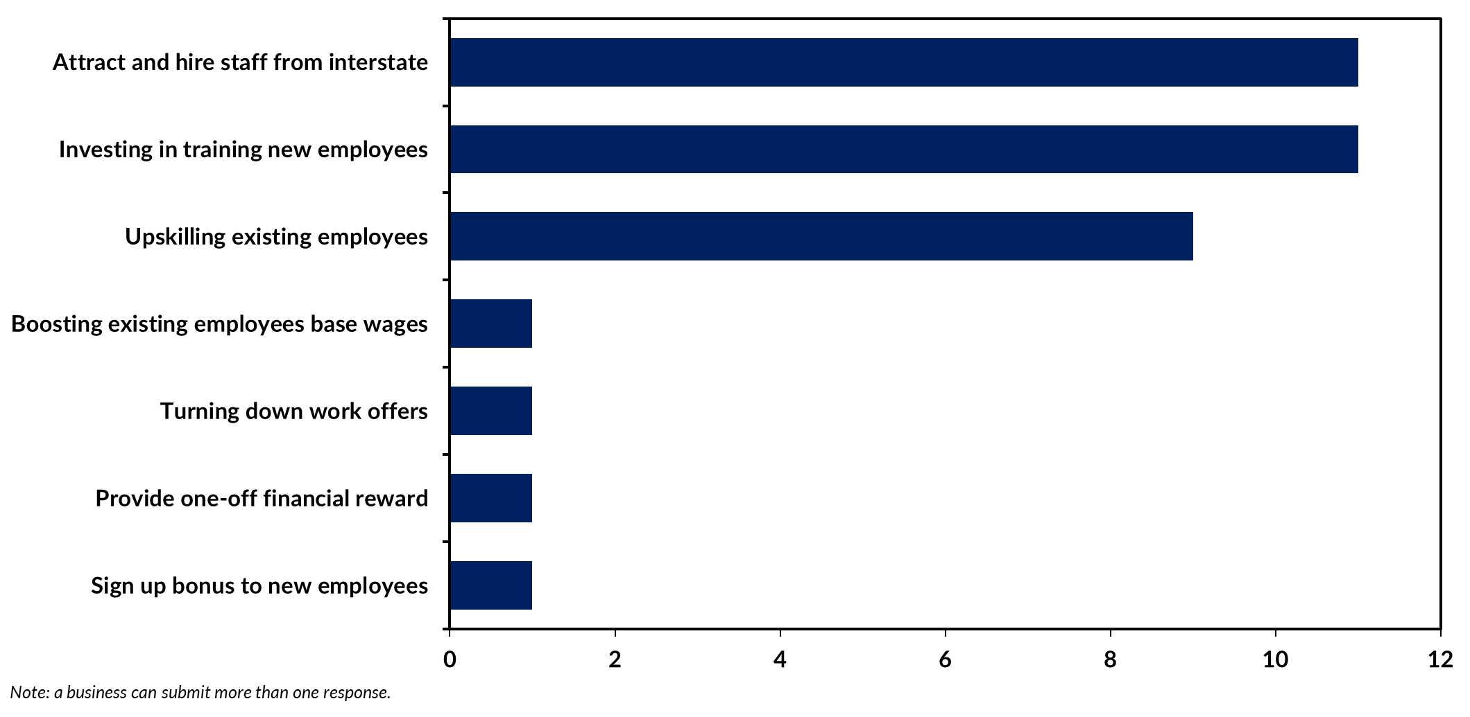

Appendix

Methodology
The Department of Industry, Tourism and Trade conducts a survey of businesses operating in the Territory on a quarterly basis. The results have been used to construct a business confidence index.
The business confidence index is calculated as the difference between the proportion of businesses that are ‘confident about their business prospects for the next 12 months' and the proportion of businesses that are ‘worried about their business prospects for the next 12 months’ (net balance approach).
The Territory-wide confidence index is weighted to account for the number of businesses in each region. The weighted result provides a more balanced reflection of overall business confidence. Business confidence results are also presented by region and industry.
541 businesses were surveyed this quarter out of 16,103 operating businesses in the Territory (Table 4). For the sample survey to achieve a 95% confidence level with a margin of error of 5%, 391 survey responses are required.
Table 4: Survey Numbers
Region | Total number of businesses | Businesses surveyed | Proportion of total
Greater Darwin | 11,907 | 226 | 1.9%
Daly-Tiwi-West Arnhem | 389 | 35 | 9.0%
East Arnhem | 275 | 11 | 4.0%
Katherine | 1,036 | 104 | 10.0%
Barkly | 182 | 35 | 19.2%
Alice Springs | 2,020 | 130 | 6.4%
Total | 16,103 | 541 | 3.4%

