# Key points

* Territory-wide business confidence was +74% in the December quarter 2022, a slight decrease of 3 percentage points on the previous quarter, but well above pre-pandemic levels. Only 5% of respondents reported to be worried.
* Business performance increased by 3 percentage points to be at its equal highest level since the survey began.
* The main reason for confidence was ‘business opportunity’. For the third consecutive year Territory demand increased in the year to September 2022, supporting favourable business conditions.
* The most commonly cited reason for being worried this quarter was ‘lack of suitably skilled workers’, reflecting the Territory’s low unemployment rate and high number of job vacancies.

# NT businesses are confident about their business prospects

The Territory-wide business confidence index is +74% for the December quarter 2022 in response to the question ‘How confident are you about your business prospects over the next 12 months?’ This is a slight decrease of 3 percentage points from the previous quarter and a 19 percentage point increase through the year (Table 1). The quarterly change reflects a decrease in the share of extremely confident businesses regarding the short term outlook in the quarter (Figure 1), while the through the year change reflects recovery from the period of weak confidence in the December quarter 2021 associated with the COVID‑19 Omicron outbreak.

**Table 1: Business confidence index**

|  |  |  |  |  |
| --- | --- | --- | --- | --- |
|  | Dec Qtr 2022 | Quarterly change | Through the year change* | |
| Confident | 79% | -2ppt | | +13ppt |
| Worried | 5% | 0ppt | | -5ppt |
| Net Balance | 74% | -3ppt | | +19ppt |

*Current quarter compared with the same quarter the previous year.

**Figure 1: Responses to the business confidence question and change from previous quarter**

|  |  |  |
| --- | --- | --- |
|  |  |  |
|  |  |  |

Note: Individual categories may not add to the net balance figure due to rounding.

# Business confidence remains well above pre-pandemic levels

Business confidence sits well above pre-pandemic levels (Graph 1). Despite a slight decrease in the December quarter 2022, the average business confidence level in 2022 is higher than the 2021 average (Graph 2).

**Graph 1**

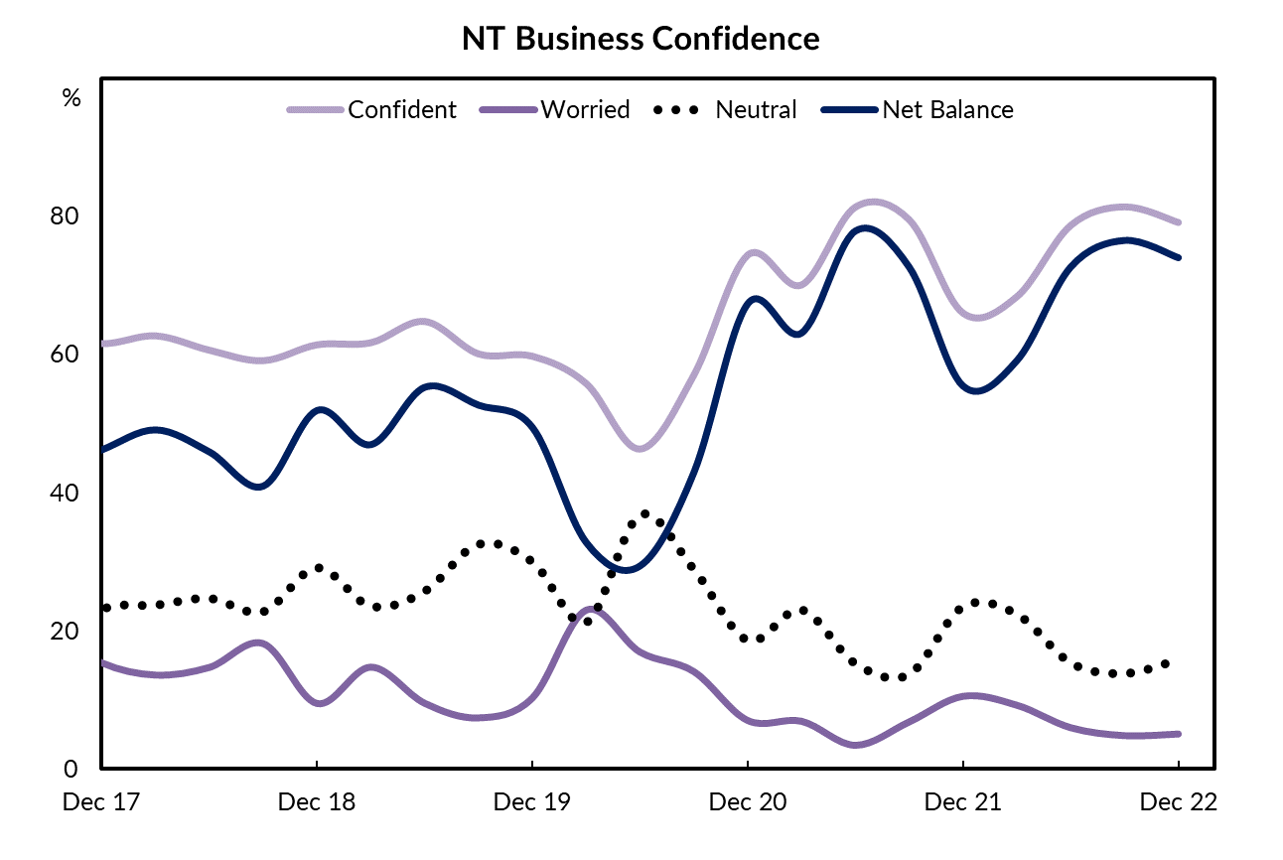

**Graph 2**

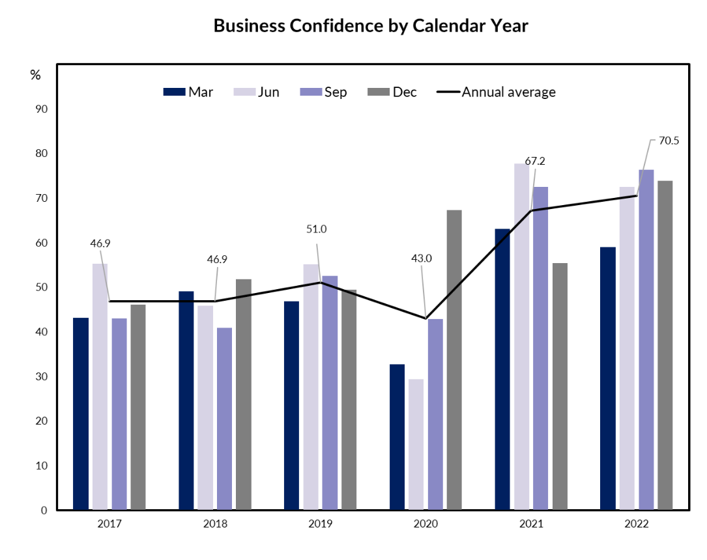

# Business performance is better this quarter

Despite a slight decrease in the business confidence this quarter, 66% of businesses responded with ‘better’ in response to the question ‘How’s your business performing this year compared to last year?’, in both quarterly and through the year terms (Table 2). This represents a 3 percentage point increase from the September quarter to its equal highest recorded level.

**Table 2: Business performance compared to last year**

|  |  |  |  |
| --- | --- | --- | --- |
|  | Dec Qtr 2022 | Quarterly change | Through the year change* |
| Better | 66% | +3ppt | +15ppt |
| Same | 28% | -2ppt | -8ppt |
| Worse | 6% | -1ppt | -8ppt |

*Current quarter compared with the same quarter the previous year.

**Figure 2: Responses to the business performance question and quarterly change**

|  |  |  |
| --- | --- | --- |
|  |  |  |

Note: Individual categories may not sum to 100 due to rounding.

The number of businesses stating their performance this year is worse than last year decreased by 1 percentage point to 6% this quarter, its lowest recorded level (Graph 3).

**Graph 3**

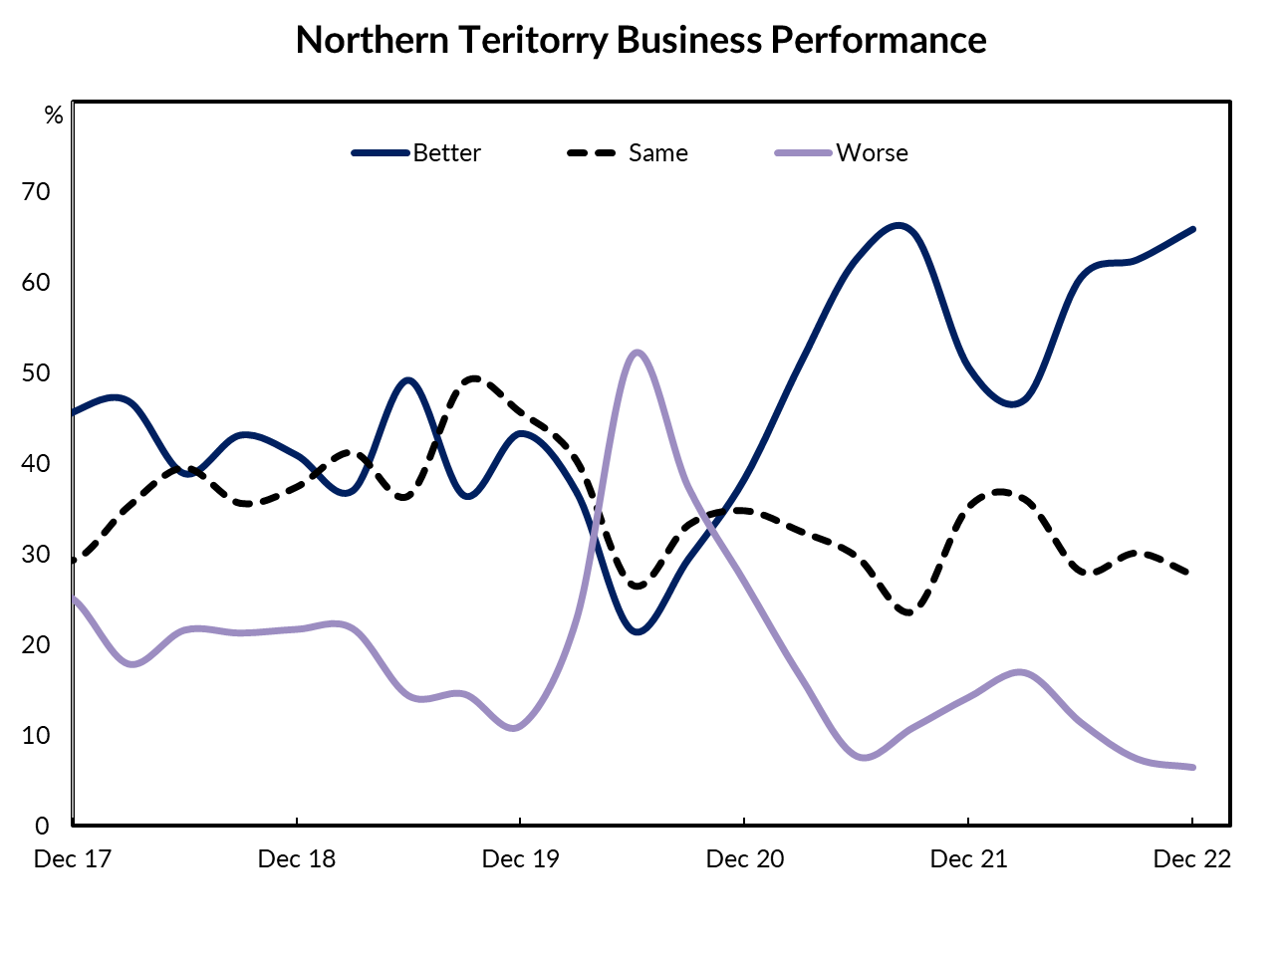

# Business opportunities and customer relations drive confidence

The key reasons cited for business confidence are ‘business opportunity’, ‘strong customer relations’ and ‘strong market position’ (Graph 4). There is a slight increase in the proportion of businesses reporting ‘favourable business environment’ and ‘good profitability’ as reasons for confidence this quarter, and in through the year terms.

**Graph 4**

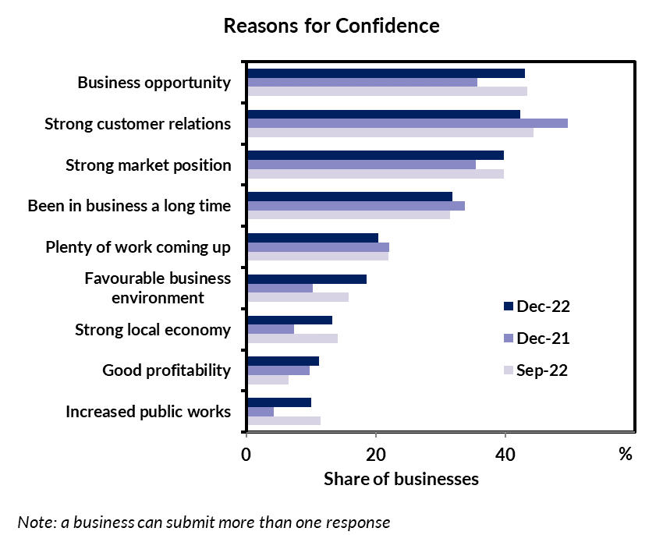

Overall demand in the Territory increased over 2022, for the third consecutive year, creating favourable business conditions (Graph 5). The increase in economic activity is reflected in the strong growth in the number of Territory businesses, and improvements in business survival rates (Graph 6). Reflecting the strong economic conditions, 13% of businesses cited ‘strong local economy’ as a reason for their confidence, while only 1% of businesses cited ‘weak local economy’ as a reason for being worried.

|  |  |
| --- | --- |
| **Graph 5** | **Graph 6** |
|  |  |

# Labour shortages and rising costs are major concerns

The key reasons cited for being worried are ‘lack of suitably skilled workers’ and ‘increasing business costs’ (Graph 7). As in recent quarters, businesses are struggling with labour shortages. These struggles are reflected in the higher proportion of businesses reporting vacancies in the Territory while the number of unemployed people to fill those vacancies has fallen (Graph 8).

There is a significant decrease in businesses citing ‘Government red tape’ as a reason for being worried, in both quarterly and through the year terms. The decrease likely reflects both buoyant economic conditions, and NT Government initiatives to streamline business application process and tailored support for Territory businesses under the Business Growth Program.

**Graph 7**

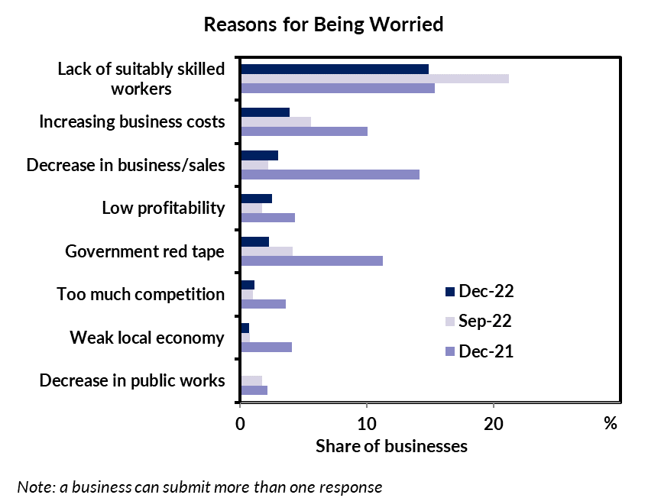

In the December quarter there is a slight increase in the businesses citing ‘decrease in business/sales’ as a reason for being worried. This is consistent with ABS data which reports nominal retail sales since July 2022 are trending down (Graph 9), during a period of increased inflationary pressures for both businesses and consumers, which will translate to more significant declines in real retail sales.

|  |  |
| --- | --- |
| **Graph 8** | **Graph 9** |

# Business confidence and performance vary among the regions

Business confidence and performance vary among the regions (Table 3). Both business confidence and performance are the highest in the Barkly region. Business confidence in the Barkly region records a net balance of +100%, a 33 percentage point increase from the previous quarter. The small sample size for the Barkly region can contribute to large quarterly movements in the indicator, though all businesses in the region reported feeling better about their performance this quarter.

Business performance in Alice Springs improved in the quarter with 63% of businesses reporting that performance is better compared to last year, an increase of 9 percentage points. Business confidence in Alice Springs also increased by 9 percentage points to a net balance of +94% of businesses feeling confident about their prospects for the coming year.

**Table 3: Business confidence and performance by region**

|  |  |  |  |  |  |  |  |  |  |
| --- | --- | --- | --- | --- | --- | --- | --- | --- | --- |
| Business Confidence | | | |  | Business Performance | | | | |
|  | **Dec Qtr 2022** | **Quarterly change** | **Through the year change** |  |  | **Dec Qtr 2022** | **Quarterly change** | **Through the year change** |
| **Greater Darwin (n=171)** | | | |  | **Greater Darwin (n=171)** | | | | |
| Confident | 76% | -5ppt | +6ppt |  | Better | 67% | +3ppt | +11ppt |
| Worried | 5% | 0ppt | -3ppt |  | Same | 27% | -2ppt | -7ppt |
| Net Balance | 71% | -6ppt | +8ppt |  | Worse | 6% | -1ppt | -5ppt |
| **Daly-Tiwi-West Arnhem (n=22)** | | | |  | **Daly-Tiwi-West Arnhem (n=22)** | | | | |
| Confident | 68% | -9ppt | -4ppt |  | Better | 59% | +5ppt | -8ppt |
| Worried | 18% | -5ppt | -10ppt |  | Same | 27% | -3ppt | +16ppt |
| Net Balance | 50% | -4ppt | +6ppt |  | Worse | 14% | -2ppt | -9ppt |
| **East Arnhem (n=20)** | | | |  | **East Arnhem (n=20)** | | | | |
| Confident | 80% | -6ppt | -13ppt |  | Better | 60% | +35ppt | -9ppt |
| Worried | 5% | +5ppt | +5ppt |  | Same | 25% | -25ppt | +6ppt |
| Net Balance | 75% | -11ppt | -18ppt |  | Worse | 15% | -10ppt | +3ppt |
| **Katherine (n=51)** | | | |  | **Katherine (n=51)** | | | | |
| Confident | 78% | -1ppt | -2ppt |  | Better | 63% | -17ppt | +9ppt |
| Worried | 10% | +8ppt | +2ppt |  | Same | 27% | +13ppt | +8ppt |
| Net Balance | 69% | -8ppt | -4ppt |  | Worse | 10% | +4ppt | -17ppt |
| **Barkly (n=5)** | | | |  | **Barkly (n=5)** | | | | |
| Confident | 100% | +33ppt | +48ppt |  | Better | 100% | +43ppt | +71ppt |
| Worried | 0% | 0ppt | -29ppt |  | Same | 0% | -43ppt | -43ppt |
| Net Balance | 100% | +33ppt | +76ppt |  | Worse | 0% | 0ppt | -29ppt |
| **Alice Springs (n=161)** | | | |  | **Alice Springs (n=161)** | | | | |
| Confident | 94% | +7ppt | +53ppt |  | Better | 63% | +9ppt | +36ppt |
| Worried | 1% | -2ppt | -21ppt |  | Same | 33% | -7ppt | -20ppt |
| Net Balance | 94% | +9ppt | +74ppt |  | Worse | 4% | -2ppt | -16ppt |

Note: Caution should be taken when interpreting these results as the sample size in some regions may be relatively small.

# Business confidence varies across industries

Business confidence varies by industry, with Construction recording the highest confidence at +97% while Accommodation and Food Services recorded the lowest confidence, but is at a very solid +70% (Graph 10).

Construction reported a +7 percentage point increase in confidence in the quarter and is consistent with an increase in the value of construction work commenced in the Territory in the September quarter.

The industry that reported the lowest confidence this quarter is Accommodation and Food Services, with a decrease of 18 percentage points relative to the previous quarter. Despite the increase in visitation in the past year, the impact of labour shortages, rising inflation and interest rate hikes – impacts to discretionary spending – is making tourism providers less confident regarding the coming year. With the prospect of continued high fuel prices impacting the drive market, high airfares and limited supply expected to impact demand for the Territory’s tourism products.

**Graph 10**

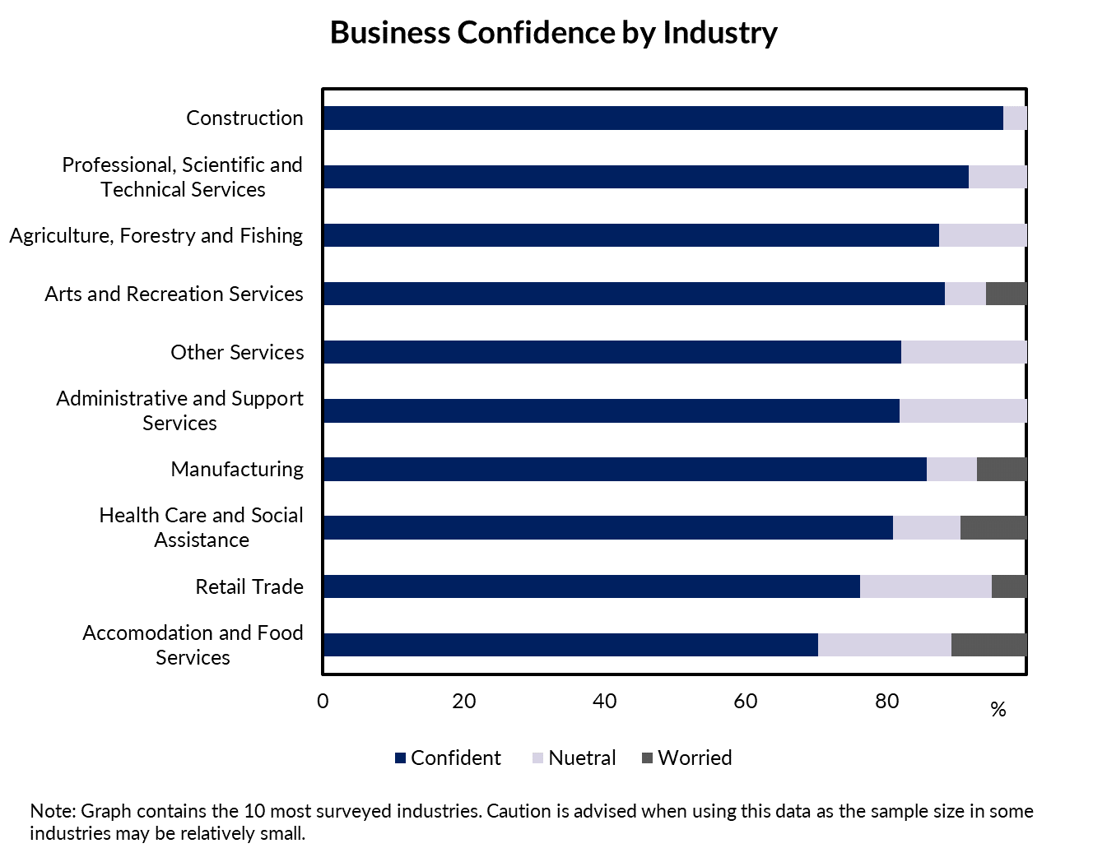

Appendix

# Methodology

The Department of Industry, Tourism and Trade conducts a face-to-face survey of businesses operating in the Territory on a quarterly basis. The results have been used to construct a business confidence index.

The business confidence index is calculated as the difference between the proportion of businesses that are ‘confident about their business prospects for the next 12 months' and the proportion of businesses that are ‘worried about their business prospects for the next 12 months’ (net balance approach).

The Territory-wide confidence index is weighted to account for the number of businesses in each region. The weighted result provides a more balanced reflection of overall business confidence. Business confidence results are also presented by region and industry.

437 businesses were surveyed out of 15,777 operating businesses in the Territory (Table 5). For the sample survey to achieve a 95% confidence level with a margin of error of 5%, 376 survey responses are required.

**Table 5: Survey Numbers**

|  |  |  |  |
| --- | --- | --- | --- |
| Region | Total number of businesses | Businesses surveyed | Proportion of total |
| Greater Darwin | 11577 | 171 | 1.5% |
| Daly-Tiwi-West Arnhem | 378 | 22 | 5.8% |
| East Arnhem | 241 | 20 | 8.3% |
| Katherine | 960 | 51 | 5.3% |
| Barkly | 193 | 5 | 2.6% |
| Alice Springs | 2034 | 161 | 7.9% |
| **Total** | **15777** | **437** | **2.8%** |