Mineral Titles Act 2010
NOTICE OF LAND CEASING TO BE A MINERAL TITLE AREA
Title Type and Number: | Exploration Licence 31730
Area Ceased on: | 30 November 2022
Area: | 4 Blocks, 13.35 km²
Locality: | PINE CREEK
Name of Applicant(s)/Holder(s): | 100% CELLIER Leon John
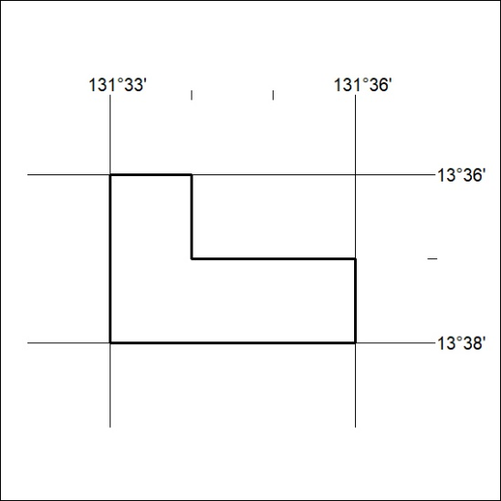

415/22

