Mineral Titles Act 2010
NOTICE OF LAND CEASING TO BE A MINERAL TITLE APPLICATION AREA
Title Type and Number: | Exploration Licence 33260
Area Ceased on: | 28 October 2022
Area: | 42 Blocks, 132.89 km²
Locality: | TOKO
Name of Applicant(s)/Holder(s): | 100% MLM DRILLING PTY LTD [ACN. 130 013 562]
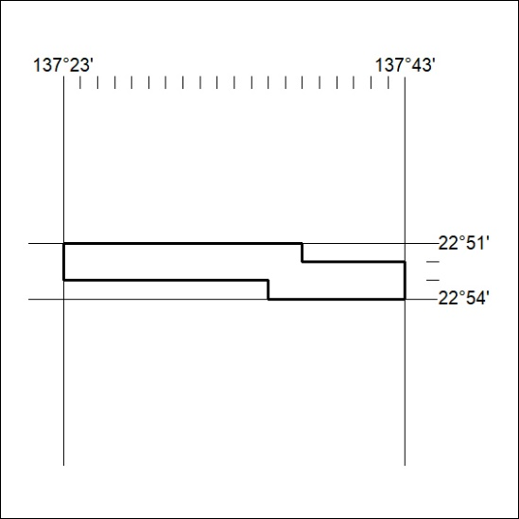

365/22

Mineral Titles Act
NOTICE OF GRANT OF A MINERAL TITLE
Title Type and Number: | Exploration Licence 32917
Granted: | 27 October 2022, for a period of 6 Years
Area: | 231 Blocks, 723.92 km²
Locality: | PEACHY
Name of Holder/s: | 100% YACIMIENTO PTY LTD [ACN. 633 215 782]
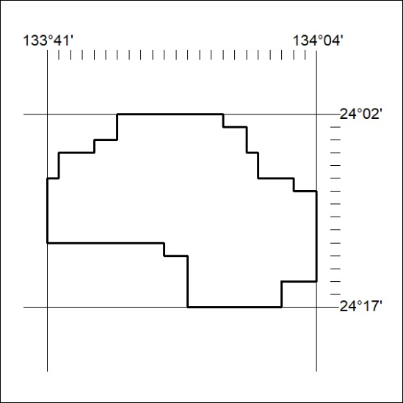
Area granted is indicated above. The titleholder is not permitted to exercise occupational rights on any land that is subject to a development title, or an application for a development title. Any land the subject of a Reserved Land gazettal under the Mineral Titles Act and all land vested in the Commonwealth of Australia is also excluded by description but not excised from the grant area.

366/22

