Mineral Titles Act 2010
NOTICE OF LAND CEASING TO BE A MINERAL TITLE AREA
Title Type and Number: | Mineral Lease 29678
Area ceased on: | 26 September 2022
Area: | 40.00 Hectare
Locality: | BATCHELOR
Name of Applicants(s)Holder(s): | 100% RESOLUTION INVESTMENTS (NT) PTY LTD [ACN. 133113685]
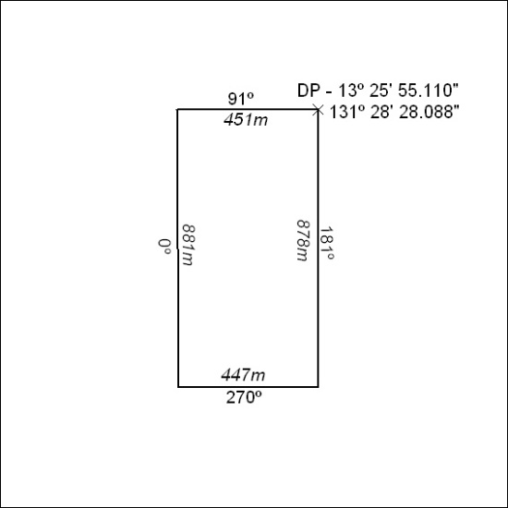

342/22

Mineral Titles Act
NOTICE OF GRANT OF A MINERAL TITLE
Title Type and Number: | Exploration Licence 33073
Granted: | 21 September 2022, for a period of 6 Years
Area: | 222 Blocks, .00 km²
Locality: | BOWMAN
Name of Holder/s: | 100% FIDDLER'S CREEK MINING COMPANY PTY LTD * [ACN. 099 215 648]
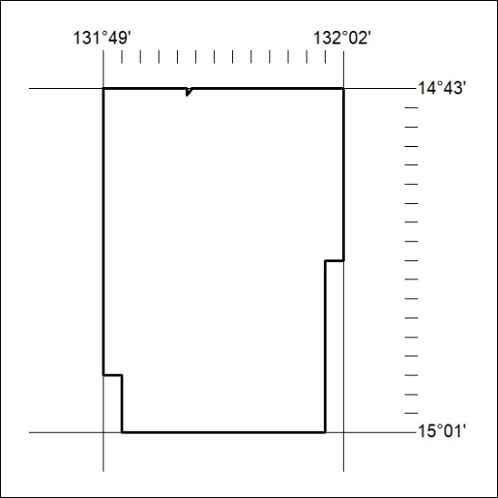
Area granted is indicated above. The titleholder is not permitted to exercise occupational rights on any land that is subject to a development title, or an application for a development title. Any land the subject of a Reserved Land gazettal under the Mineral Titles Act and all land vested in the Commonwealth of Australia is also excluded by description but not excised from the grant area.

343/22

