Mineral Titles Act 2010
NOTICE OF LAND CEASING TO BE A MINERAL TITLE AREA
Title Type and Number: | Exploration Licence 23602
Area Ceased on: | 05 July 2022
Area: | 13 Blocks, 42.39 km²
Locality: | RENEHAN
Name of Applicant(s)/Holder(s): | 100% ASIAN MINERALS PTY LTD [ACN. 099 804 467]
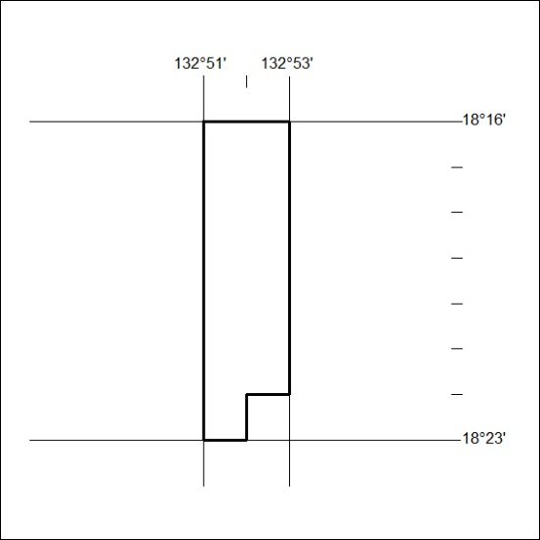

249/22

Mineral Titles Act 2010
NOTICE OF LAND CEASING TO BE A MINERAL TITLE AREA
Title Type and Number: | Exploration Licence 23603
Area Ceased on: | 07 March 2022
Area: | 54 Blocks, 175.56 km²
Locality: | THRING
Name of Applicant(s)/Holder(s): | 100% ASIAN MINERALS PTY LTD [ACN. 099 804 467]
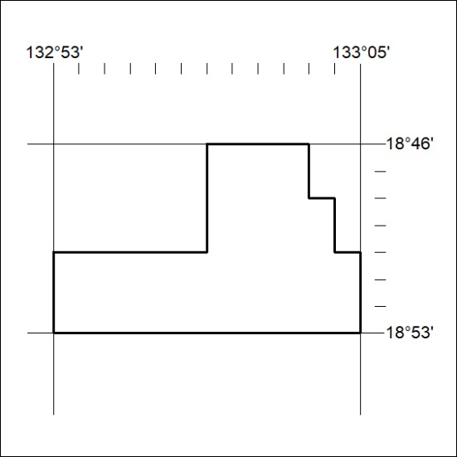

250/22

