Mineral Titles Act 2010
NOTICE OF LAND CEASING TO BE A MINERAL TITLE AREA
Title Type and Number: | Extractive Mineral Lease 23443
Area ceased on: | 20 June 2022
Area: | 4.00 Hectare
Locality: | KATHERINE
Name of Applicants(s)Holder(s): | 50% ADAMSON TIMOTHY JOHN [ACN. 605413983], 50% ADAMSON Michael John
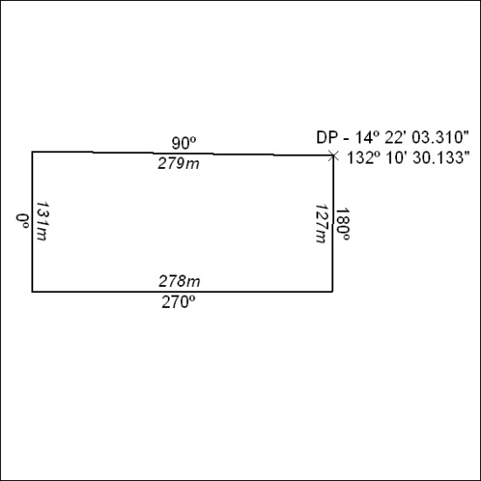

202/22

Mineral Titles Act
NOTICE OF GRANT OF A MINERAL TITLE
Title Type and Number: | Exploration Licence 32985
Granted: | 20 June 2022, for a period of 6 Years
Area: | 22 Blocks, 71.63 km²
Locality: | PHIBBS
Name of Holder/s: | 100% AUSTRALIAN EXPLORATION PTY LTD [ACN. 640 413 823]
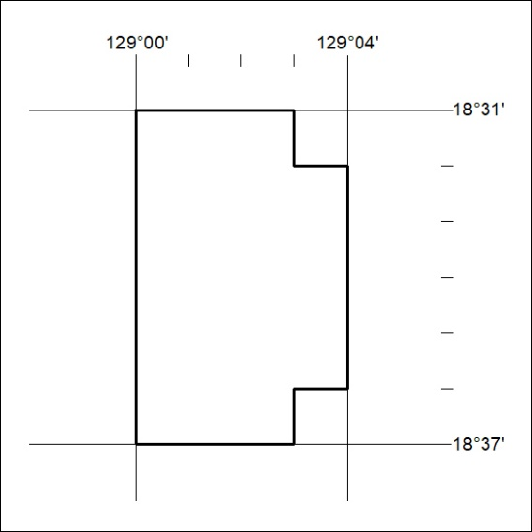
Area granted is indicated above. The titleholder is not permitted to exercise occupational rights on any land that is subject to a development title, or an application for a development title. Any land the subject of a Reserved Land gazettal under the Mineral Titles Act and all land vested in the Commonwealth of Australia is also excluded by description but not excised from the grant area.

203/22

