Mineral Titles Act 2010
NOTICE OF LAND CEASING TO BE A MINERAL TITLE APPLICATION AREA
Title Type and Number: | Exploration Licence 32143
Area Ceased on: | 08 March 2022
Area: | 23 Blocks, 63.78 km²
Locality: | BATCHELOR
Name of Applicant(s)/Holder(s): | 100% NEWMONT EXPLORATION PTY LTD* [ACN. 006 306 690]
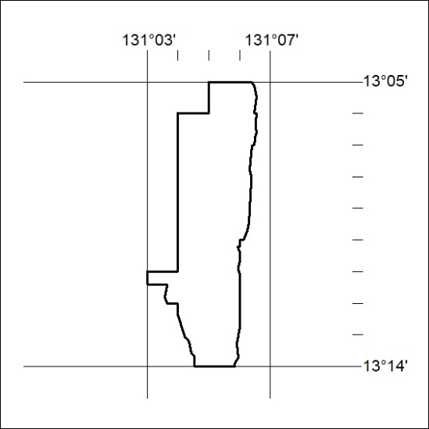

51/22

Mineral Titles Act 2010
NOTICE OF LAND CEASING TO BE A MINERAL TITLE APPLICATION AREA
Title Type and Number: | Exploration Licence 32952
Area Ceased on: | 08 March 2022
Area: | 46 Blocks, 144.58 km²
Locality: | PARGEE
Name of Applicant(s)/Holder(s): | 100% COPPER GREEN PTY LTD [ACN. 119 559 974]
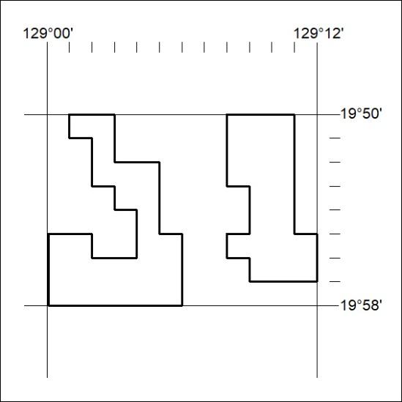

52/22

