Mineral Titles Act 2010
NOTICE OF LAND CEASING TO BE A MINERAL TITLE APPLICATION AREA
Title Type and Number: | Exploration Licence 29774
Area Ceased on: | 14 February 2022
Area: | 88 Blocks, 293.81 km²
Locality: | GREENWOOD
Name of Applicant(s)/Holder(s): | 100% GEOMINERALS PTY LTD [ACN. 157 870 383]
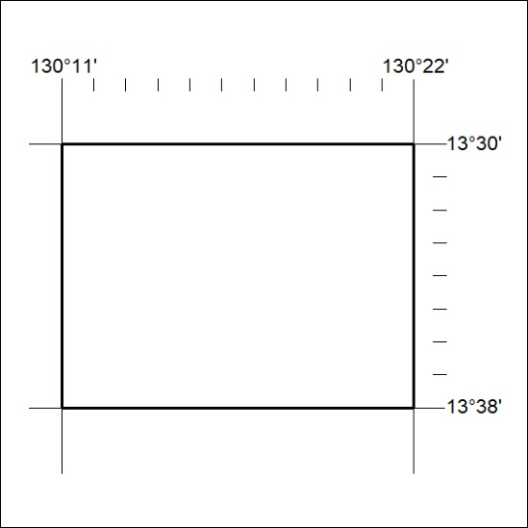

27/22

