Mineral Titles Act 2010
NOTICE OF LAND CEASING TO BE A MINERAL TITLE AREA
Title Type and Number: | Exploration Licence 32070
Area Ceased on: | 12 January 2022
Area: | 103 Blocks, 338.60 km²
Locality: | MALLAPUNYAH
Name of Applicant(s)/Holder(s): | 100% CERBERUS RESOURCES PTY LTD [ACN. 615 192 535]
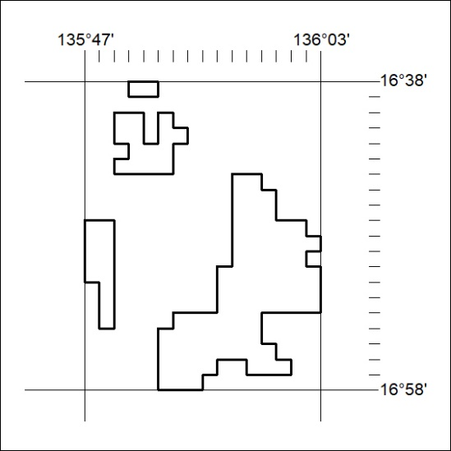

010/22

Mineral Titles Act 2010
NOTICE OF LAND CEASING TO BE A MINERAL TITLE AREA
Title Type and Number: | Exploration Licence 32122
Area Ceased on: | 12 January 2022
Area: | 93 Blocks, 284.16 km²
Locality: | QUARTZ
Name of Applicant(s)/Holder(s): | 100% COPPEROZ PTY LTD [ACN. 603 957 124]
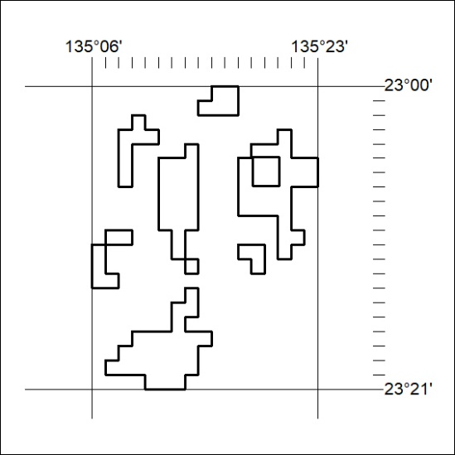

011/22

Mineral Titles Act 2010
NOTICE OF LAND CEASING TO BE A MINERAL TITLE AREA
Title Type and Number: | Extractive Mineral Permit 24598
Area ceased on: | 11 January 2022
Area: | 30.00 Hectare
Locality: | NOONAMAH
Name of Applicants(s)Holder(s): | 100% BOB KERR TRANSPORT PTY LTD [ACN. 109 115 059]
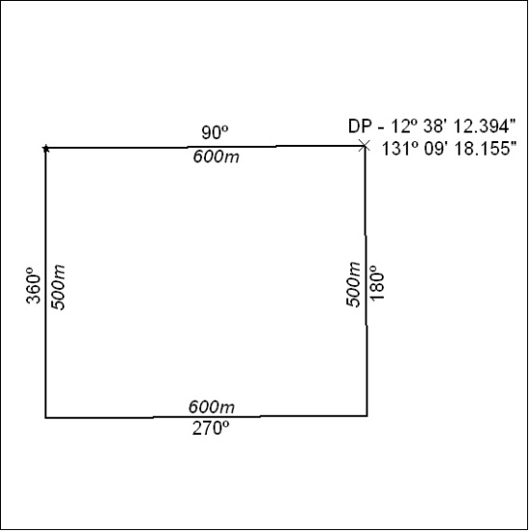

012/22

Mineral Titles Act
NOTICE OF GRANT OF A MINERAL TITLE
Title Type and Number: | Exploration Licence 32725
Granted: | 11 January 2022, for a period of 6 Years
Area: | 45 Blocks, 141.63 km²
Locality: | SHORT RANGE
Name of Holder/s: | 100% PAYNE GULLY GOLD PTY LTD [ACN. 638 017 731]
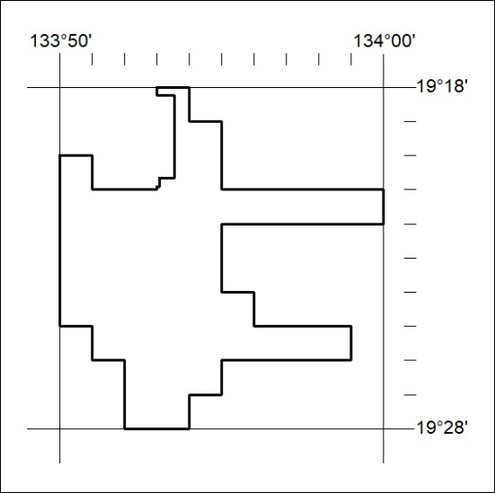
Area granted is indicated above. The titleholder is not permitted to exercise occupational rights on any land that is subject to a development title, or an application for a development title. Any land the subject of a Reserved Land gazettal under the Mineral Titles Act and all land vested in the Commonwealth of Australia is also excluded by description but not excised from the grant area.

013/22

Mineral Titles Act
NOTICE OF GRANT OF A MINERAL TITLE
Title Type and Number: | Exploration Licence 32736
Granted: | 11 January 2022, for a period of 6 Years
Area: | 199 Blocks, 591.19 km²
Locality: | UNDOOLYA
Name of Holder/s: | 100% RIO TINTO EXPLORATION PTY LIMITED [ACN. 000 057 125]
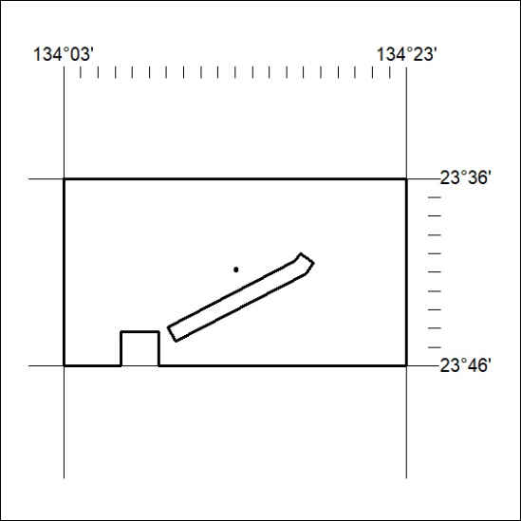
Area granted is indicated above. The titleholder is not permitted to exercise occupational rights on any land that is subject to a development title, or an application for a development title. Any land the subject of a Reserved Land gazettal under the Mineral Titles Act and all land vested in the Commonwealth of Australia is also excluded by description but not excised from the grant area.

014/22

