Mineral Titles Act 2010
NOTICE OF LAND CEASING TO BE A MINERAL TITLE AREA
Title Type and Number: | Extractive Mineral Permit (Northern) 1136
Area ceased on: | 24 November 2021
Area: | 15.00 Hectare
Locality: | BYNOE
Name of Applicants(s)Holder(s): | 100% INNOCENTE TRANSPORT PTY. LIMITED [ACN. 009 609 563]
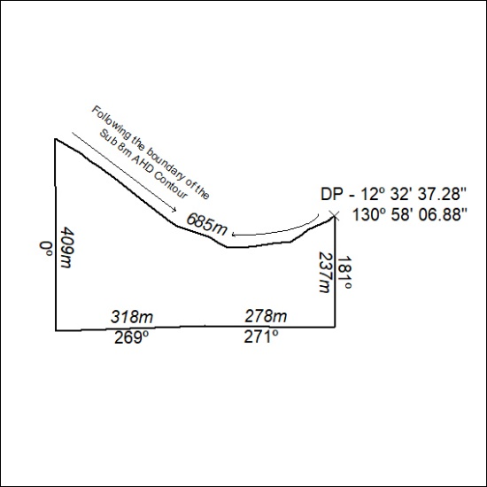

443/21

