Mineral Titles Act 2010
NOTICE OF LAND CEASING TO BE A MINERAL TITLE APPLICATION AREA
Title Type and Number: | Exploration Licence 27883
Area Ceased on: | 22 November 2021
Area: | 2 Blocks, .44 km²
Locality: | ROSE RIVER
Name of Applicant(s)/Holder(s): | 100% YUKIDA RESOURCES PTY LTD [ACN. 141 116 083]
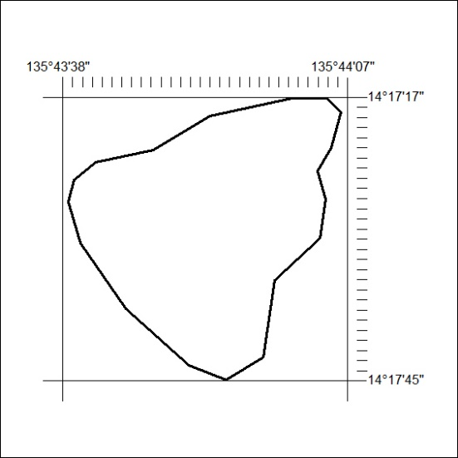

432/21

Mineral Titles Act 2010
NOTICE OF LAND CEASING TO BE A MINERAL TITLE AREA
Title Type and Number: | Exploration Licence 31125
Area Ceased on: | 22 November 2021
Area: | 10 Blocks, 33.21 km²
Locality: | MOROAK
Name of Applicant(s)/Holder(s): | 100% ROPER ILMENITE PTY LTD [ACN. 609 843 978]
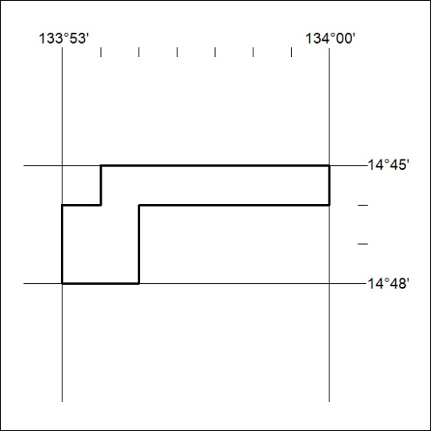

433/21
Mineral Titles Act 2010
NOTICE OF LAND CEASING TO BE A MINERAL TITLE AREA
Title Type and Number: | Exploration Licence 31129
Area Ceased on: | 22 November 2021
Area: | 107 Blocks, 354.39 km²
Locality: | FLYING FOX
Name of Applicant(s)/Holder(s): | 100% ROPER ILMENITE PTY LTD [ACN. 609 843 978]
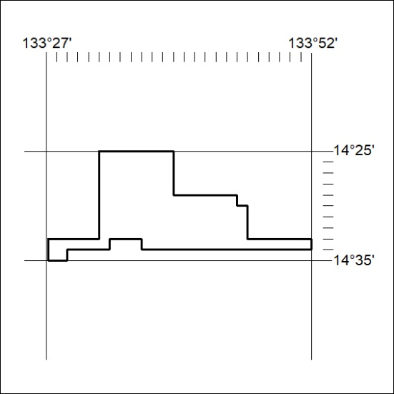

434/21

Mineral Titles Act 2010
NOTICE OF LAND CEASING TO BE A MINERAL TITLE AREA
Title Type and Number: | Exploration Licence 31142
Area Ceased on: | 22 November 2021
Area: | 169 Blocks, 557.43 km²
Locality: | CHAPMAN
Name of Applicant(s)/Holder(s): | 100% ROPER ILMENITE PTY LTD [ACN. 609 843 978]
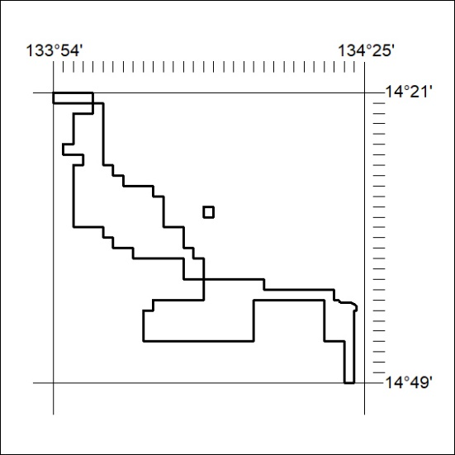

435/21
Mineral Titles Act 2010
NOTICE OF LAND CEASING TO BE A MINERAL TITLE AREA
Title Type and Number: | Exploration Licence 31489
Area Ceased on: | 22 November 2021
Area: | 129 Blocks, 427.92 km²
Locality: | MOROAK
Name of Applicant(s)/Holder(s): | 100% MOROAK RESOURCES PTY LTD [ACN. 616 553 014]
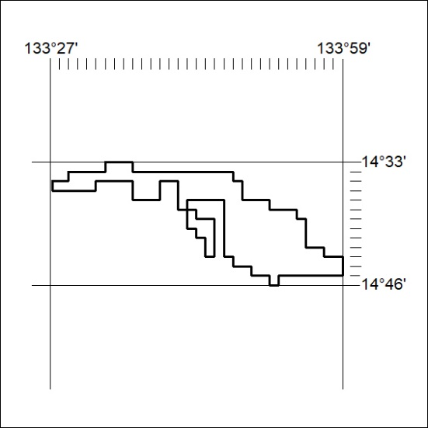

436/21

Mineral Titles Act 2010
NOTICE OF LAND CEASING TO BE A MINERAL TITLE APPLICATION AREA
Title Type and Number: | Mineral Authority 27884
Area Ceased on: | 22 November 2021
Area: | Blocks, 6.33 km²
Locality: | LIMMEN
Name of Applicant(s)/Holder(s): | 100% YUKIDA RESOURCES PTY LTD [ACN. 141 116 083]
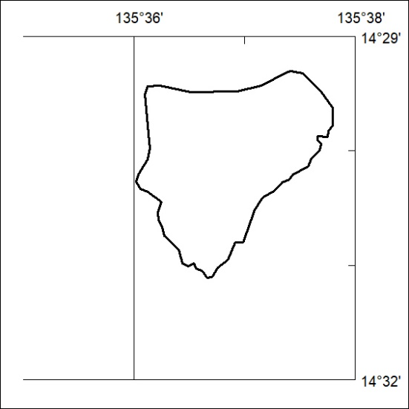

437/21

