Mineral Titles Act 2010
NOTICE OF LAND CEASING TO BE A MINERAL TITLE AREA
Title Type and Number: | Exploration Licence 31530
Area Ceased on: | 25 October 2021
Area: | 11 Blocks, 23.73 km²
Locality: | WILSON CREEK
Name of Applicant(s)/Holder(s): | 100% PRODIGY GOLD NL* [ACN. 009 127 020]
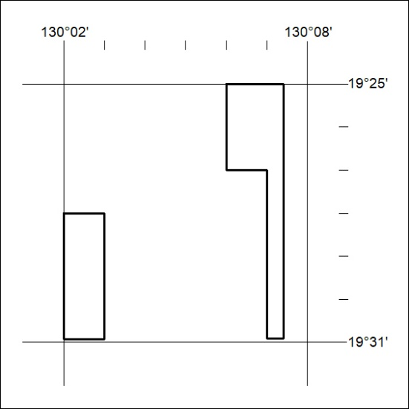

401/21

Mineral Titles Act 2010
NOTICE OF LAND CEASING TO BE A MINERAL TITLE AREA
Title Type and Number: | Exploration Licence 32041
Area Ceased on: | 26 October 2021
Area: | 6 Blocks, 4.65 km²
Locality: | NOONAMAH
Name of Applicant(s)/Holder(s): | 100% ALDEBARAN CONTRACTING PTY LTD [ACN. 128 020 299]
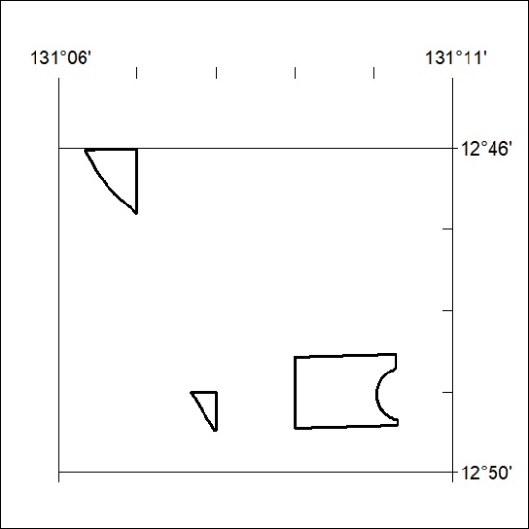

402/21

Mineral Titles Act
NOTICE OF GRANT OF A MINERAL TITLE
Title Type and Number: | Exploration Licence 32693
Granted: | 26 October 2021, for a period of 6 Years
Area: | 248 Blocks, 805.46 km²
Locality: | MITCHIEBO
Name of Holder/s: | 100% CHALCO RESOURCES PTY LTD [ACN. 648 662 346]
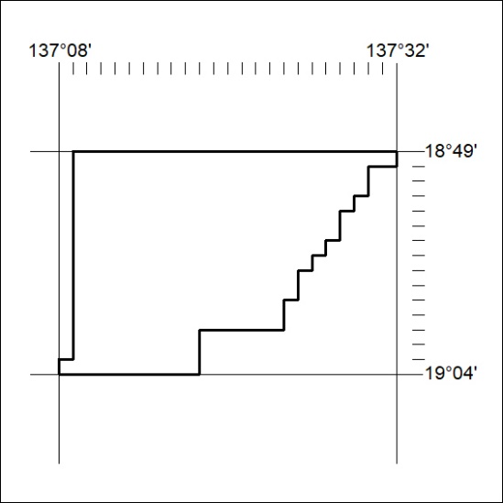
Area granted is indicated above. The titleholder is not permitted to exercise occupational rights on any land that is subject to a development title, or an application for a development title. Any land the subject of a Reserved Land gazettal under the Mineral Titles Act and all land vested in the Commonwealth of Australia is also excluded by description but not excised from the grant area.

403/21

