Mineral Titles Act 2010
NOTICE OF LAND CEASING TO BE A MINERAL TITLE AREA
Title Type and Number: | Extractive Mineral Permit 30368
Area ceased on: | 29 September 2021
Area: | 29.00 Hectare
Locality: | NOONAMAH
Name of Applicants(s)Holder(s): | 100% EAST ARM CIVIL PTY LTD [ACN. 073 382 251]
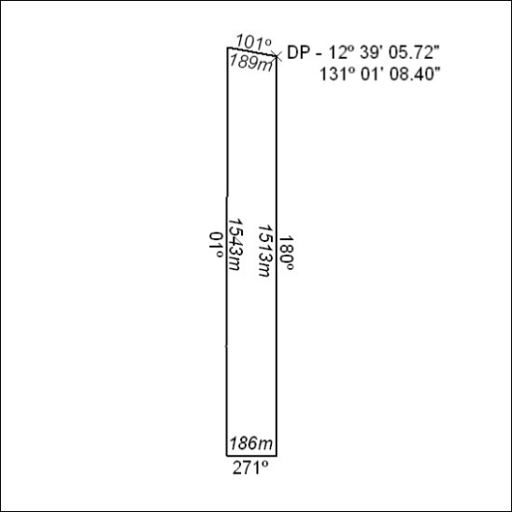

363/21

Mineral Titles Act 2010
NOTICE OF LAND CEASING TO BE A MINERAL TITLE AREA
Title Type and Number: | Exploration Licence 26626
Area Ceased on: | 01 October 2021
Area: | 37 Blocks, 118.81 km²
Locality: | INNINGARRA
Name of Applicant(s)/Holder(s): | 90% PRODIGY GOLD NL* [ACN. 009 127 020], 10% NGUNGAJU LITHIUM OPERATIONS PTY LTD* [ACN. 095 384 491]
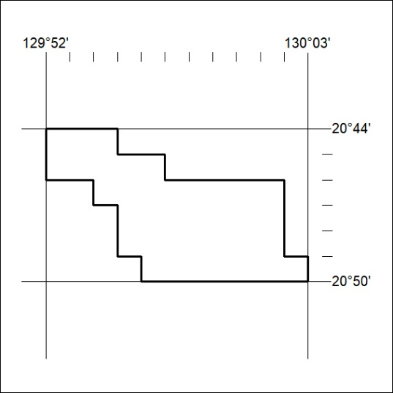

364/21
Mineral Titles Act 2010
NOTICE OF LAND CEASING TO BE A MINERAL TITLE AREA
Title Type and Number: | Exploration Licence 31784
Area Ceased on: | 29 September 2021
Area: | 29 Blocks, 92.12 km²
Locality: | VAUGHAN
Name of Applicant(s)/Holder(s): | 100% CERBERUS RESOURCES PTY LTD [ACN. 615 192 535]
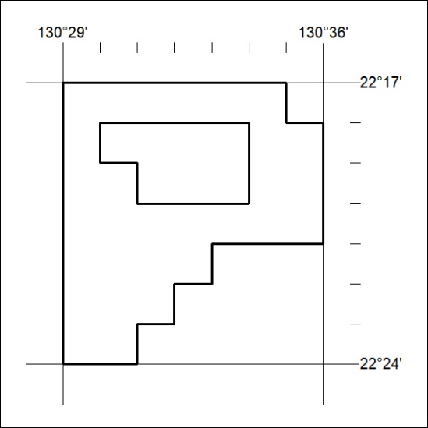

365/21

Mineral Titles Act
NOTICE OF GRANT OF A MINERAL TITLE
Title Type and Number: | Extractive Mineral Permit 32358
Granted: | 28 September 2021, for a period of 5 Years
Area: | 29.00 Hectares
Locality: | MARY RIVER
Name of Holder/s: | 100% MOUSELLIS & SONS PTY. LTD. [ACN. 009 654 791]
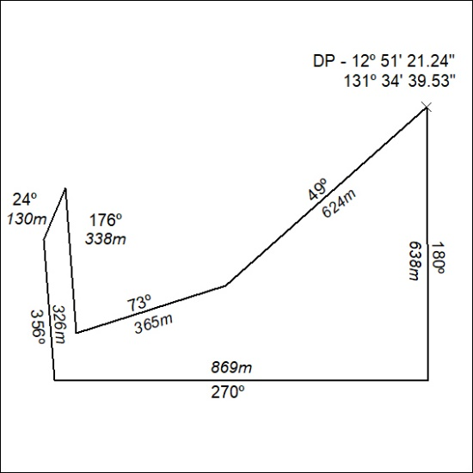

366/21

Mineral Titles Act
NOTICE OF GRANT OF A MINERAL TITLE
Title Type and Number: | Exploration Licence 32680
Granted: | 04 October 2021, for a period of 6 Years
Area: | 250 Blocks, 809.04 km²
Locality: | RANKEN
Name of Holder/s: | 100% BARKLY OPERATIONS PTY LTD [ACN. 641 856 706]
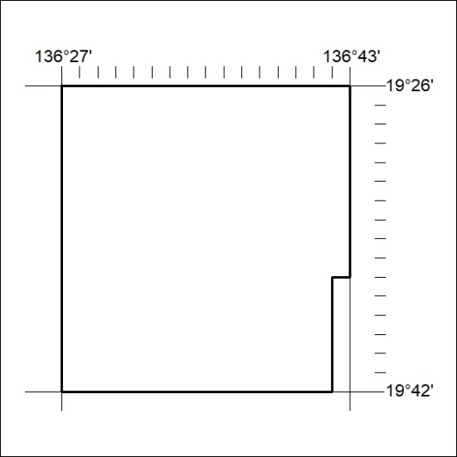
Area granted is indicated above. The titleholder is not permitted to exercise occupational rights on any land that is subject to a development title, or an application for a development title. Any land the subject of a Reserved Land gazettal under the Mineral Titles Act and all land vested in the Commonwealth of Australia is also excluded by description but not excised from the grant area.
367/21

Mineral Titles Act
NOTICE OF GRANT OF A MINERAL TITLE
Title Type and Number: | Extractive Mineral Permit 32702
Granted: | 24 September 2021, for a period of 5 Years
Area: | 95.40 Hectares
Locality: | KATHERINE
Name of Holder/s: | 100% NT LAND DEVELOPMENT CORPORATION PTY LTD [ACN. 078 816 814]
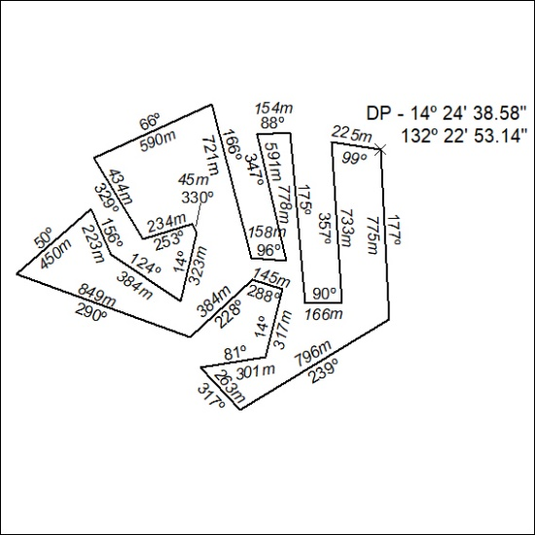

368/21

Mineral Titles Act
NOTICE OF GRANT OF A MINERAL TITLE
Title Type and Number: | Exploration Licence 32664
Granted: | 29 September 2021, for a period of 6 Years
Area: | 38 Blocks, 117.73 km²
Locality: | RIDDOCH
Name of Holder/s: | 100% BATH RESOURCES PTY LTD [ACN. 643 937 713]
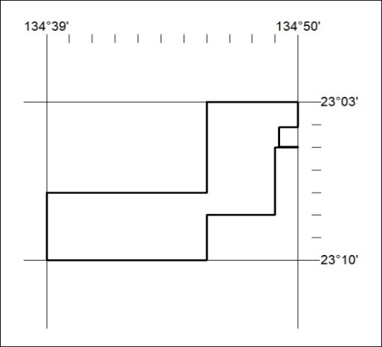
Area granted is indicated above. The titleholder is not permitted to exercise occupational rights on any land that is subject to a development title, or an application for a development title. Any land the subject of a Reserved Land gazettal under the Mineral Titles Act and all land vested in the Commonwealth of Australia is also excluded by description but not excised from the grant area.
369/21

Corrigendum
Notice Number 362/21 appearing in MN95/21 on 24 September 2021 is hereby cancelled and replaced by the following:
Mineral Titles Act 2010
NOTICE OF LAND CEASING TO BE A MINERAL TITLE AREA
Title Type and Number: | Exploration Licence 29803
Area Ceased on: | 23 September 2021
Area: | 22 Blocks, 71.96 km²
Locality: | NAPIER
Name of Applicant(s)/Holder(s): | 100% MARTIN Anthony Ernest
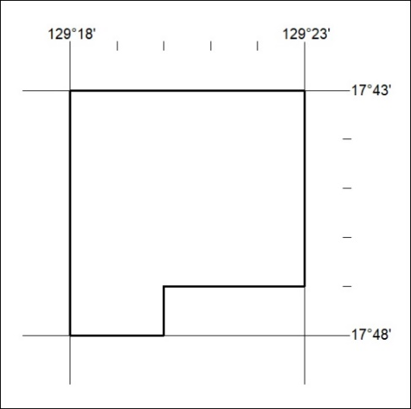
370/21

