Mineral Titles Act
NOTICE OF GRANT OF A MINERAL TITLE
Title Type and Number: | Exploration Licence 32228
Granted: | 29 March 2021, for a period of 6 Years
Area: | 203 Blocks, 663.24 km²
Locality: | COANJULA
Name of Holder/s: | 100% STRATEGIC ENERGY RESOURCES LIMITED* [ACN. 051 212 429]
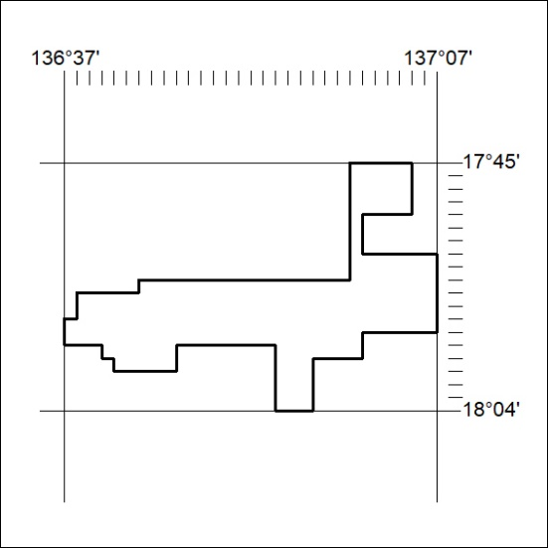
Area granted is indicated above. The titleholder is not permitted to exercise occupational rights on any land that is subject to a development title, or an application for a development title. Any land the subject of a Reserved Land gazettal under the Mineral Titles Act and all land vested in the Commonwealth of Australia is also excluded by description but not excised from the grant area.
60/21

Mineral Titles Act
NOTICE OF GRANT OF A MINERAL TITLE
Title Type and Number: | Exploration Licence 32238
Granted: | 29 March 2021, for a period of 6 Years
Area: | 132 Blocks, 434.95 km²
Locality: | VICTORIA RIVER DOWNS
Name of Holder/s: | 100% ALBIAN RESOURCES PTY LTD [ACN. 629 786 161]
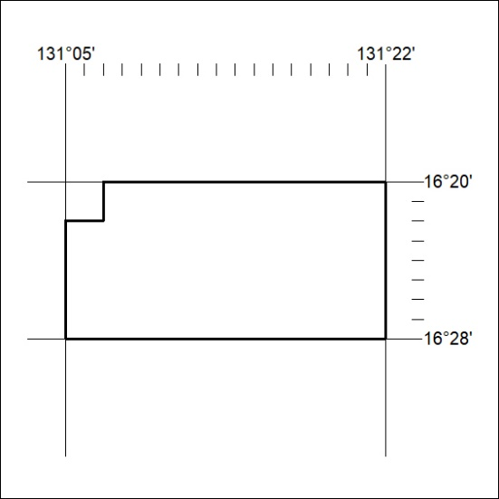
Area granted is indicated above. The titleholder is not permitted to exercise occupational rights on any land that is subject to a development title, or an application for a development title. Any land the subject of a Reserved Land gazettal under the Mineral Titles Act and all land vested in the Commonwealth of Australia is also excluded by description but not excised from the grant area.
61/21

Mineral Titles Act
NOTICE OF GRANT OF A MINERAL TITLE
Title Type and Number: | Exploration Licence 32316
Granted: | 29 March 2021, for a period of 6 Years
Area: | 152 Blocks, 501.37 km²
Locality: | VICTORIA RIVER DOWNS
Name of Holder/s: | 100% ALBIAN RESOURCES PTY LTD [ACN. 629 786 161]
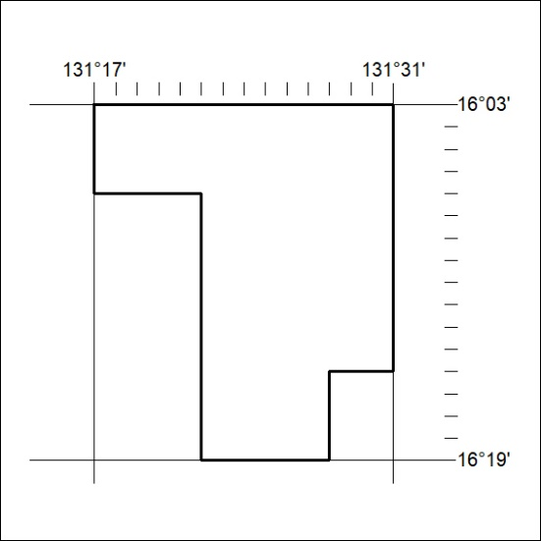
Area granted is indicated above. The titleholder is not permitted to exercise occupational rights on any land that is subject to a development title, or an application for a development title. Any land the subject of a Reserved Land gazettal under the Mineral Titles Act and all land vested in the Commonwealth of Australia is also excluded by description but not excised from the grant area.
62/21

Mineral Titles Act
NOTICE OF GRANT OF A MINERAL TITLE
Title Type and Number: | Exploration Licence 32443
Granted: | 29 March 2021, for a period of 6 Years
Area: | 40 Blocks, 121.77 km²
Locality: | RIDDOCH
Name of Holder/s: | 50% RED DINGO CORP PTY LTD [ACN. 161 336 081], 25% BOHNING Gary R, 25% BOHNING Elaine
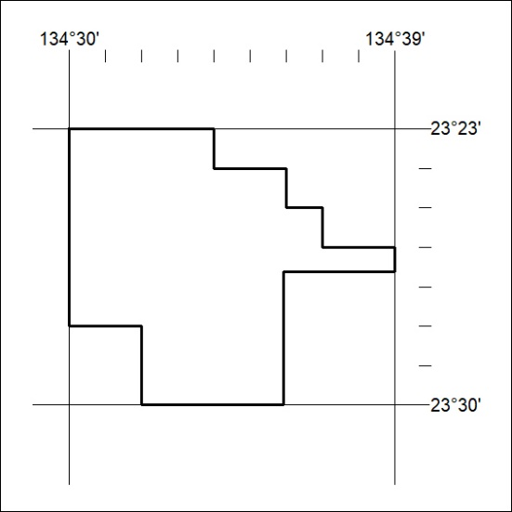
Area granted is indicated above. The titleholder is not permitted to exercise occupational rights on any land that is subject to a development title, or an application for a development title. Any land the subject of a Reserved Land gazettal under the Mineral Titles Act and all land vested in the Commonwealth of Australia is also excluded by description but not excised from the grant area.
63/21

Mineral Titles Act
NOTICE OF GRANT OF A MINERAL TITLE
Title Type and Number: | Extractive Mineral Permit 32150
Granted: | 29 March 2021, for a period of 5 Years
Area: | 15.00 Hectares
Locality: | VICTORIA RIVER DOWNS
Name of Holder/s: | 100% ALBIAN RESOURCES PTY LTD [ACN. 629 786 161]
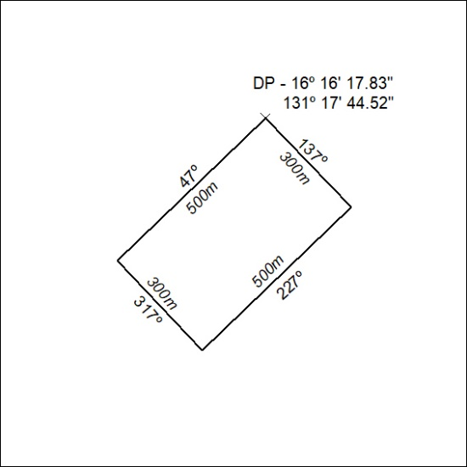

64/21

