Mineral Titles Act 2010
NOTICE OF LAND CEASING TO BE A MINERAL TITLE AREA
Title Type and Number: | Extractive Mineral Permit 30682
Area ceased on: | 18 March 2021
Area: | 37.00 Hectare
Locality: | NOONAMAH
Name of Applicants(s)Holder(s): | 100% OSTOJIC GROUP PTY LTD* [ACN. 009 629 805]
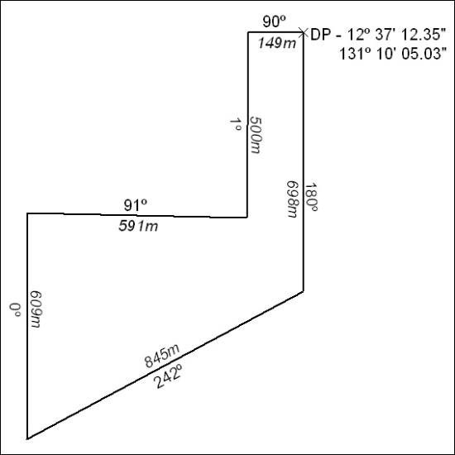

50/21

