Mineral Titles Act
NOTICE OF GRANT OF A MINERAL TITLE
Title Type and Number: | Exploration Licence 32436
Granted: | 11 March 2021, for a period of 6 Years
Area: | 24 Blocks, 55.39 km²
Locality: | McKINLAY RIVER
Name of Holder/s: | 50% KARIOTIS Stefanos, 50% KARIOTIS John
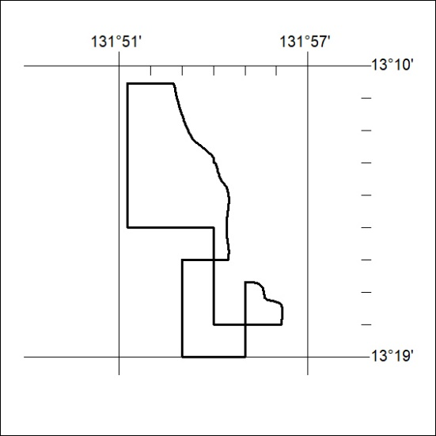
Area granted is indicated above. The titleholder is not permitted to exercise occupational rights on any land that is subject to a development title, or an application for a development title. Any land the subject of a Reserved Land gazettal under the Mineral Titles Act and all land vested in the Commonwealth of Australia is also excluded by description but not excised from the grant area.

47/21

