Mineral Titles Act 2010
NOTICE OF LAND CEASING TO BE A MINERAL TITLE APPLICATION AREA
Title Type and Number: | Extractive Mineral Permit 32053
Area ceased on: | 05 March 2021
Area: | 47.00 Hectare
Locality: | NOONAMAH
Name of Applicants(s)Holder(s): | 50% HILLIER Jennifer Mary, 50% HILLIER Anthony Michael
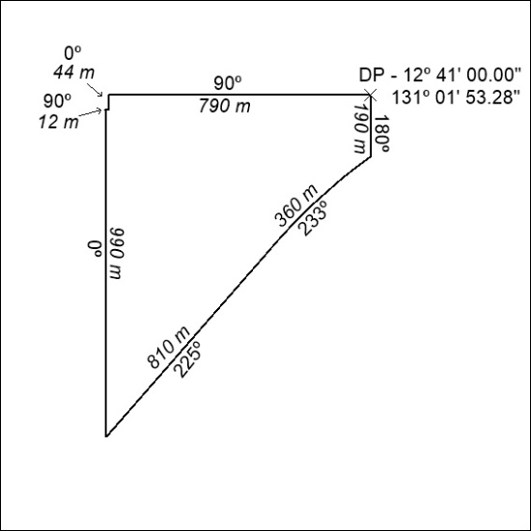

45/21

Mineral Titles Act
NOTICE OF GRANT OF A MINERAL TITLE
Title Type and Number: | Exploration Licence 32435
Granted: | 10 March 2021, for a period of 6 Years
Area: | 2 Blocks, 6.68 km²
Locality: | McKINLAY RIVER
Name of Holder/s: | 100% GMG MINING (NT) PTY LTD [ACN. 634 618 410]
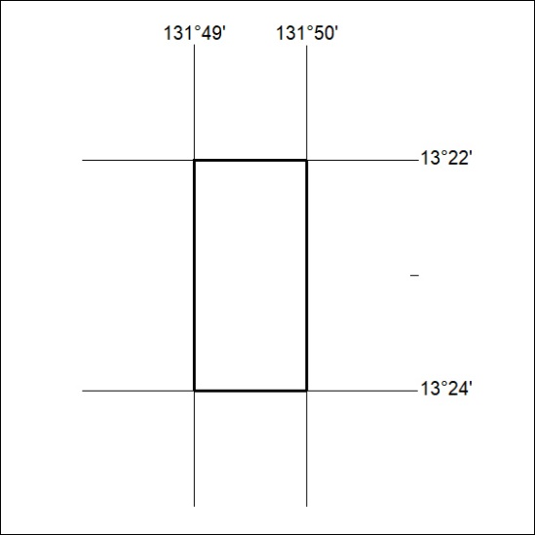
Area granted is indicated above. The titleholder is not permitted to exercise occupational rights on any land that is subject to a development title, or an application for a development title. Any land the subject of a Reserved Land gazettal under the Mineral Titles Act and all land vested in the Commonwealth of Australia is also excluded by description but not excised from the grant area.

46/21

