Mineral Titles Act
NOTICE OF GRANT OF A MINERAL TITLE
Title Type and Number: | Extractive Mineral Permit 32054
Granted: | 05 March 2021, for a period of 5 Years
Area: | 34.48 Hectares
Locality: | NOONAMAH
Name of Holder/s: | 50% HILLIER Jennifer Mary, 50% HILLIER Anthony Michael
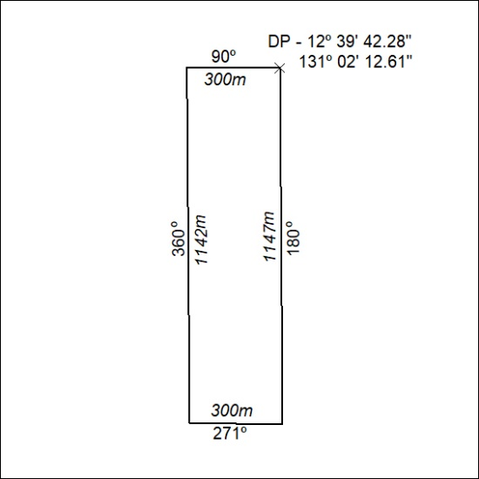

41/21

Mineral Titles Act
NOTICE OF GRANT OF A MINERAL TITLE
Title Type and Number: | Extractive Mineral Permit 32501
Granted: | 04 March 2021, for a period of 5 Years
Area: | 5.00 Hectares
Locality: | MARY RIVER
Name of Holder/s: | 100% ALLAN KING & SONS CONSTRUCTION PTY LTD [ACN. 068 688 148]
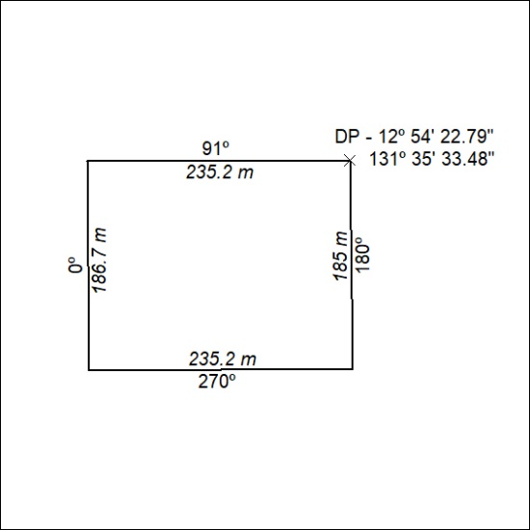

42/21

