Mineral Titles Act 2010
NOTICE OF LAND CEASING TO BE A MINERAL TITLE AREA
Title Type and Number: | Exploration Licence 26593
Area Ceased on: | 14 December 2020
Area: | 31 Blocks, 99.85 km²
Locality: | DAVIDSON
Name of Applicant(s)/Holder(s): | 100% PRODIGY GOLD NL* [ACN. 009 127 020]
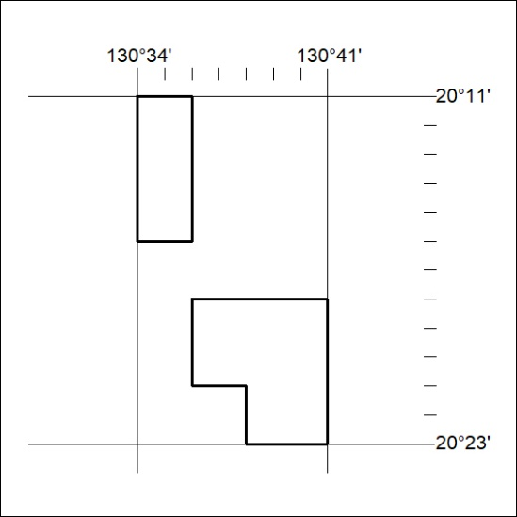

414/20

Mineral Titles Act 2010
NOTICE OF LAND CEASING TO BE A MINERAL TITLE AREA
Title Type and Number: | Exploration Licence 26613
Area Ceased on: | 14 December 2020
Area: | 15 Blocks, 48.39 km²
Locality: | PTILOTUS
Name of Applicant(s)/Holder(s): | 100% PRODIGY GOLD NL* [ACN. 009 127 020]
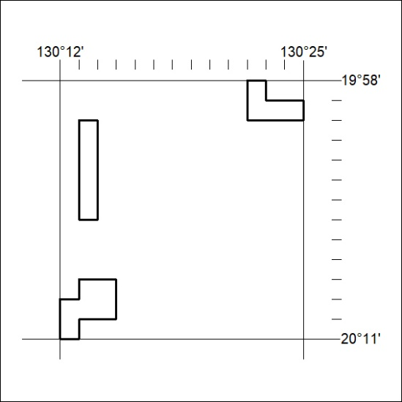

415/20

