Mineral Titles Act 2010
NOTICE OF LAND CEASING TO BE A MINERAL TITLE APPLICATION AREA
Title Type and Number: | Exploration Licence 25048
Area Ceased on: | 10 December 2020
Area: | 475 Blocks, 1458.83 km²
Locality: | AREYONGA
Name of Applicant(s)/Holder(s): | 100% NOVA ENERGY PTY LTD* [ACN. 111 599 154]
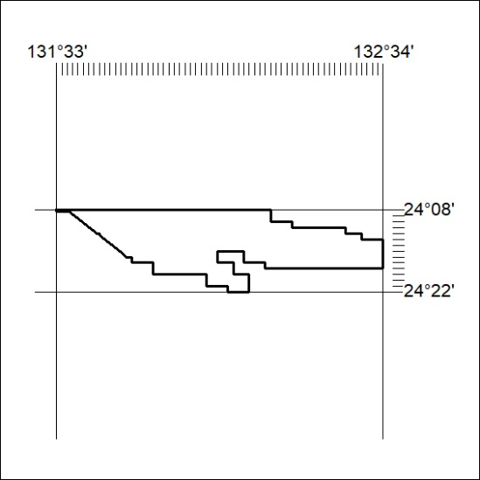

408/20

Mineral Titles Act 2010
NOTICE OF LAND CEASING TO BE A MINERAL TITLE APPLICATION AREA
Title Type and Number: | Exploration Licence 26601
Area Ceased on: | 10 December 2020
Area: | 25 Blocks, 79.99 km²
Locality: | PARGEE
Name of Applicant(s)/Holder(s): | 100% TORO ENERGY LIMITED [ACN. 117 127 590]
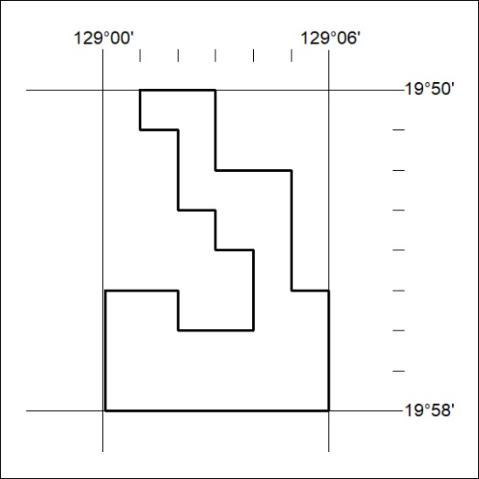

409/20
Mineral Titles Act 2010
NOTICE OF LAND CEASING TO BE A MINERAL TITLE APPLICATION AREA
Title Type and Number: | Exploration Licence 26636
Area Ceased on: | 10 December 2020
Area: | 20 Blocks, 63.79 km²
Locality: | PARGEE
Name of Applicant(s)/Holder(s): | 100% TORO ENERGY LIMITED [ACN. 117 127 590]
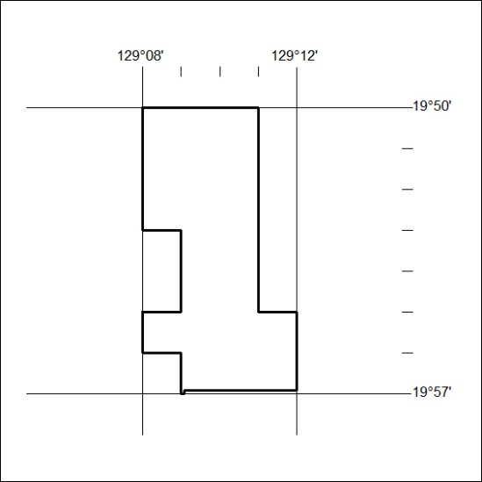

410/20

Mineral Titles Act 2010
NOTICE OF LAND CEASING TO BE A MINERAL TITLE APPLICATION AREA
Title Type and Number: | Exploration Licence 26740
Area Ceased on: | 10 December 2020
Area: | 321 Blocks, 923.82 km²
Locality: | MOUNT PEAKE
Name of Applicant(s)/Holder(s): | 100% TORO ENERGY LIMITED [ACN. 117 127 590]
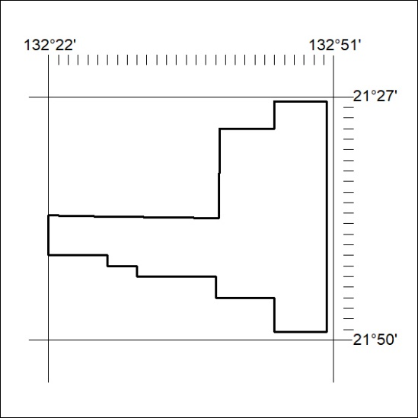

411/20
Mineral Titles Act 2010
NOTICE OF LAND CEASING TO BE A MINERAL TITLE APPLICATION AREA
Title Type and Number: | Exploration Licence 27534
Area Ceased on: | 10 December 2020
Area: | 68 Blocks, 183.57 km²
Locality: | WILLOWRA
Name of Applicant(s)/Holder(s): | 100% TORO ENERGY LIMITED [ACN. 117 127 590]
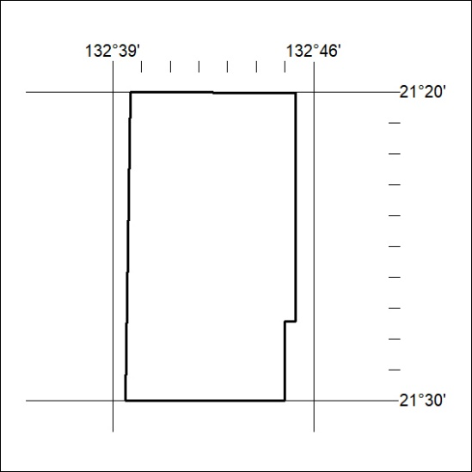

412/20

Mineral Titles Act 2010
NOTICE OF LAND CEASING TO BE A MINERAL TITLE APPLICATION AREA
Title Type and Number: | Exploration Licence 27535
Area Ceased on: | 10 December 2020
Area: | 248 Blocks, 747.55 km²
Locality: | STUDHOLME
Name of Applicant(s)/Holder(s): | 100% TORO ENERGY LIMITED [ACN. 117 127 590]
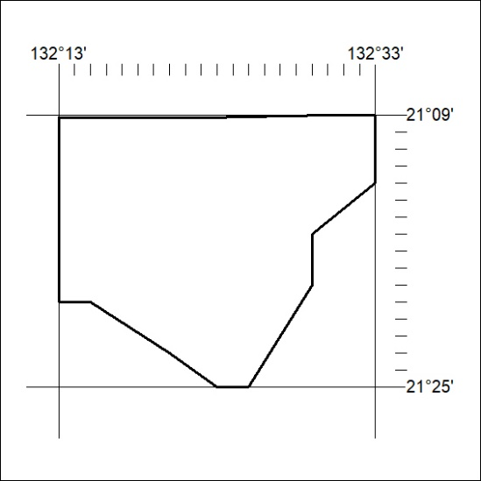

413/20

