Mineral Titles Act 2010
NOTICE OF LAND CEASING TO BE A MINERAL TITLE AREA
Title Type and Number: | Exploration Licence 31139
Area Ceased on: | 07 November 2020
Area: | 79 Blocks, 252.23 km²
Locality: | ANNINGIE
Name of Applicant(s)/Holder(s): | 100% LITHIUM DEVELOPMENTS PTY LTD [ACN. 612 245 020]
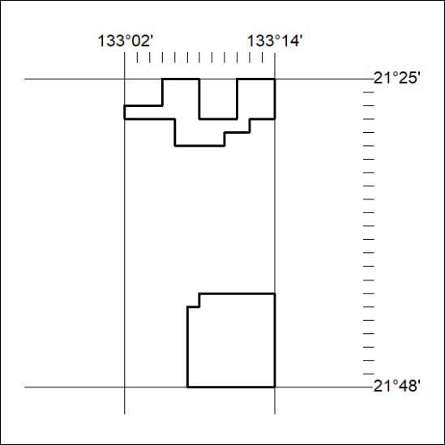

356/20

Mineral Titles Act 2010
NOTICE OF LAND CEASING TO BE A MINERAL TITLE AREA
Title Type and Number: | Exploration Licence 31145
Area Ceased on: | 07 November 2020
Area: | 95 Blocks, 303.96 km²
Locality: | CRAWFORD
Name of Applicant(s)/Holder(s): | 100% LITHIUM DEVELOPMENTS PTY LTD [ACN. 612 245 020]
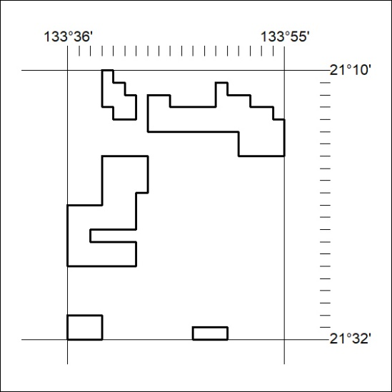

357/20

Mineral Titles Act
NOTICE OF GRANT OF A MINERAL TITLE
Title Type and Number: | Extractive Mineral Exploration Licence 32371
Granted: | 06 November 2020, for a period of 2 Years
Area: | 4 Blocks, 13.16 km²
Locality: | MALLAPUNYAH
Name of Holder/s: | 100% EAST ARM CIVIL PTY LTD [ACN. 073 382 251]
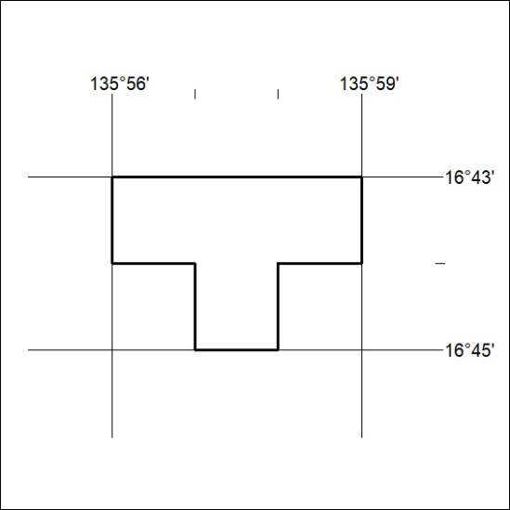
Area granted is indicated above. The titleholder is not permitted to exercise occupational rights on any land that is subject to a development title, or an application for a development title. Any land the subject of a Reserved Land gazettal under the Mineral Titles Act and all land vested in the Commonwealth of Australia is also excluded by description but not excised from the grant area.
358/20

Mineral Titles Act
NOTICE OF GRANT OF A MINERAL TITLE
Title Type and Number: | Extractive Mineral Exploration Licence 32372
Granted: | 06 November 2020, for a period of 2 Years
Area: | 4 Blocks, 13.15 km²
Locality: | MALLAPUNYAH
Name of Holder/s: | 100% EAST ARM CIVIL PTY LTD [ACN. 073 382 251]
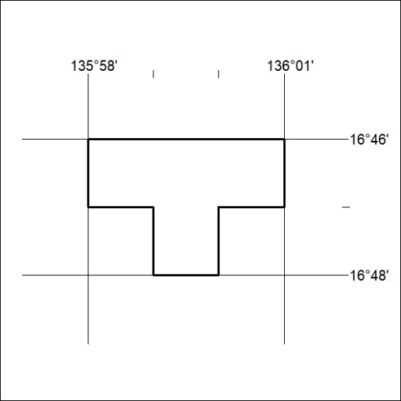
Area granted is indicated above. The titleholder is not permitted to exercise occupational rights on any land that is subject to a development title, or an application for a development title. Any land the subject of a Reserved Land gazettal under the Mineral Titles Act and all land vested in the Commonwealth of Australia is also excluded by description but not excised from the grant area.
359/20

Mineral Titles Act
NOTICE OF GRANT OF A MINERAL TITLE
Title Type and Number: | Extractive Mineral Exploration Licence 32373
Granted: | 06 November 2020, for a period of 2 Years
Area: | 4 Blocks, 13.15 km²
Locality: | GLYDE
Name of Holder/s: | 100% EAST ARM CIVIL PTY LTD [ACN. 073 382 251]
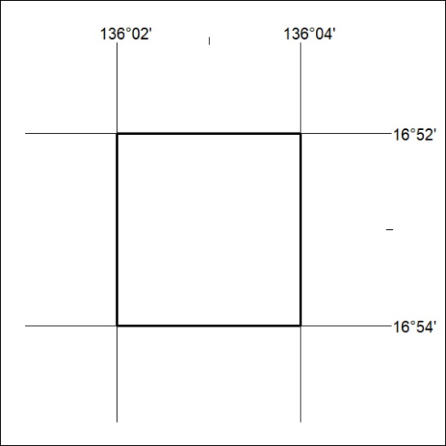
Area granted is indicated above. The titleholder is not permitted to exercise occupational rights on any land that is subject to a development title, or an application for a development title. Any land the subject of a Reserved Land gazettal under the Mineral Titles Act and all land vested in the Commonwealth of Australia is also excluded by description but not excised from the grant area.
360/20

