Mineral Titles Act 2010
NOTICE OF LAND CEASING TO BE A MINERAL TITLE AREA
Title Type and Number: | Exploration Licence 31443
Area Ceased on: | 02 July 2020
Area: | 10 Blocks, 31.66 km²
Locality: | JINKA
Name of Applicant(s)/Holder(s): | 100% MOLYHIL MINING PTY LTD [ACN. 112 922 497]
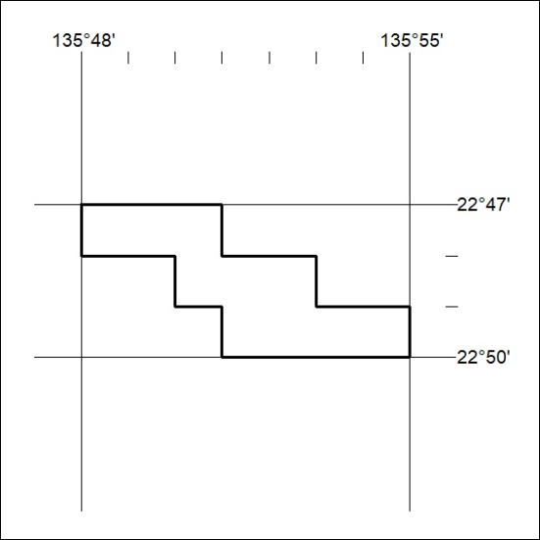

221/20

