Mineral Titles Act 2010
NOTICE OF LAND CEASING TO BE A MINERAL TITLE AREA
Title Type and Number: | Mineral Authority 30395
Area ceased on: | 19 May 2020
Area: | 1.00 Hectare
Locality: | TENNANT CREEK
Name of Applicants(s)Holder(s): | 100% BATTERY HILL MINING CENTRE INCORPORATED [ACN. NT02258C]
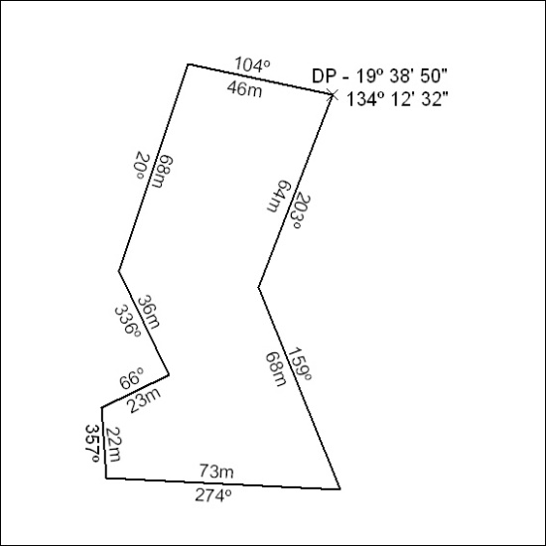
186/20

