Mineral Titles Act 2010
NOTICE OF LAND CEASING TO BE A MINERAL TITLE AREA
Title Type and Number: | Exploration Licence 29790
Area Ceased on: | 15 May 2020
Area: | 9 Blocks, 28.77 km²
Locality: | McFARLANE
Name of Applicant(s)/Holder(s): | 100% PRODIGY GOLD NL* [ACN. 009 127 020]
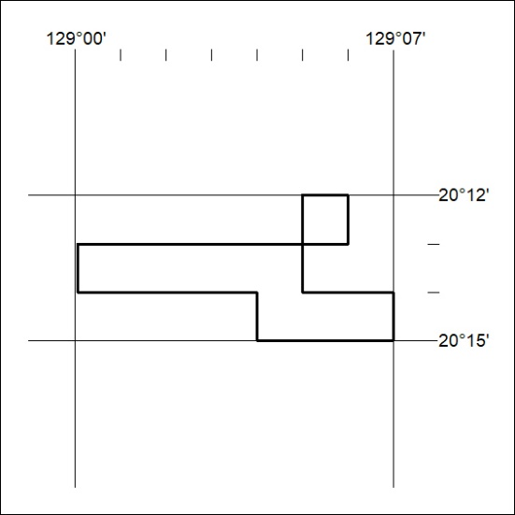
179/20

Mineral Titles Act 2010
NOTICE OF LAND CEASING TO BE A MINERAL TITLE AREA
Title Type and Number: | Exploration Licence 31703
Area Ceased on: | 14 May 2020
Area: | 22 Blocks, 72.27 km²
Locality: | MALLAPUNYAH
Name of Applicant(s)/Holder(s): | 100% TODD RIVER METALS PTY LTD [ACN. 600 314 038]
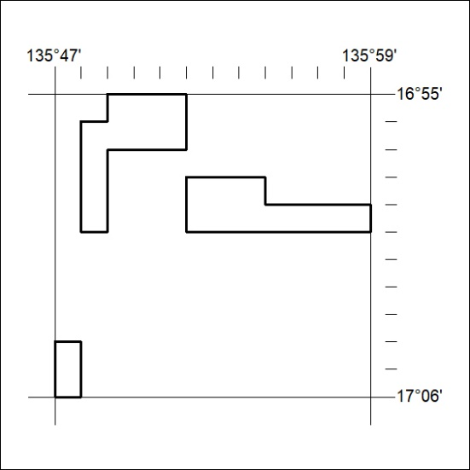
180/20

Mineral Titles Act 2010
NOTICE OF LAND CEASING TO BE A MINERAL TITLE AREA
Title Type and Number: | Exploration Licence 31704
Area Ceased on: | 14 May 2020
Area: | 39 Blocks, 127.96 km²
Locality: | KILGOUR
Name of Applicant(s)/Holder(s): | 100% TODD RIVER METALS PTY LTD [ACN. 600 314 038]
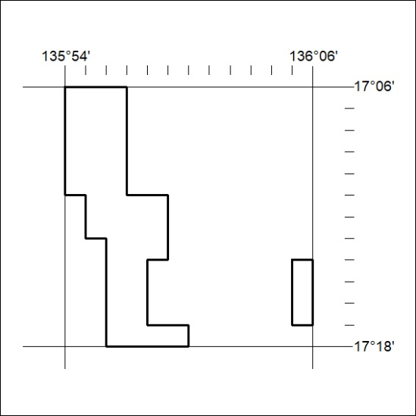
181/20

