Mineral Titles Act 2010
NOTICE OF LAND CEASING TO BE A MINERAL TITLE APPLICATION AREA
Title Type and Number: | Exploration Licence 32180
Area Ceased on: | 02 April 2020
Area: | 250 Blocks, 781.12 km²
Locality: | TEA TREE
Name of Applicant(s)/Holder(s): | 100% NEW AGE RESOURCES PTY LTD [ACN. 622 780 072]
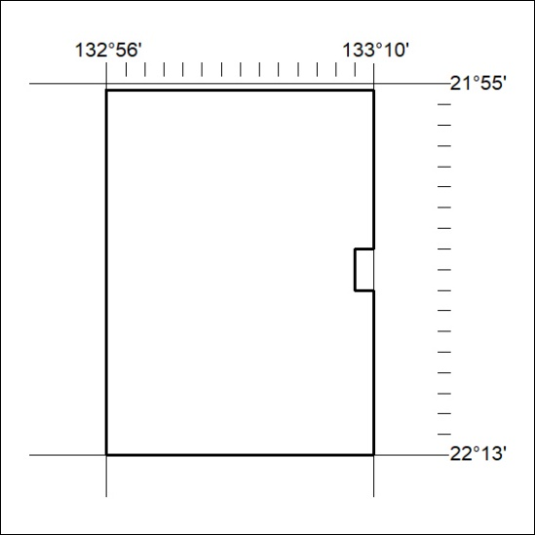
158/20

Mineral Titles Act 2010
NOTICE OF LAND CEASING TO BE A MINERAL TITLE AREA
Title Type and Number: | Mineral Lease 31400
Area ceased on: | 02 April 2020
Area: | 39.00 Hectare
Locality: | QUARTZ
Name of Applicants(s)Holder(s): | 100% BARFUSS CORPORATION PTY. LTD. [ACN. 006 917 666]
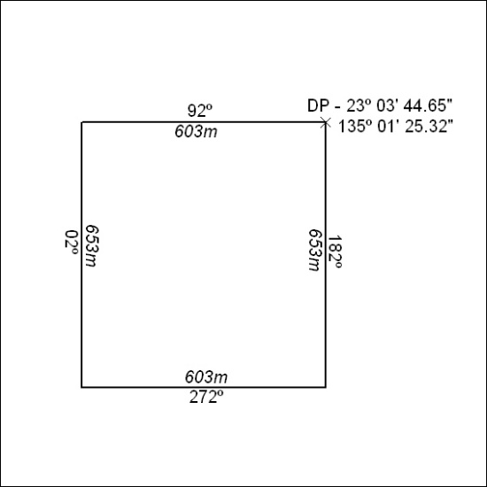
159/20

