Mineral Titles Act 2010
NOTICE OF LAND CEASING TO BE A MINERAL TITLE AREA
Title Type and Number: | Exploration Licence 30222
Area Ceased on: | 13 February 2020
Area: | 57 Blocks, 185.52 km²
Locality: | BRUNCHILLY
Name of Applicant(s)/Holder(s): | 100% TERRITORY PHOSPHATE PTY LTD [ACN. 130 065 351]
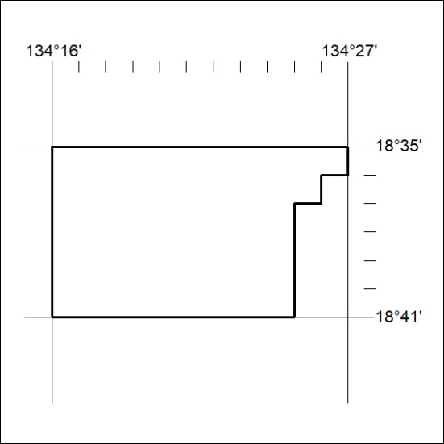

92/20

Mineral Titles Act 2010
NOTICE OF LAND CEASING TO BE A MINERAL TITLE AREA
Title Type and Number: | Exploration Licence 30223
Area Ceased on: | 13 February 2020
Area: | 13 Blocks, 42.26 km²
Locality: | MUNKADERRY
Name of Applicant(s)/Holder(s): | 100% TERRITORY PHOSPHATE PTY LTD [ACN. 130 065 351]
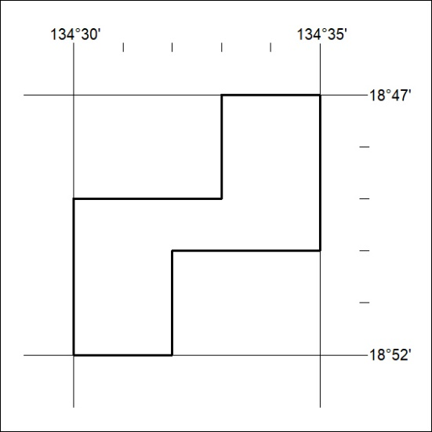

93/20
Mineral Titles Act 2010
NOTICE OF LAND CEASING TO BE A MINERAL TITLE AREA
Title Type and Number: | Exploration Licence 30224
Area Ceased on: | 13 February 2020
Area: | 30 Blocks, 97.55 km²
Locality: | BRUNCHILLY
Name of Applicant(s)/Holder(s): | 100% TERRITORY PHOSPHATE PTY LTD [ACN. 130 065 351]
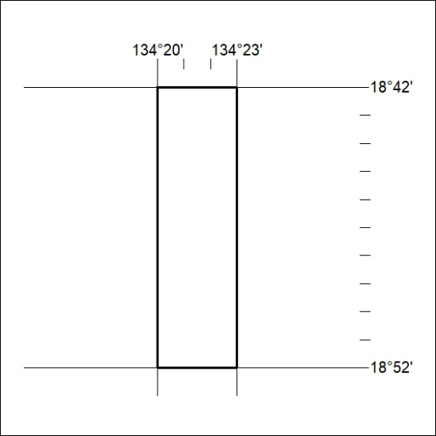

94/20

Mineral Titles Act 2010
NOTICE OF LAND CEASING TO BE A MINERAL TITLE AREA
Title Type and Number: | Exploration Licence 30225
Area Ceased on: | 13 February 2020
Area: | 108 Blocks, 352.87 km²
Locality: | LAKE WOODS
Name of Applicant(s)/Holder(s): | 100% TERRITORY PHOSPHATE PTY LTD [ACN. 130 065 351]
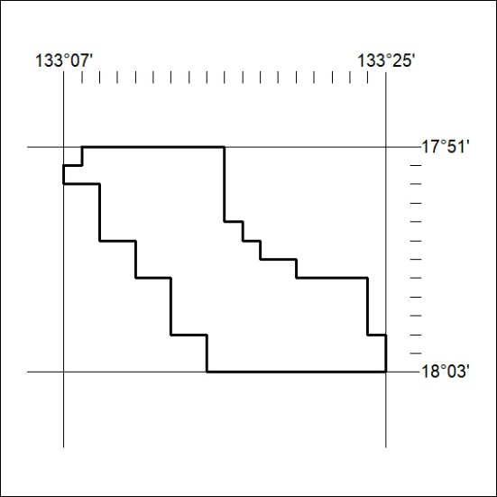

95/20
Mineral Titles Act 2010
NOTICE OF LAND CEASING TO BE A MINERAL TITLE AREA
Title Type and Number: | Exploration Licence 30613
Area Ceased on: | 13 February 2020
Area: | 18 Blocks, 57.79 km²
Locality: | WAUCHOPE
Name of Applicant(s)/Holder(s): | 100% TERRITORY PHOSPHATE PTY LTD [ACN. 130 065 351]
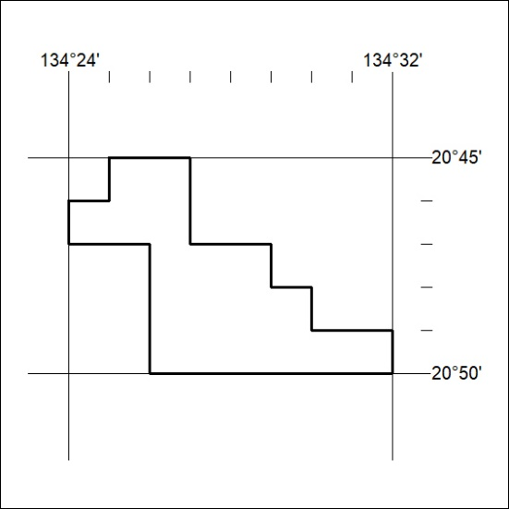

96/20

Mineral Titles Act 2010
NOTICE OF LAND CEASING TO BE A MINERAL TITLE AREA
Title Type and Number: | Exploration Licence 31841
Area Ceased on: | 14 February 2020
Area: | 250 Blocks, 799.51 km²
Locality: | CONICAL HILL
Name of Applicant(s)/Holder(s): | 100% VANADIUM MINING PTY LTD [ACN. 621 703 991]
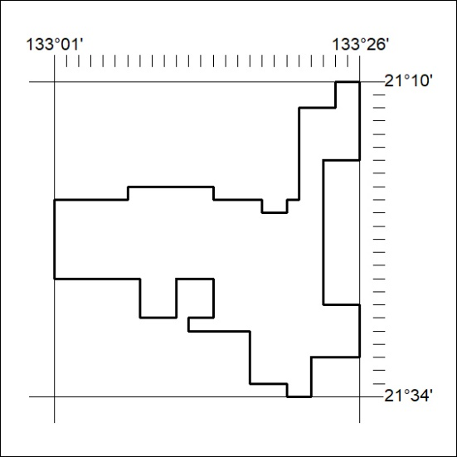

97/20
Mineral Titles Act 2010
NOTICE OF LAND CEASING TO BE A MINERAL TITLE AREA
Title Type and Number: | Exploration Licence 31842
Area Ceased on: | 14 February 2020
Area: | 250 Blocks, 787.09 km²
Locality: | ANNINGIE
Name of Applicant(s)/Holder(s): | 100% VANADIUM MINING PTY LTD [ACN. 621 703 991]
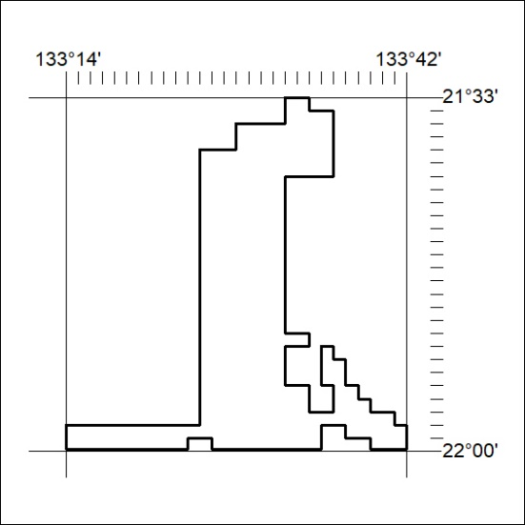

98/20

