Mineral Titles Act 2010
NOTICE OF LAND CEASING TO BE A MINERAL TITLE AREA
Title Type and Number: | Extractive Mineral Exploration Licence 31247
Area Ceased on: | 26 September 2018
Area: | 1 Block, 2.81 km²
Locality: | KATHERINE
Name of Applicant(s)/Holder(s): | 100% NT LAND DEVELOPMENT CORPORATION PTY LTD [ACN. 078 816 814]
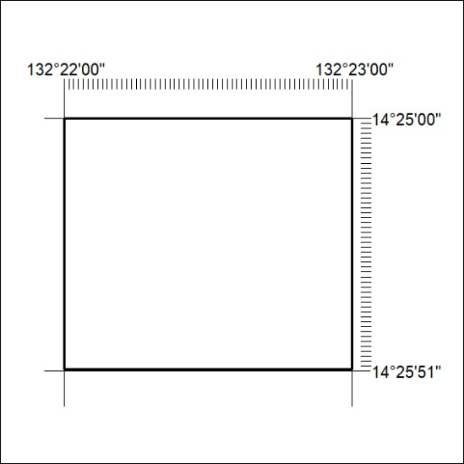

72/20

