Mineral Titles Act 2010
NOTICE OF LAND CEASING TO BE A MINERAL TITLE APPLICATION AREA
Title Type and Number: | Exploration Licence 32155
Area Ceased on: | 04 February 2020
Area: | 110 Blocks, 358.65 km²
Locality: | BOWMAN
Name of Applicant(s)/Holder(s): | 100% TERRITORY PROSPECTING PTY LTD [ACN. 627 334 034]
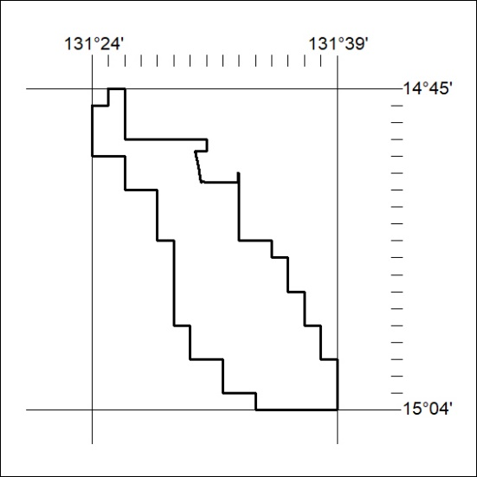

53/20

Mineral Titles Act 2010
NOTICE OF LAND CEASING TO BE A MINERAL TITLE APPLICATION AREA
Title Type and Number: | Exploration Licence 32160
Area Ceased on: | 04 February 2020
Area: | 180 Blocks, 590.57 km²
Locality: | NEWCASTLE WATERS
Name of Applicant(s)/Holder(s): | 100% BAUDIN RESOURCES PTY LTD [ACN. 618 455 593]
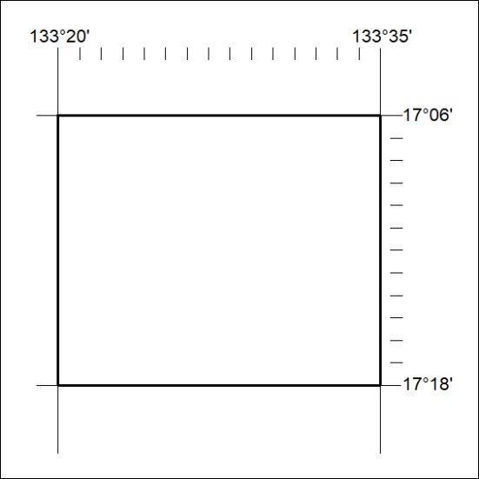

54/20
Mineral Titles Act 2010
NOTICE OF LAND CEASING TO BE A MINERAL TITLE APPLICATION AREA
Title Type and Number: | Exploration Licence 32318
Area Ceased on: | 04 February 2020
Area: | 50 Blocks, 166.19 km²
Locality: | FLORA
Name of Applicant(s)/Holder(s): | 100% REDSTONE METALS PTY LTD [ACN. 106 360 678]
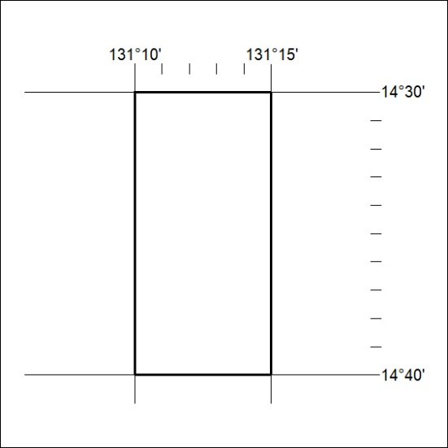

55/20

Mineral Titles Act
NOTICE OF GRANT OF A MINERAL TITLE
Title Type and Number: | Exploration Licence 32140
Granted: | 04 February 2020, for a period of 6 Years
Area: | 45 Blocks, 149.76 km²
Locality: | MARY RIVER
Name of Holder/s: | 100% PANTHER METALS PTY LTD [ACN. 614 676 578]
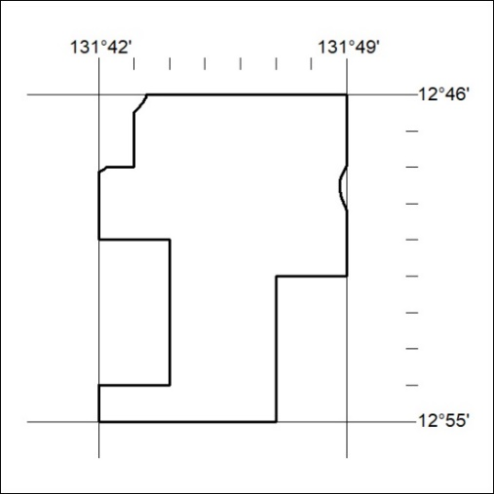
Area granted is indicated above. The titleholder is not permitted to exercise occupational rights on any land that is subject to a development title, or an application for a development title. Any land the subject of a Reserved Land gazettal under the Mineral Titles Act and all land vested in the Commonwealth of Australia is also excluded by description but not excised from the grant area.

56/20

