Mineral Titles Act 2010
NOTICE OF LAND CEASING TO BE A MINERAL TITLE AREA
Title Type and Number: | Extractive Mineral Lease 23140
Area ceased on: | 24 January 2020
Area: | 12.00 Hectare
Locality: | NOONAMAH
Name of Applicants(s)Holder(s): | 100% EARTHWORKS NT PTY LTD [ACN. 145 461 169]
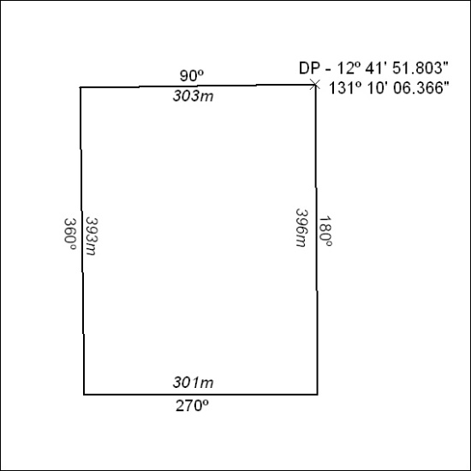

28/20

Mineral Titles Act 2010
NOTICE OF LAND CEASING TO BE A MINERAL TITLE AREA
Title Type and Number: | Exploration Licence 28224
Area Ceased on: | 24 January 2020
Area: | 15 Blocks, 47.19 km²
Locality: | MACDONNELL RANGES
Name of Applicant(s)/Holder(s): | 100% CROSSLAND NICKEL PTY LTD* [ACN. 099 477 915]
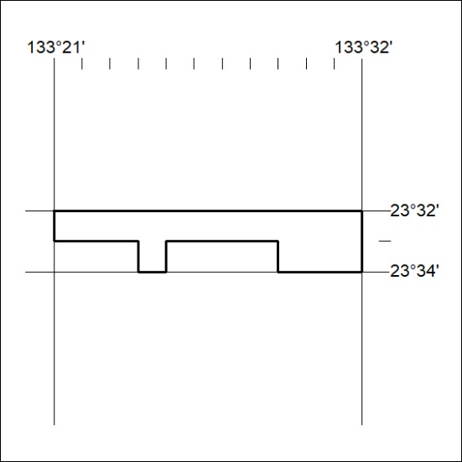

29/20
Mineral Titles Act 2010
NOTICE OF LAND CEASING TO BE A MINERAL TITLE AREA
Title Type and Number: | Exploration Licence 28226
Area Ceased on: | 24 January 2020
Area: | 22 Blocks, 69.34 km²
Locality: | BURT
Name of Applicant(s)/Holder(s): | 100% CROSSLAND NICKEL PTY LTD* [ACN. 099 477 915]
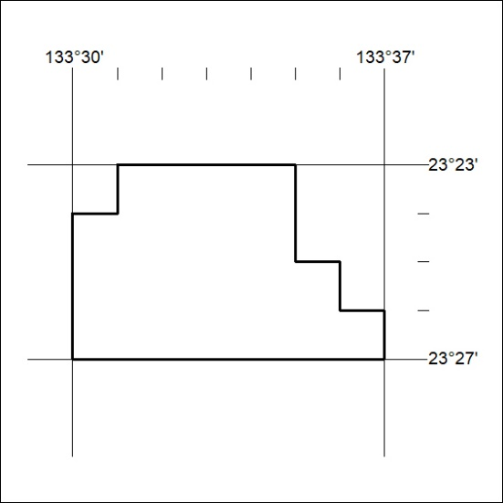

30/20

Mineral Titles Act
NOTICE OF GRANT OF A MINERAL TITLE
Title Type and Number: | Exploration Licence 32196
Granted: | 23 January 2020, for a period of 6 Years
Area: | 240 Blocks, 744.31 km²
Locality: | HALE
Name of Holder/s: | 100% GEMPART (NT) PTY LTD* [ACN. 081 859 896]
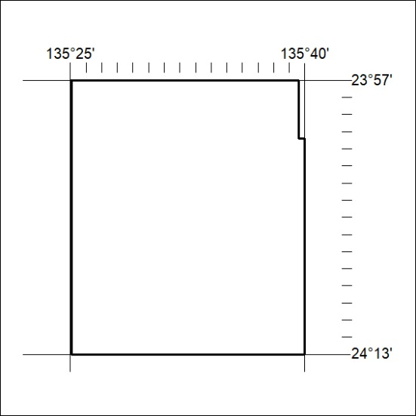
Area granted is indicated above. The titleholder is not permitted to exercise occupational rights on any land that is subject to a development title, or an application for a development title. Any land the subject of a Reserved Land gazettal under the Mineral Titles Act and all land vested in the Commonwealth of Australia is also excluded by description but not excised from the grant area.

31/20

Mineral Titles Act
NOTICE OF GRANT OF A MINERAL TITLE
Title Type and Number: | Exploration Licence 32227
Granted: | 23 January 2020, for a period of 6 Years
Area: | 1 Block, 0.18 km²
Locality: | WONARAH
Name of Holder/s: | 100% MINEMAKERS AUSTRALIA PTY LTD* [ACN. 081 911 917]
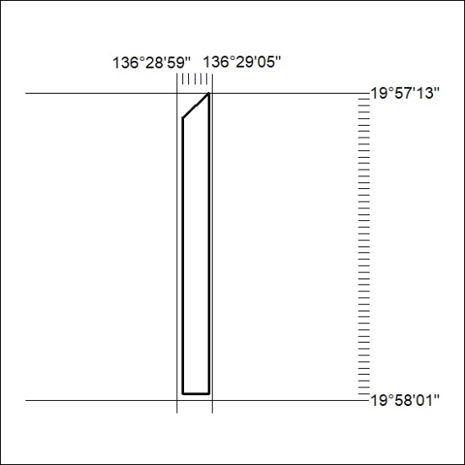
Area granted is indicated above. The titleholder is not permitted to exercise occupational rights on any land that is subject to a development title, or an application for a development title. Any land the subject of a Reserved Land gazettal under the Mineral Titles Act and all land vested in the Commonwealth of Australia is also excluded by description but not excised from the grant area.

32/20

