Mineral Titles Act 2010
NOTICE OF LAND CEASING TO BE A MINERAL TITLE AREA
Title Type and Number: | Mineral Authority 22621
Area ceased on: | 18 December 2019
Area: | 1.00 Hectare
Locality: | ALICE SPRINGS
Name of Applicants(s)Holder(s): | 100% ROCKLAKE PTY. LIMITED [ACN. 050 221 899]
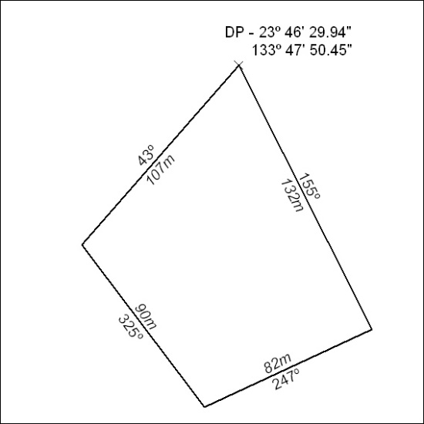

539/19

Mineral Titles Act 2010
NOTICE OF LAND CEASING TO BE A MINERAL TITLE AREA
Title Type and Number: | Mineral Authority 22622
Area ceased on: | 18 December 2019
Area: | 8.00 Hectare
Locality: | ALICE SPRINGS
Name of Applicants(s)Holder(s): | 100% ROCKLAKE PTY. LIMITED [ACN. 050 221 899]
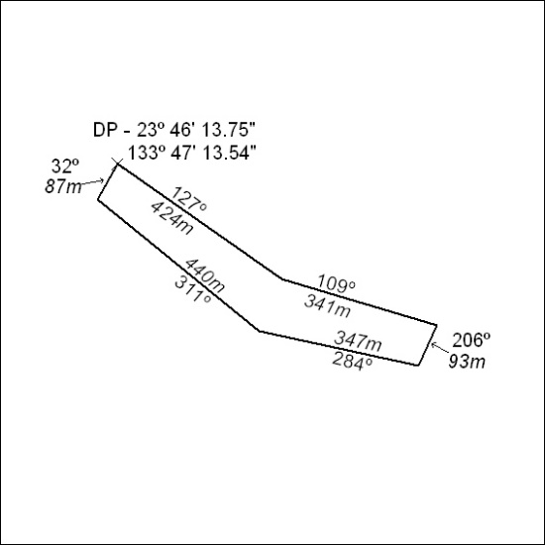

540/19

Mineral Titles Act 2010
NOTICE OF LAND CEASING TO BE A MINERAL TITLE AREA
Title Type and Number: | Mineral Authority 28732
Area ceased on: | 18 December 2019
Area: | 1.00 Hectare
Locality: | ALICE SPRINGS
Name of Applicants(s)Holder(s): | 100% ROCKLAKE PTY. LIMITED [ACN. 050 221 899]
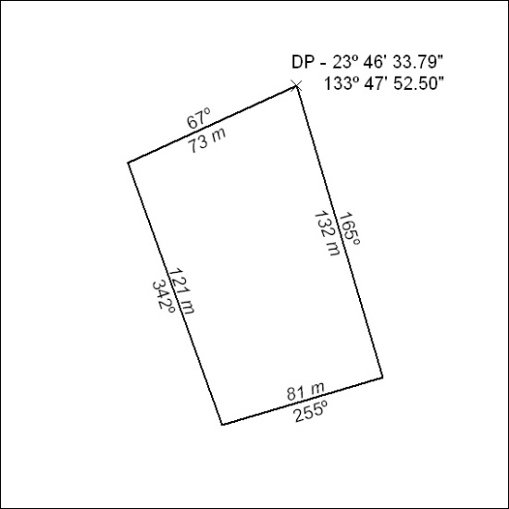

541/19

