Mineral Titles Act 2010
NOTICE OF LAND CEASING TO BE A MINERAL TITLE AREA
Title Type and Number: | Exploration Licence 26626
Area Ceased on: | 14 November 2019
Area: | 36 Blocks, 115.59 km²
Locality: | INNINGARRA
Name of Applicant(s)/Holder(s): | 90% PRODIGY GOLD NL* [ACN. 009 127 020], 10% ALTURA LITHIUM OPERATIONS PTY LTD* [ACN. 095 384 491]
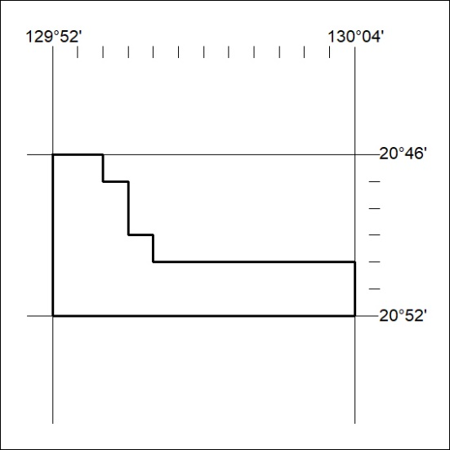

479/19

Mineral Titles Act 2010
NOTICE OF LAND CEASING TO BE A MINERAL TITLE APPLICATION AREA
Title Type and Number: | Exploration Licence 29035
Area Ceased on: | 14 November 2019
Area: | 273 Blocks, 884.77 km²
Locality: | CONDER
Name of Applicant(s)/Holder(s): | 100% KALBAR RESOURCES LTD [ACN. 149 545 362]
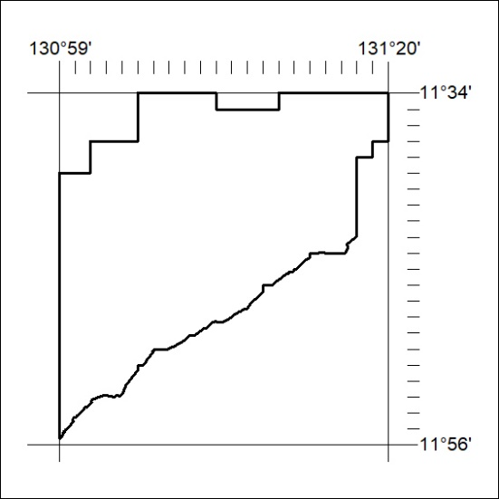

480/19
Mineral Titles Act 2010
NOTICE OF LAND CEASING TO BE A MINERAL TITLE APPLICATION AREA
Title Type and Number: | Exploration Licence 29036
Area Ceased on: | 14 November 2019
Area: | 247 Blocks, 805.83 km²
Locality: | MELVILLE
Name of Applicant(s)/Holder(s): | 100% KALBAR RESOURCES LTD [ACN. 149 545 362]
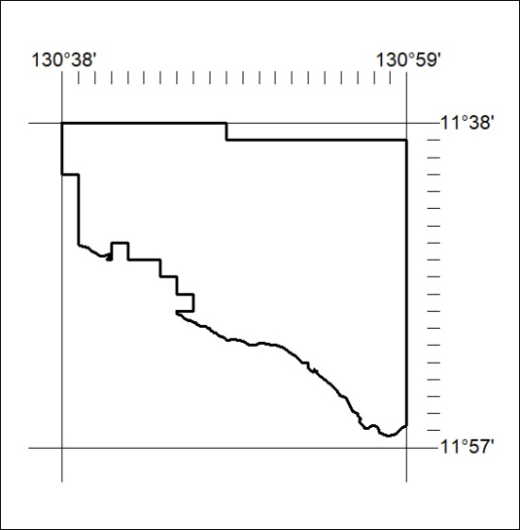

481/19

Mineral Titles Act 2010
NOTICE OF LAND CEASING TO BE A MINERAL TITLE APPLICATION AREA
Title Type and Number: | Exploration Licence 29222
Area Ceased on: | 14 November 2019
Area: | 207 Blocks, 664.69 km²
Locality: | BATHURST ISLAND
Name of Applicant(s)/Holder(s): | 100% KALBAR RESOURCES LTD [ACN. 149 545 362]
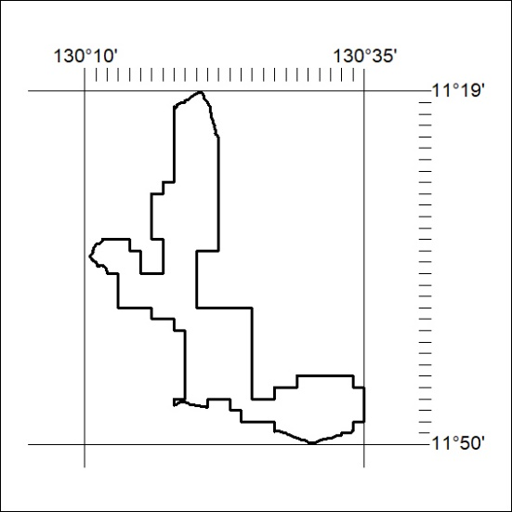

482/19

Mineral Titles Act
NOTICE OF GRANT OF A MINERAL TITLE
Title Type and Number: | Exploration Licence 32115
Granted: | 14 November 2019, for a period of 6 Years
Area: | 51 Blocks, 167.71 km²
Locality: | MALLAPUNYAH
Name of Holder/s: | 100% SCRIVEN EXPLORATION PTY LTD [ACN. 006 264 615]
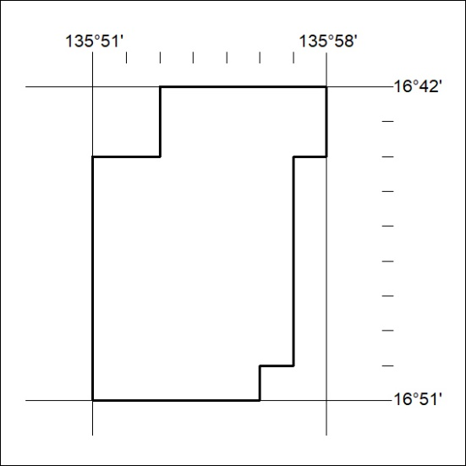
Area granted is indicated above. The titleholder is not permitted to exercise occupational rights on any land that is subject to a development title, or an application for a development title. Any land the subject of a Reserved Land gazettal under the Mineral Titles Act and all land vested in the Commonwealth of Australia is also excluded by description but not excised from the grant area.

483/19

