Mineral Titles Act
NOTICE OF GRANT OF A MINERAL TITLE
Title Type and Number: | Exploration Licence 32106
Granted: | 12 November 2019, for a period of 6 Years
Area: | 93 Blocks, 304.81 km²
Locality: | KILGOUR
Name of Holder/s: | 100% RIO TINTO EXPLORATION PTY LIMITED [ACN. 000 057 125]
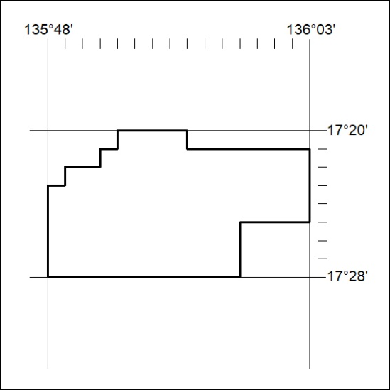
Area granted is indicated above. The titleholder is not permitted to exercise occupational rights on any land that is subject to a development title, or an application for a development title. Any land the subject of a Reserved Land gazettal under the Mineral Titles Act and all land vested in the Commonwealth of Australia is also excluded by description but not excised from the grant area.

478/19

