Northern Territory project development framework

Document title | Northern Territory project development framework
Contact details | Development Strategy, 08 8999 6035, EconomicInnovation.DTBI@nt.gov.au
Approved by | JSC Cabinet
Date approved | 8 October 2019
Document review | Annually

Version | Date | Author | Changes made
1.0 | 8 October 2019 | Development Strategy | First version

Acronyms | Full form
NT | Northern Territory
NT Government | Northern Territory Government

Please read in outline view for best navigational experience.

What is the Northern Territory Project Development Framework?
The Northern Territory Project Development Framework (NTPDF) is a structured approach to project development, from determining the strategic need through to project development and evaluation of the government investment.
The NTPDF applies to capital projects that are NT Government funded or require some level of NT Government support, whether they are projects funded through the government capital works program or government facilitated strategic projects.
The NTPDF emphasises the importance of up-front analysis and requires qualitative and economically measurable information to assess and prioritise public funds. It supports project and contract management guidelines already used by the NT Government and, as such, does not provide specific guidance on project or contract management.
The Framework outlines four project phases:
- Strategic assessment and planning
- Project development
- Prioritisation and project delivery, and
- Project implementation and evaluation.
The NTPDF aims to ensure that government facilitated and funded projects are developed, evaluated and progressed through a consistent framework which enhances transparency and public accountability, and maximises the outcomes and public benefit of government expenditure. The framework relies principally on a considered and detailed project assessment informing the delivery options and investment decision for each project.

Why use this document?
The NTPDF guides project development to ensure government facilitated and funded capital projects are well defined, risks and delivery options are understood, so that government resources are invested in projects that meet an identified strategic need.
Adhering to the NTPDF will promote prudent management of government resources, enhance accountability and maximise the outcomes of projects.

Further help and additional guidance
Support can be provided at any stage of a project’s lifecycle by the Economic Innovation Division of the Department of Trade, Business and Innovation’s by telephone on 08 8999 6035 or EconomicInnovation.DTBI@nt.gov.au
The NT Government also encourages users of the NTPDF to leverage the specialist skill sets available across agencies to help validate, check and/or collaborate on a project.
This document explains the process below
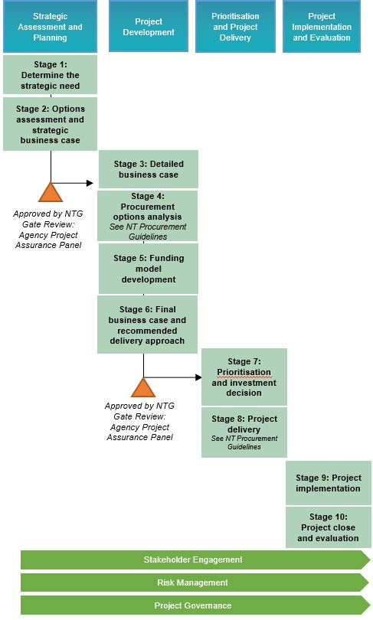
Once detailed project planning is complete as above and funding approvals granted, agency-specific project management tools should be utilised.
Acknowledge the following work which has informed this document:
- Building Queensland
- Australian Capital Territory

Contents
What is the Northern Territory Project Development Framework? 3
Why use this document? 3
Further help and additional guidance 3
1. Introduction 6
2. Key Features 7
2.1. Project Classification 7
2.2. Evidence-based Business Cases 7
2.3. Business Case Assurance: Agency Project Assurance Panel 7
2.4. Governance 8
2.5. Stakeholder Engagement 8
3. The Northern Territory Project Development Framework 8
3.1. Phase 1: Strategic Assessment and Planning 10
Stage 1 – Determine the Strategic Need 10
Stage 2 – Options Assessment and Strategic Business Case 10
3.2. Phase 2: Project Development 11
Stage 3 - Detailed Business Case 11
Stage 4 – Delivery Options Analysis 11
Stage 5 – Funding Model Development 12
Stage 6 – Final Business Case and Recommended Delivery Approach 12
3.3. Phase 3: Prioritisation and Project Delivery 13
Stage 7 – Prioritisation and Investment Decision 13
Stage 8 – Project Delivery 13
3.4. Phase 4: Project Implementation and Evaluation 14
Stage 9 – Project Implementation 14
Stage 10 – Project Close and Evaluation 14
4. Exception and Variation Processes 15
4.1. Exception Process 15
4.2. Variation Process 16
5. Guidance on NTPDF Templates 16
5.1. Strategic Assessment and Planning: Strategic Business Case 16
5.2. Project Development: Detailed Business Case 17
5.3. Communication: Highlight/Status Report 17
5.4. Risk Management: Project Risks Register 17
5.5. Project Evaluation/Review: Benefits Realisation Report 17
5.6. Project Review: ‘Lessons Learned’ Register 18
5.7. Exception Request Form 18
5.8. Variation Request Form 18

Introduction
The Northern Territory Project Development Framework (NTPDF) outlines requirements for capital works project initiation and development in the NT Government. This NTPDF will assist with the prudent management of government resources, ensuring accountability and achieving successful project outcomes.
It is critical that government resources are invested to maximise economic and social outcomes, and government funds are prioritised against clearly articulated outcomes. Identifying the strategic need of a capital project and developing an evidence-based business case represent the crucial first stages in this process.
The NTPDF builds on the existing project knowledge in the NT Government by providing clear guidance and templates that will ensure that projects are developed, evaluated and progressed through a transparent and consistent approach. For guidance on project management, please refer to NT Government agency-specific project management tools and templates and the NT Government Procurement Guidelines.
Under certain circumstances and with sufficient justification, NT Government agencies may seek to modify the application of the NTPDF to a specific project in accordance with the exception and variation processes outlined in this document.
The overarching structure of the NTPDF was included in the Northern Territory Infrastructure Strategy (NTIS), released in May 2017. The NTIS charts how and why government will undertake infrastructure investment. The vision, drivers and desired outcomes of the NTIS are outlined below in Figure 1.
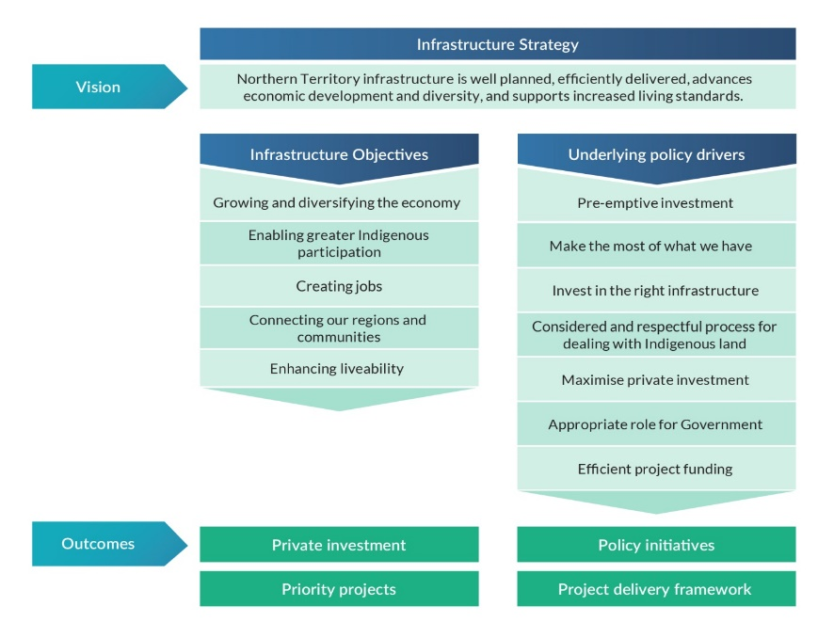
Figure 1 Outline of the Northern Territory Infrastructure Strategy (NTIS) p4
The NTPDF has been developed to align, where reasonable, with the Australian Government’s Infrastructure Australia’s Assessment Framework.

Key Features

Project Classification
The level of detail and supporting documentation should be commensurate with the size, complexity and risk profile of the project. The NTPDF uses levels to provide additional guidance to users of the NTPDF on the level of detail expected in the development of project business cases.
Level 1: Territory Government contribution of $30 million and over, or as otherwise determined by government.
Note: All projects above $50 million are required to be considered for a public-private partnership, in line with the National Public-Private Partnership Guidelines and NT-specific guidance material.
Level 2: Territory Government contribution of $10 million to $30 million.
Level 3: Territory Government contribution of $500 000 - $10 million.
While the NTPDF is not mandated for Level 2 and 3 projects, the guidance material provides examples of where the level of information and detail may differ, depending on the size and complexity of the project.
Note: Major ICT projects are developed in accordance with existing Treasurer’s Directions.

Evidence-based Business Cases
Evidence-based business cases with adequate analysis are required by senior decision-makers to make the best decisions regarding prioritisation of public funds and achieve the ‘best value for money’ for Territorians. The level of detail and supporting documentation should be commensurate with the size, complexity and risk profile of the capital project (further outlined below).
In Stage One of the NTPDF, a Strategic Business Case is developed to determine the strategic need of a proposed capital project and alignment with government priorities.
In Stage Two of the NTPDF, a Detailed Business Case is developed with a high level of analysis. The Detailed Business Case will be a single complete document used by senior decision makers to assess a proposed capital project.
A consistent approach to developing and presenting business cases:
- enables government to assess and compare investment opportunities, to achieve the best value for Territorians
- reduces the cost and time taken to develop Business Cases, and
- ensures Business Cases meet Territory government requirements.

Business Case Assurance: Agency Project Assurance Panel
Throughout the development of a project there are mandatory stage gate review points that must be approved by the appropriate governance body. The NTPDF proposes that agencies establish an assurance panel for each project comprised of senior officers with relevant skills and technical expertise, including at least two independent reviewers comprising representatives from the Department of Infrastructure, Planning and Logistics and the Department of the Treasury and Finance. Where necessary, the assurance panel will also engage external independent expertise to appraise project business cases. Project appraisal costs should be included in project budgets.
Agencies should submit strategic and detailed business cases and related proposal documents for Level 1 projects to the assurance panel for review and endorsement prior to progressing to the next stage of project development.
The project assurance panel has an appraisal/review role, which requires project proposals to be critically analysed in terms of the quality of the business case, particularly estimates of cost, time, resources and any underlying assumptions; and the level of confidence that the project will be successfully delivered on time, on budget and with planned benefits realised.
The assurance panel is not a decision making body but a gateway reviewer. An assurance panel’s advice does not impact or reduce the delegation, accountability or discretion of each agency Chief Executive for Capital Works projects within their agency. The CEO maintains the option to take the project to JSC Coordination for CEO level consideration prior to proceeding to Cabinet or Ministerial consideration.
The relevant CEO as the Accountable Officer would then sign off the project for Cabinet or the Minister as required. Existing Cabinet processes will be adopted to progress each project.
A Project Assurance Panel Terms of Reference Template is attached as a guide for agencies.

Governance
Clearly articulating governance arrangements for the project’s development, that is, the roles and responsibilities of key decision makers and project managers is another key feature of the NTPDF. Cabinet will assess and determine the final investment decision. Ensuring strong governance arrangements are in place from the earliest phases of project development will enhance accountability in project approvals and maximise project outcomes.

Stakeholder Engagement
The NT Government is committed to stakeholder engagement, including with NT business and the public. A key feature built into the NTPDF is ensuring an adequate level of stakeholder engagement is conducted at all stages of a project’s development.
The Strategic Business Case and Detailed Business Case templates require the documentation of engagement with relevant stakeholders as early in the project planning phase as is reasonably practical.

The Northern Territory Project Development Framework
The NTPDF supports the prudent management of government resources, accountability of decision-making and maximises the outcomes of capital projects that are funded or facilitated by government. Each of the NTPDF’s 10 stages have target actions, required outcomes and key project development documents. The level of analysis required at each stage reflects the project’s complexity, value and risk profile. Figure 2 below provides an outline of the NTPDF.
Figure 2 Northern Territory Project Development Framework
At a minimum, projects should produce the following project development documents, detailed guidance on which can be found in Chapter 5 ‘Guidance on NTPDF Templates’:
- Strategic Business Case
- Detailed Business Case
- Risk and Issues Register
- Highlight (Progress) Reports, and
- Benefits Realisation Register.
The NTPDF does not extend to providing specific guidance on project management and contract management, which can be found in the NT Government Procurement Guidelines and agency-specific project management tools and templates.

Phase 1: Strategic Assessment and Planning
In this initial phase, the project is proposed for assessment and a strategic need is presented. A Strategic Business Case, which includes an analysis of potential options, high-level financial and public benefit assessment, is developed to obtain funding approval to progress to the next stage of project development.

Stage 1 – Determine the Strategic Need
Purpose | Determine the strategic need or value proposition for the project presented.
Actions | - Present the evidence for the strategic need and why it needs to be addressed, including any underlying assumptions (e.g. population/demand projections).  - Issue information to stakeholder groups about intent of project covering the high-level details of the project proposal (if appropriate).
Outcome | Clear understanding of the need and alignment with government priorities.
Documents | - A high-level report that outlines the potential project and describes what is being investigated.  - External studies or submission to NT Government agencies.

Stage 2 – Options Assessment and Strategic Business Case
Purpose | Develop an initial business case for investment, including an assessment of alternative approaches or options to address the strategic need.
Actions | - Identify the strategic importance, high-level costs and benefits and risk profile of the potential approaches to address the need.  - Conduct high-level analysis of options and delivery models, including where appropriate a sensitivity analysis to underlying assumptions.
Outcome | - High-level options assessment with a description of the intended scope for further assessment.  - Shortlist of options.  - Governance arrangements established.
Documents | - Strategic Business Case  - Gate Review through the Project Assurance Panel for Level 1 projects to ensure adequate details are provided in the business case.  Refer to Section 2.3 for an overview of the Gate Review process.

Phase 2: Project Development
Phase 2 is initiated when approval is received to develop a detailed business case. The stages within this phase facilitates the investment decision-based on the needs, costs, benefits, risks, delivery and funding model. The outcome of this phase is an agency-endorsed detailed business case.
**Figure above needs updating

Stage 3 - Detailed Business Case
Purpose | Develop a detailed project business case that assesses shortlisted options.
Actions | - Review strategic business case to confirm short-list of options is still applicable and addresses the strategic need.  - Define the scope of the project and outcomes to be achieved.  - Seek early review and input from relevant agencies.  - Undertake detailed analysis of the net financial cost to government, the public benefits, project risks and delivery models.  - Identify a preferred option to deliver the desired outcomes based on robust analysis and the value for money principle.
Outcome | A preferred option that is the most feasible solution to address the strategic need and deliver the intended outcomes.
Documents | - Detailed Business Case.  - Functional Brief/Output Specification (if applicable).

Stage 4 – Delivery Options Analysis
Purpose | To select the optimal delivery/procurement model that will deliver the best value for the NT.
Actions | - Review data and evidence prepared in the detailed business case, such as the risk analysis, market analysis, costs and project characteristics to inform the procurement options analysis.  - Conduct a validation process with industry/market participants.  - Consider delivery through public-private partnership for projects above $50 million, consistent with the National Public-Private Partnership Guidelines.
Outcome | A recommended delivery/procurement model, subject to final funding being confirmed.
Documents | Delivery Model Assessment/Summary – contained within the Final Detailed Business Case.

Stage 5 – Funding Model Development
Purpose | Define the appropriate approach to project funding based on the type of project, including consideration of the allocation of NT capital funds that may need to be drawn down for the project.
Actions | - Consider opportunities for alternative funding sources for the project, including from user charges, local and Australian Government participation.  - Consider opportunities for private sector participation in the project, through service provision and financing.  - For PPP projects, initial cost estimates should be refined to include a public sector comparator, consistent with the National PPP Guidelines.
Outcome | A recommended delivery and funding model to deliver the best value for money.
Documents | Detailed cost estimate and/or financial model – contained within the final Detailed Business Case.

Stage 6 – Final Business Case and Recommended Delivery Approach
Purpose | Finalise details in the Detailed Business Case for Cabinet consideration.
Actions | Consolidate Stages 3-5 to align and finalise the business case.
Outcome | A detailed final business case for Government’s consideration that clearly articulates:  - project scope  - expected outcomes  - procurement  - funding and delivery models, and  - project governance and assurances.
Documents | Final Detailed Business Case  - Risk Management Plan/ Risk Registers – NTPDF templates  - Gate Review through the Project Assurance Panel for Level 1 projects to ensure adequate details are provided in the business case for Cabinet consideration.  Refer to Section 2.3 for an overview of the Gate Review process.

Phase 3: Prioritisation and Project Delivery
During this phase, the NT Government will prioritise proposed projects and make an investment decision in line with strategic priorities and budgetary considerations. If a project is approved, it will progress to project delivery stage.

Stage 7 – Prioritisation and Investment Decision
Purpose | Government will consider the relative priority of a proposed project and make an investment decision.
Actions | - Assess the affordability of any government funding required in the context of government’s strategic priorities.  - Determine if, and when the proposed project shall proceed.
Outcome | Investment decision made regarding project delivery and timing based on the analysis contained in the detailed business case.
Documents | A record of a final investment decision made for the project.

Stage 8 – Project Delivery
Purpose | Finalise detailed design and procurement documentation stage for the project.
Actions | - Engage with industry through market sounding processes to confirm appropriate allocation of project risks.  - Implement tender process.  - Negotiate and execute contracts and development agreements.
Outcome | Detailed project design completed and contracts executed.
Documents | - Project Management Plan – see agency-specific project management tools and templates  - Relevant project documentation (i.e. tender, contracts)  – see NT Government Procurement Guidelines  - Benefits Realisation Register.

Phase 4: Project Implementation and Evaluation
In this final phase, the project has moved into execution and work has commenced in building/executing the project approved by government. Upon project completion, the government investment will be evaluated to determine whether the outcomes sought were achieved.
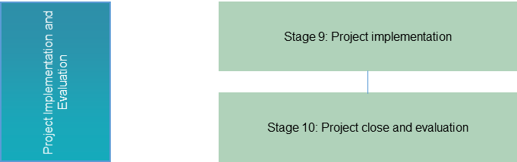

Stage 9 – Project Implementation
Purpose | Oversee the delivery of infrastructure and/or associated services.
Actions | - Establish appropriate governance and processes for the transition from execution of final contract documents through project construction, to the commissioning and operations phase.  - Keep key project stakeholders adequately informed of project progress.  - Continue to identify and mitigate risks and issues associated with the project.
Outcome | Robust contract management arrangements are in place to ensure all parties involved in the project continue to meet their obligations and the expected benefits from the project are achieved.
Documents | - Highlight (Progress) Reports – NTPDF template  - Risk Register – NTPDF template  - Contract Management Plan/ Finalised Contract – See NT Procurement Guidelines  - Detailed Project Management Plan – see agency-specific project management tools and templates  - Other project management documents as agreed by the relevant governance committees.

Stage 10 – Project Close and Evaluation
Purpose | To determine whether the project achieved the outcomes that were anticipated and appropriately met the identified need.
Actions | Evaluate the government’s investment against the benefits realised by the project.
Outcome | Key stakeholders are informed of the actual outcomes delivered by the project.
Documents | - Benefits Realisation – NTPDF template  - Lessons Learned Register – NTPDF template

Exception and Variation Processes
The NTPDF has been designed so it can be applied across capital projects of varying size and complexity. In using the NTPDF, some sections may not be suitable for a particular project.
Projects can change in response to a range of factors. The NTPDF provides the flexibility for this to occur with clear accountability and evidence to support the adjustment of key elements of a project. This is consistent with the overall objective of the NTPDF process to develop the best projects to address the strategic needs of government and deliver value for money.
Similarly, the NTPDF does not operate to fetter Cabinet decision-making processes and Cabinet remains free to make decisions in its total discretion.
Departure (exceptions) from the NTPDF require approvals as per section 4.1. Major scope variations require Cabinet approval and any increase in funding requires approval consistent with the Treasurer’s Directions (Infrastructure Series).

Exception Process
The exception process exists to accommodate circumstances that require an adjustment in the application of the NTPDF for a particular project.
Each project is a unique endeavour and will be developed differently. The exception process enables organisations and governance teams to exercise judgement and determine which aspects of the Framework are relevant and those aspects that are not, while providing clear accountability for such decisions.
The exception process is in place to authorise a deviation from the NTPDF where possible. A template is available.
A project exception request details the nature of the changes from the Framework sought and may seek exemption from specific elements within the NTPDF. This may include:
- A project development phase
- A project development stage
- A project deliverable
Depending on the governance arrangements established for the project, and having regard for the level of exceptions requested and the scale of the project, the exception request will be submitted to either:
- The Project Control Group
- Chief Executive Officer
- Project Assurance Panel
- Chief Minister, and/or
- Cabinet.
Notwithstanding the above, the NTPDF does not operate to remove Cabinet discretion to make an investment decision. Under the NTPDF, Cabinet retains ultimate responsibility for the consideration, assessment and determination of investment decisions. In such scenarios, the NTPDF and exception process provide guidance on documenting departures from the standard process and the rationale for doing so.

Variation Process
The variation process provides the means to change the agreed baseline of a project. A variation is a quantifiable and significant deviation, departure, or divergence from the agreed baseline or accepted component of a project. A template is available.
Variations can be raised as a result of changes in the operating environment that require adjustments to project scope, budget, quality or timeline.
A project variation request outlines:
- The nature of the variation (time, cost, scope, quality)
- The justification for the variation, and/or
- The impact of the change variation on the agreed baseline of the project
(business case/deliverables, project outcomes) including the magnitude of the change (in $ value, duration or items of scope).
The agreed governance structure for a project will outline the level required to authorise a significant scope variation. Major scope variations would ordinarily require Cabinet approval, and any increase in funding would require the Treasurer’s approval. Depending on the level of variation sought, the variation request will be submitted to:
- The Project Control Group
- Chief Executive Officer
- Project Assurance Panel
- Chief Minister, and/or
- Cabinet.

Guidance on NTPDF Templates
The NT Government funded or facilitated capital projects must produce project development documents that contain the following elements, to ensure prudent management of government resources, enhance accountability and maximise the outcomes of projects.
Detailed guidance on project development fundamentals is contained in each of the NTPDF templates.
Once detailed project planning is complete and funding approvals granted, agency-specific project management tools and guidance should be used.

Strategic Assessment and Planning: Strategic Business Case
The Strategic Business Case identifies the strategic need of the project, as considered against the identified objectives and priorities of the NT Government. It includes high-level benefits, key assumptions and costs (including estimated funding requirement for the project), and risk profiles of the potential approaches to addressing the strategic need identified.
This template should be completed, submitted, reviewed and approved by the appropriate authorities.
Further detailed guidance on this stage of the NTPDF is contained within the Strategic Business Case template.

Project Development: Detailed Business Case
The Detailed Business Case is a single complete document used by senior decision makers to assess the justification of a proposed project. If approved, it confirms support and/or resourcing for a recommended course of action (option).
A Detailed Business Case is developed to:
- gain agreement on the project scope and approval to proceed with a project
- obtain resourcing for a project through NT Government processes, and
- document what the project will accomplish for the funding and how it will deliver benefits.
The document enables those approving the resources to analyse the rationale for the project by assessing the impact of the project.
Further detailed guidance on this stage of the NTPDF is contained within the Detailed Business Case template.

Communication: Highlight/Status Report
The NT Government Project Managers are encouraged to use the NTPDF project status reporting template (Highlight Report) to ensure the project stakeholders (i.e. key decision makers) are kept suitably informed of the project’s stage status and progress.
The Project Manager can also use the Highlight Report to advise key governance stakeholders of any potential problems or areas where they could assist. The NTPDF employs the traffic light system to give a snapshot of a project’s status.
Further detailed guidance on this stage of the NTPDF is contained within the Highlight Report template.

Risk Management: Project Risks Register
Identifying, monitoring and mitigating project issues and risks is a fundamental element of project development. Project Managers should use the NTPDF Project Risks Register template to identify risks and potential ways to manage those risks (mitigation strategies).
Further detailed guidance on this stage of the NTPDF is contained within the Project Risks and Issues Register template.

Project Evaluation/Review: Benefits Realisation Report
At a predetermined review date, an evaluation should be undertaken to assess the actual outcomes of a project against the expected outcomes.
Level 1 and Level 2 projects should use the NTPDF Benefits Realisation template to register/record the benefits that are stated for a given project. This template allows the project to identify and allocate benefits to the associated benefit owner or agency. The document seeks to ensure/facilitate traceability of benefits throughout and post project delivery.
The Benefits Realisation Report should be consistent with the outcomes originally identified in the final Detailed Business Case.
Further detailed guidance on project evaluation and review are contained within the Benefits Realisation template.

Project Review: ‘Lessons Learned’ Register
Upon project completion, a review of ‘lessons learned’ should be undertaken by the project team, utilising the NTPDF ‘Lessons Learned’ template, which provides detailed guidance on effective project review.

Exception Request Form
An exception request form is used to authorise a deviation from the NTPDF. A copy of the exception request template is located in the NTPDF templates document.

Variation Request Form
A variation request is seeking a quantifiable and significant deviation, departure, or divergence from the agreed baseline or accepted component of the business case. The project variation request form should be completed to request approval for a significant business, technical or financial change to the approved requirements in the original project plan.

Includes cash and non-cash contributions (for example, land) towards and/or associated with the project.

