Mineral Titles Act 2010
NOTICE OF LAND CEASING TO BE A MINERAL TITLE AREA
Title Type and Number: | Mineral Lease 31019
Area ceased on: | 30 September 2019
Area: | 64.00 Hectare
Locality: | QUARTZ
Name of Applicants(s)Holder(s): | 100% BARFUSS CORPORATION PTY. LTD. [ACN. 006 917 666]
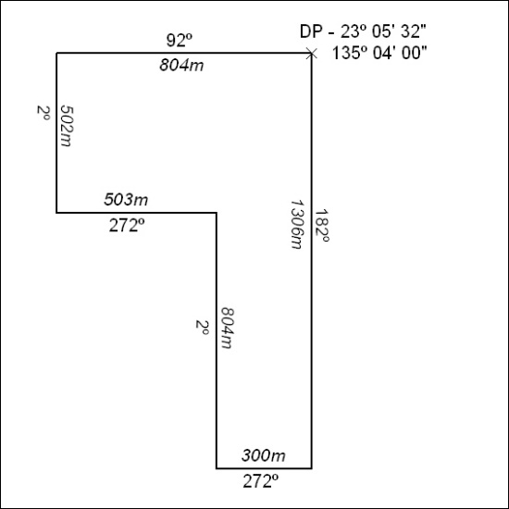

406/19

Mineral Titles Act 2010
NOTICE OF LAND CEASING TO BE A MINERAL TITLE AREA
Title Type and Number: | Mineral Lease 31399
Area ceased on: | 30 September 2019
Area: | 39.00 Hectare
Locality: | QUARTZ
Name of Applicants(s)Holder(s): | 100% BARFUSS CORPORATION PTY. LTD. [ACN. 006 917 666]
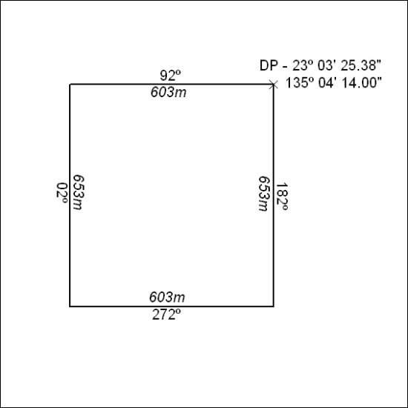

407/19
Mineral Titles Act 2010
NOTICE OF LAND CEASING TO BE A MINERAL TITLE AREA
Title Type and Number: | Exploration Licence 31777
Area Ceased on: | 30 September 2019
Area: | 250 Blocks, 780.55 km²
Locality: | DNEIPER
Name of Applicant(s)/Holder(s): | 100% XAVIER RESOURCES PTY LTD [ACN. 623 262 304]
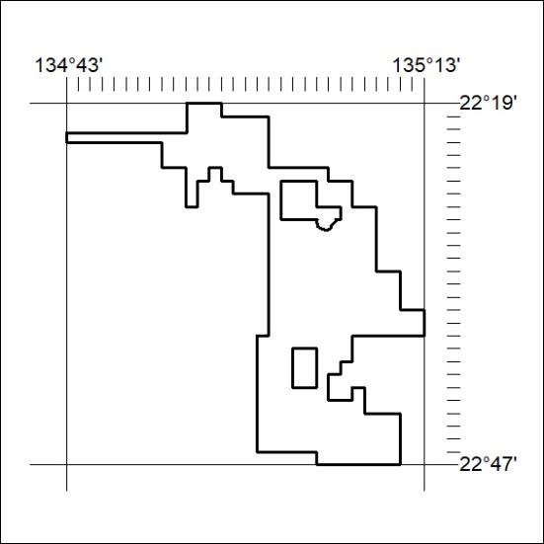

408/19

Mineral Titles Act 2010
NOTICE OF LAND CEASING TO BE A MINERAL TITLE AREA
Title Type and Number: | Exploration Licence 31778
Area Ceased on: | 30 September 2019
Area: | 94 Blocks, 297.48 km²
Locality: | DELNY
Name of Applicant(s)/Holder(s): | 100% XAVIER RESOURCES PTY LTD [ACN. 623 262 304]
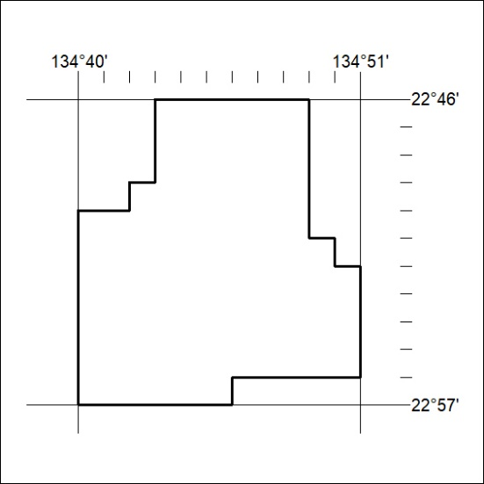

409/19
Mineral Titles Act 2010
NOTICE OF LAND CEASING TO BE A MINERAL TITLE AREA
Title Type and Number: | Exploration Licence 31779
Area Ceased on: | 30 September 2019
Area: | 175 Blocks, 554.46 km²
Locality: | DELNY
Name of Applicant(s)/Holder(s): | 100% XAVIER RESOURCES PTY LTD [ACN. 623 262 304]
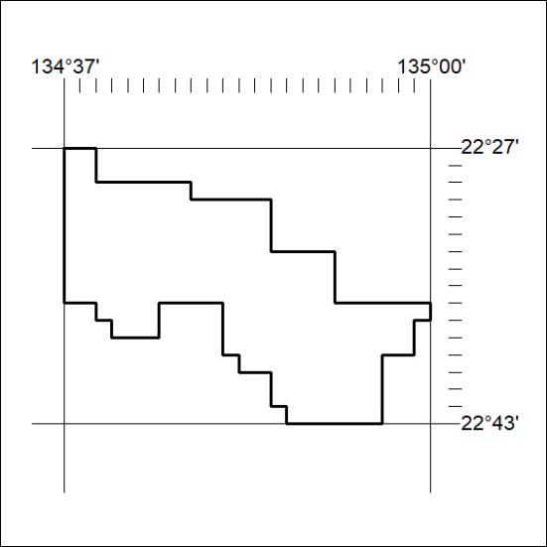

410-19

