Mineral Titles Act 2010
NOTICE OF LAND CEASING TO BE A MINERAL TITLE AREA
Title Type and Number: | Extractive Mineral Exploration Licence 31497
Area Ceased on: | 17 September 2019
Area: | 4 Blocks, 13.29 km²
Locality: | MANBULLOO
Name of Applicant(s)/Holder(s): | 100% DAY BREAK HELICOPTERS PTY LTD [ACN. 113 046 165]
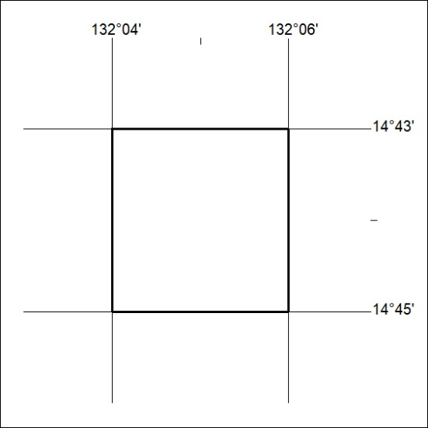

390/19

Mineral Titles Act 2010
NOTICE OF LAND CEASING TO BE A MINERAL TITLE AREA
Title Type and Number: | Extractive Mineral Exploration Licence 31498
Area Ceased on: | 17 September 2019
Area: | 4 Blocks, 13.28 km²
Locality: | MANBULLOO
Name of Applicant(s)/Holder(s): | 100% DAY BREAK HELICOPTERS PTY LTD [ACN. 113 046 165]
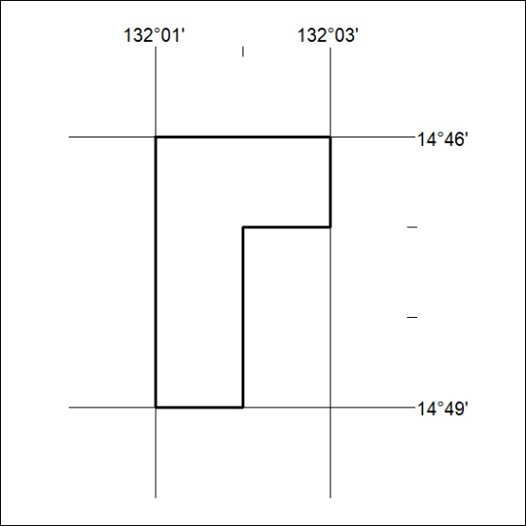

391/19
Mineral Titles Act 2010
NOTICE OF LAND CEASING TO BE A MINERAL TITLE APPLICATION AREA
Title Type and Number: | Exploration Licence 25387
Area Ceased on: | 17 September 2019
Area: | 269 Blocks, 900.92 km²
Locality: | CADELL
Name of Applicant(s)/Holder(s): | 100% ARNHEM MINERALS PTY LTD [ACN. 158 247 226]
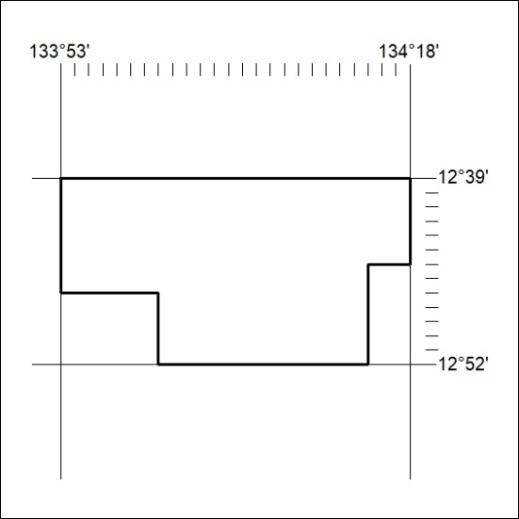

392/19

Mineral Titles Act 2010
NOTICE OF LAND CEASING TO BE A MINERAL TITLE APPLICATION AREA
Title Type and Number: | Exploration Licence 25391
Area Ceased on: | 17 September 2019
Area: | 83 Blocks, 278.42 km²
Locality: | GOOMADEER
Name of Applicant(s)/Holder(s): | 100% ARNHEM MINERALS PTY LTD [ACN. 158 247 226]
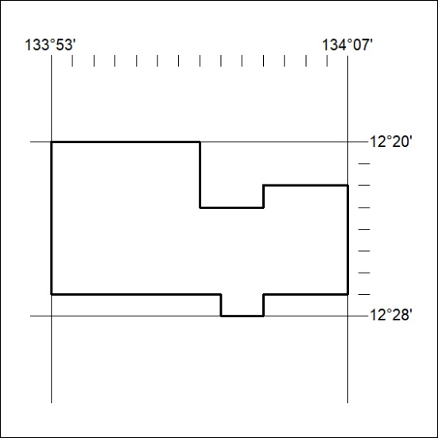

393/19
Mineral Titles Act 2010
NOTICE OF LAND CEASING TO BE A MINERAL TITLE APPLICATION AREA
Title Type and Number: | Exploration Licence 25393
Area Ceased on: | 17 September 2019
Area: | 125 Blocks, 372.48 km²
Locality: | TOMKINSON
Name of Applicant(s)/Holder(s): | 100% ARNHEM MINERALS PTY LTD [ACN. 158 247 226]
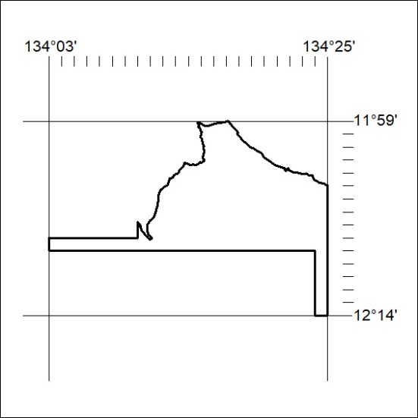

394/19

