Mineral Titles Act 2010
NOTICE OF LAND CEASING TO BE A MINERAL TITLE AREA
Title Type and Number: | Exploration Licence 25566
Area Ceased on: | 26 August 2019
Area: | 125 Blocks, 386.91 km²
Locality: | COCKBURN
Name of Applicant(s)/Holder(s): | 100% GEMPART (NT) PTY LTD* [ACN. 081 859 896]
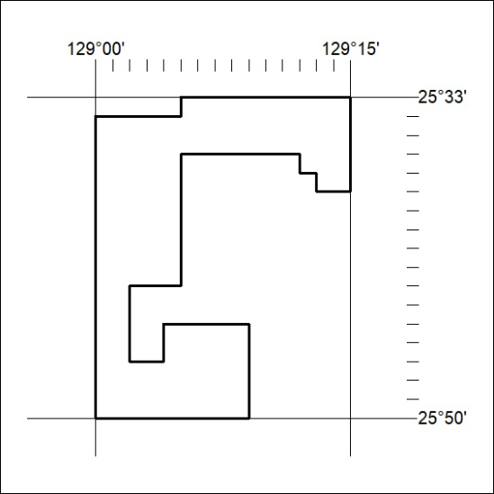

354/19

Mineral Titles Act 2010
NOTICE OF LAND CEASING TO BE A MINERAL TITLE AREA
Title Type and Number: | Exploration Licence 29853
Area Ceased on: | 26 August 2019
Area: | 15 Blocks, 47.28 km²
Locality: | BURT
Name of Applicant(s)/Holder(s): | 100% CROSSLAND NICKEL PTY LTD* [ACN. 099 477 915]
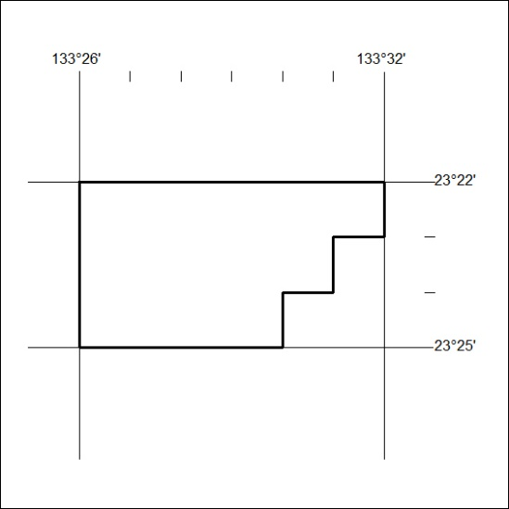

355/19
Mineral Titles Act 2010
NOTICE OF LAND CEASING TO BE A MINERAL TITLE AREA
Title Type and Number: | Exploration Licence 31383
Area Ceased on: | 26 August 2019
Area: | 125 Blocks, 384.43 km²
Locality: | COCKBURN
Name of Applicant(s)/Holder(s): | 100% GEMPART (NT) PTY LTD* [ACN. 081 859 896]
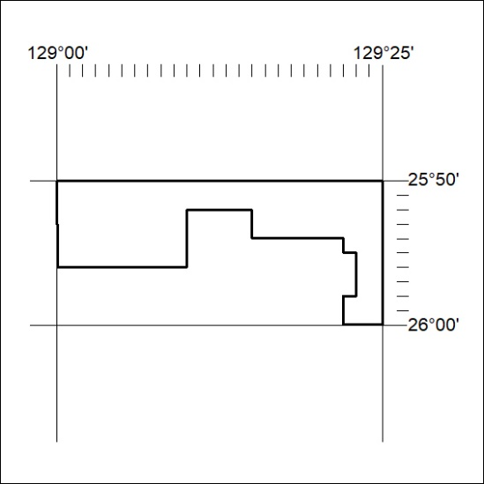

356/19

