Mineral Titles Act 2010
NOTICE OF LAND CEASING TO BE A MINERAL TITLE APPLICATION AREA
Title Type and Number: | Exploration Licence 31033
Area Ceased on: | 18 July 2019
Area: | 110 Blocks, 349.70 km²
Locality: | TOBERMORY
Name of Applicant(s)/Holder(s): | 100% TERRITORY MINING PTY LTD [ACN. 122 356 398]
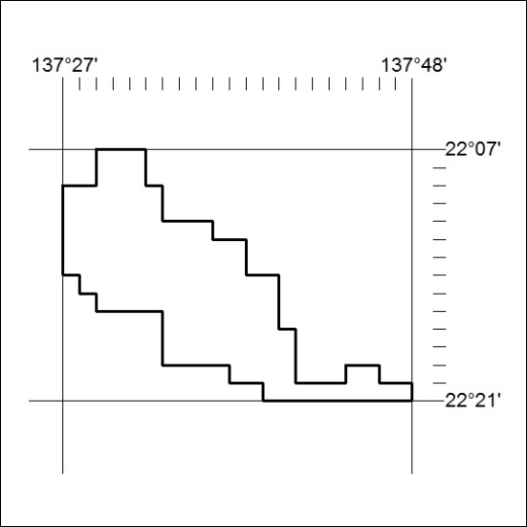

292/19

Mineral Titles Act 2010
NOTICE OF LAND CEASING TO BE A MINERAL TITLE APPLICATION AREA
Title Type and Number: | Exploration Licence 31034
Area Ceased on: | 18 July 2019
Area: | 113 Blocks, 359.08 km²
Locality: | TOBERMORY
Name of Applicant(s)/Holder(s): | 100% TERRITORY MINING PTY LTD [ACN. 122 356 398]
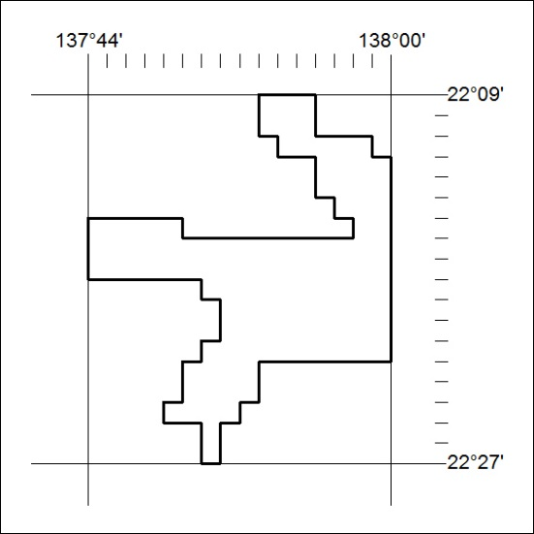

293/19
Mineral Titles Act 2010
NOTICE OF LAND CEASING TO BE A MINERAL TITLE APPLICATION AREA
Title Type and Number: | Exploration Licence 31035
Area Ceased on: | 18 July 2019
Area: | 12 Blocks, 37.99 km²
Locality: | DNEIPER
Name of Applicant(s)/Holder(s): | 100% TERRITORY MINING PTY LTD [ACN. 122 356 398]
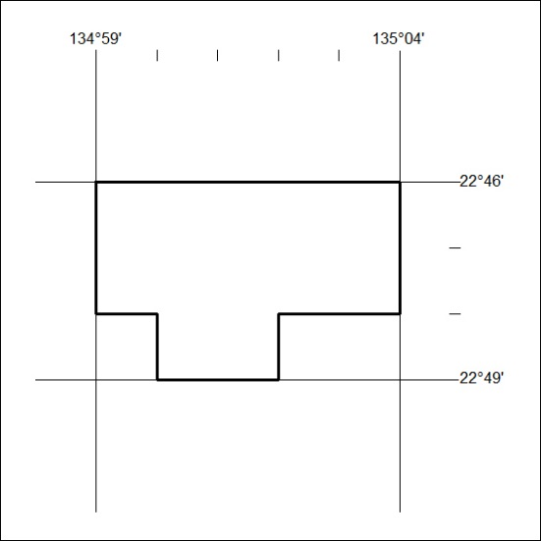

294/19

Mineral Titles Act 2010
NOTICE OF LAND CEASING TO BE A MINERAL TITLE APPLICATION AREA
Title Type and Number: | Exploration Licence 31036
Area Ceased on: | 18 July 2019
Area: | 65 Blocks, 205.92 km²
Locality: | DNEIPER
Name of Applicant(s)/Holder(s): | 100% TERRITORY MINING PTY LTD [ACN. 122 356 398]
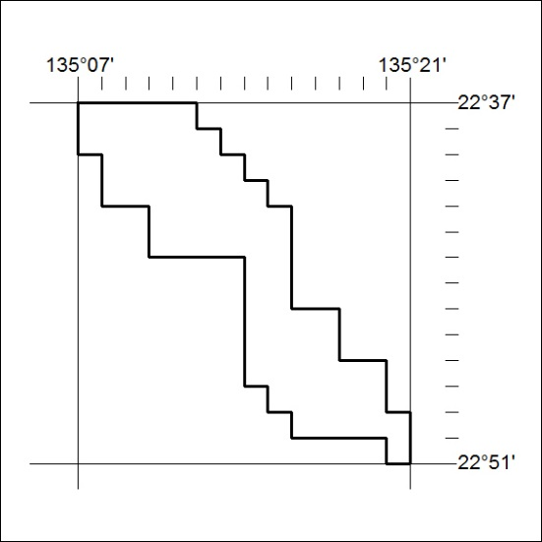

295/19
Mineral Titles Act 2010
NOTICE OF LAND CEASING TO BE A MINERAL TITLE APPLICATION AREA
Title Type and Number: | Exploration Licence 31041
Area Ceased on: | 18 July 2019
Area: | 14 Blocks, 43.80 km²
Locality: | PEACHY
Name of Applicant(s)/Holder(s): | 100% TERRITORY MINING PTY LTD [ACN. 122 356 398]
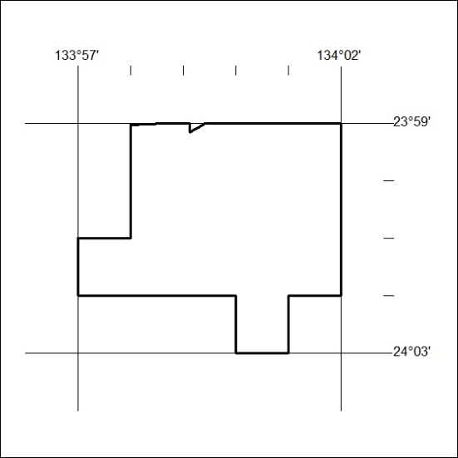

296/19

Mineral Titles Act 2010
NOTICE OF LAND CEASING TO BE A MINERAL TITLE AREA
Title Type and Number: | Exploration Licence 31532
Area Ceased on: | 18 July 2019
Area: | 11 Blocks, 26.25 km²
Locality: | TENNANT CREEK
Name of Applicant(s)/Holder(s): | 100% TRUSCOTT MINING CORPORATION LTD [ACN. 116 420 378]
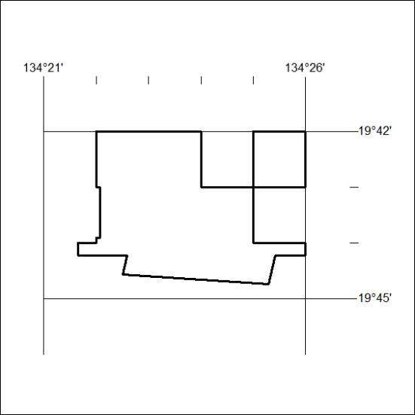

297/19

Mineral Titles Act
NOTICE OF GRANT OF A MINERAL TITLE
Title Type and Number: | Extractive Mineral Permit 31277
Granted: | 16 July 2019, for a period of 5 Years
Area: | 8.66 Hectares
Locality: | FLYNN
Name of Holder/s: | 100% SWOOCABE PTY. LIMITED [ACN. 009 617 118]
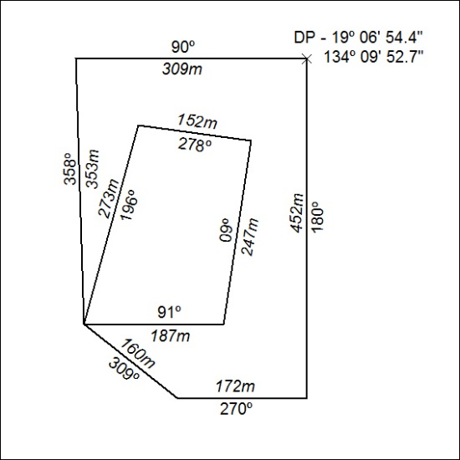

298/19

Corrigendum
Notice number 289/19 appearing in MN86/19 on 17 JULY 2019 is hereby cancelled.

Corrigendum
Notice number 290/19 appearing in MN86/19 on 17 JULY 2019 is hereby cancelled.

