Mineral Titles Act 2010
NOTICE OF LAND CEASING TO BE A MINERAL TITLE AREA
Title Type and Number: | Exploration Licence 29631
Area Ceased on: | 23 April 2019
Area: | 95 Blocks, 243.60 km²
Locality: | MARUMBA
Name of Applicant(s)/Holder(s): | 100% AUSTRALIAN ILMENITE RESOURCES PTY LIMITED* [ACN. 093 419 311]
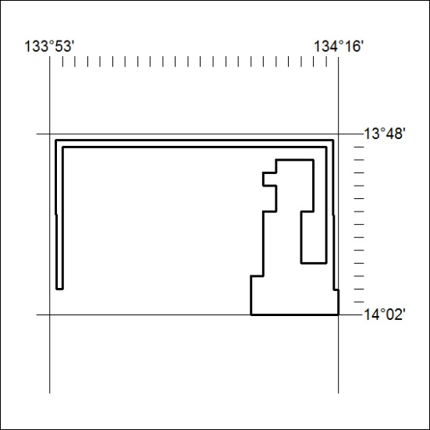

136/19

Mineral Titles Act 2010
NOTICE OF LAND CEASING TO BE A MINERAL TITLE AREA
Title Type and Number: | Exploration Licence 29632
Area Ceased on: | 23 April 2019
Area: | 24 Blocks, 73.33 km²
Locality: | MARUMBA
Name of Applicant(s)/Holder(s): | 100% AUSTRALIAN ILMENITE RESOURCES PTY LIMITED* [ACN. 093 419 311]
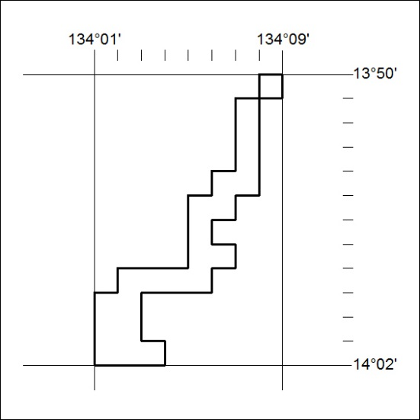

137/19
Mineral Titles Act 2010
NOTICE OF LAND CEASING TO BE A MINERAL TITLE AREA
Title Type and Number: | Exploration Licence 29633
Area Ceased on: | 23 April 2019
Area: | 14 Blocks, 46.62 km²
Locality: | FLYING FOX
Name of Applicant(s)/Holder(s): | 100% AUSTRALIAN ILMENITE RESOURCES PTY LIMITED* [ACN. 093 419 311]
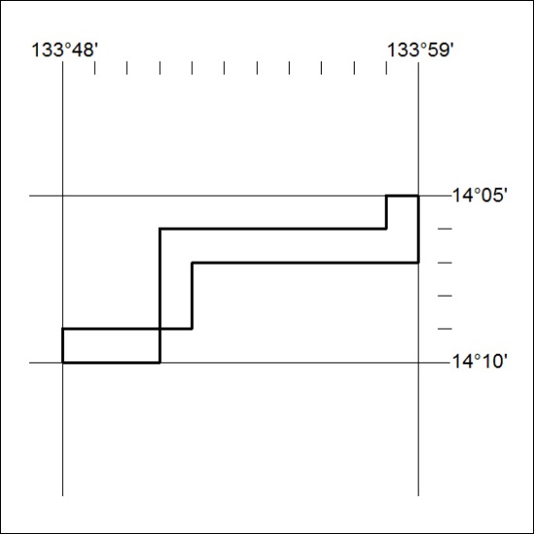

138/19

Mineral Titles Act 2010
NOTICE OF LAND CEASING TO BE A MINERAL TITLE AREA
Title Type and Number: | Exploration Licence 29634
Area Ceased on: | 23 April 2019
Area: | 97 Blocks, 319.68 km²
Locality: | FLYING FOX
Name of Applicant(s)/Holder(s): | 100% AUSTRALIAN ILMENITE RESOURCES PTY LIMITED* [ACN. 093 419 311]
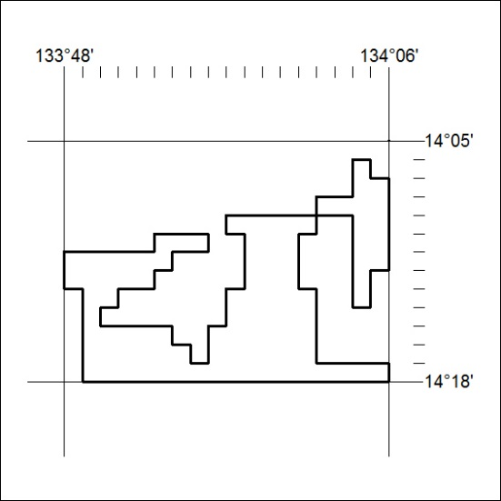

139/19
Mineral Titles Act 2010
NOTICE OF LAND CEASING TO BE A MINERAL TITLE AREA
Title Type and Number: | Exploration Licence 29635
Area Ceased on: | 23 April 2019
Area: | 41 Blocks, 107.29 km²
Locality: | THROSBY
Name of Applicant(s)/Holder(s): | 100% AUSTRALIAN ILMENITE RESOURCES PTY LIMITED* [ACN. 093 419 311]
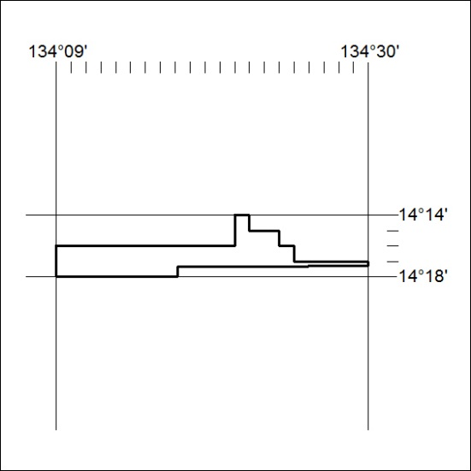

140/19

Mineral Titles Act 2010
NOTICE OF LAND CEASING TO BE A MINERAL TITLE AREA
Title Type and Number: | Exploration Licence 29659
Area Ceased on: | 23 April 2019
Area: | 245 Blocks, 741.20 km²
Locality: | THROSBY
Name of Applicant(s)/Holder(s): | 100% AUSTRALIAN ILMENITE RESOURCES PTY LIMITED* [ACN. 093 419 311]
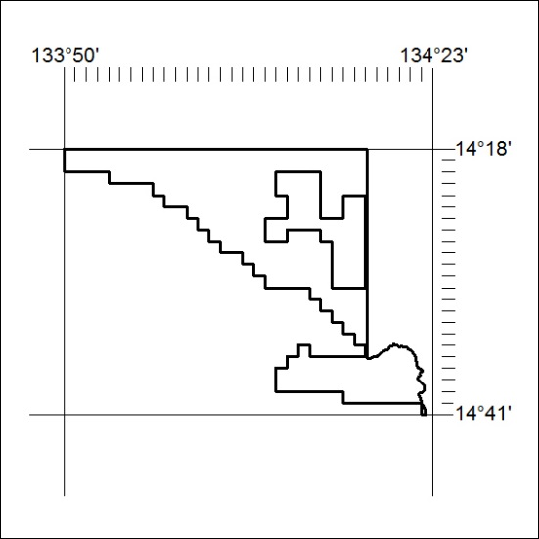

141/19
Mineral Titles Act 2010
NOTICE OF LAND CEASING TO BE A MINERAL TITLE AREA
Title Type and Number: | Exploration Licence 29675
Area Ceased on: | 29 April 2019
Area: | 15 Blocks, 46.46 km²
Locality: | CHAPMAN
Name of Applicant(s)/Holder(s): | 100% AUSTRALIAN ILMENITE RESOURCES PTY LIMITED* [ACN. 093 419 311]
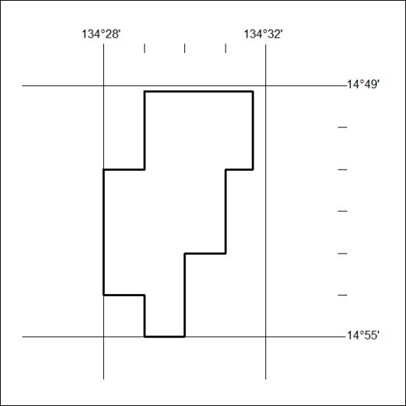

142/19

Mineral Titles Act 2010
NOTICE OF LAND CEASING TO BE A MINERAL TITLE AREA
Title Type and Number: | Exploration Licence 30040
Area Ceased on: | 30 April 2019
Area: | 4 Blocks, 12.87 km²
Locality: | DAVENPORT RANGE
Name of Applicant(s)/Holder(s): | 20% DUNNELL Kevin, 20% FALZON Angelo, 20% HALL Mary Anne, 20% HALL Thomas Raymond, 20% HOPPE Andrew Steven
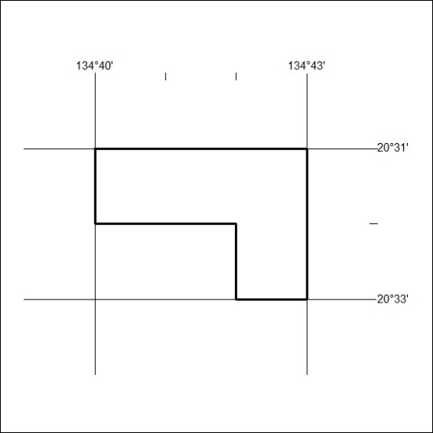

143/19

