Mineral Titles Act 2010
NOTICE OF LAND CEASING TO BE A MINERAL TITLE AREA
Title Type and Number: | Exploration Licence 29669
Area Ceased on: | 23 April 2019
Area: | 47 Blocks, 148.75 km²
Locality: | JERVOIS RANGE
Name of Applicant(s)/Holder(s): | 100% DBL BLUES PTY LTD [ACN. 140 024 442]
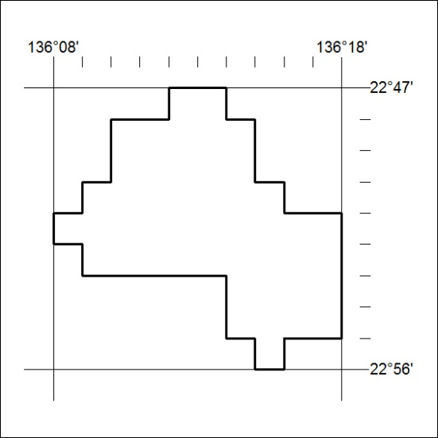

134/19

