Mineral Titles Act 2010
NOTICE OF LAND CEASING TO BE A MINERAL TITLE AREA
Title Type and Number: | Exploration Licence 31391
Area Ceased on: | 12 April 2019
Area: | 38 Blocks, 119.80 km²
Locality: | ADAM
Name of Applicant(s)/Holder(s): | 100% GBE EXPLORATION PTY LTD [ACN. 121 535 948]
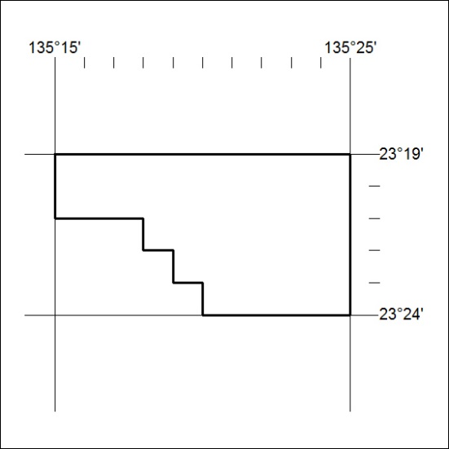

125/19

