Mineral Titles Act 2010
NOTICE OF LAND CEASING TO BE A MINERAL TITLE APPLICATION AREA
Title Type and Number: | Exploration Licence 27980
Area Ceased on: | 29 March 2019
Area: | 100 Blocks, 325.23 km²
Locality: | MT WINNECKE
Name of Applicant(s)/Holder(s): | 100% PRODIGY GOLD NL* [ACN. 009 127 020]
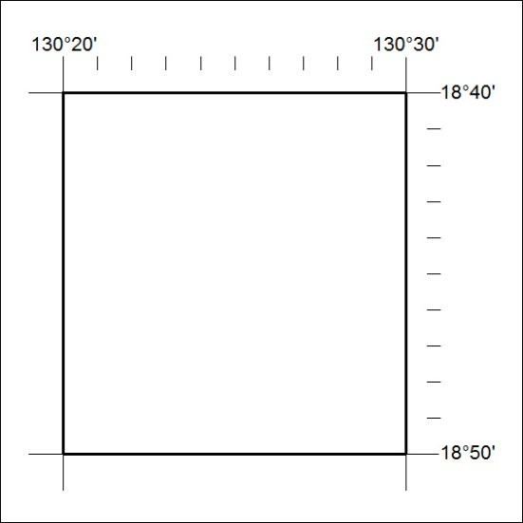

115/19

