Mineral Titles Act
NOTICE OF GRANT OF A MINERAL TITLE
Title Type and Number: | Extractive Mineral Permit 31891
Granted: | 26 February 2019, for a period of 5 Years
Area: | 24.13 Hectares
Locality: | NOONAMAH
Name of Holder/s: | 100% BIRCH Alan James
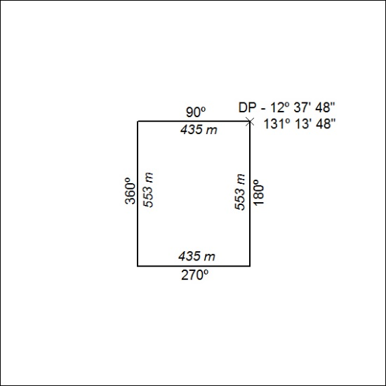

66/19

