Mineral Titles Act
NOTICE OF LAND CEASING TO BE A MINERAL TITLE AREA
Title Type and Number: | Exploration Licence 30672
Area Ceased on: | 14 August 2018
Area: | 139 Blocks, 447.96 km²
Locality: | OORADIDGEE
Name of Applicant(s)/Holder(s): | 100% TERRITORY PHOSPHATE PTY LTD [ACN. 130 065 351]
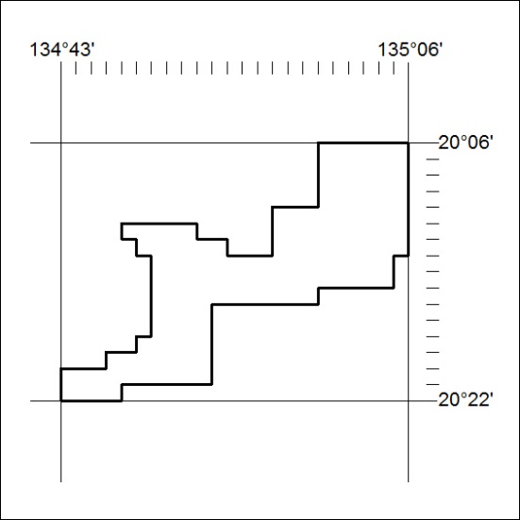

342/18

Mineral Titles Act
NOTICE OF LAND CEASING TO BE A MINERAL TITLE AREA
Title Type and Number: | Exploration Licence 31880
Area Ceased on: | 15 August 2018
Area: | 33 Blocks, 96.79 km²
Locality: | AILERON
Name of Applicant(s)/Holder(s): | 100% NEOTECH METALS PTY LTD [ACN. 625 419 838]
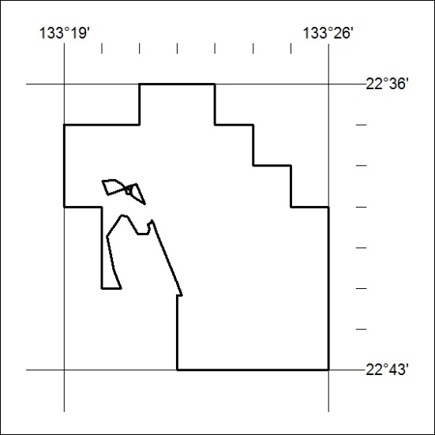

343/18

Mineral Titles Act
NOTICE OF LAND CEASING TO BE A MINERAL TITLE AREA
Title Type and Number: | Exploration Licence 31881
Area Ceased on: | 15 August 2018
Area: | 32 Blocks, 101.43 km²
Locality: | AILERON
Name of Applicant(s)/Holder(s): | 100% NEOTECH METALS PTY LTD [ACN. 625 419 838]
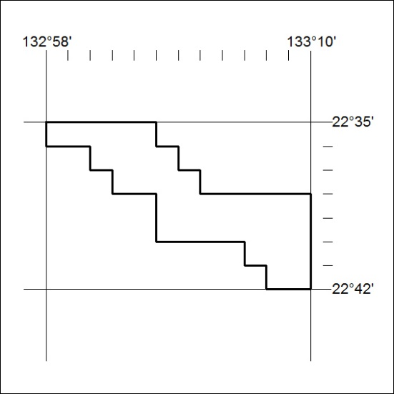

344/18

Mineral Titles Act
NOTICE OF LAND CEASING TO BE A MINERAL TITLE AREA
Title Type and Number: | Exploration Licence 31882
Area Ceased on: | 15 August 2018
Area: | 15 Blocks, 47.60 km²
Locality: | TEA TREE
Name of Applicant(s)/Holder(s): | 100% NEOTECH METALS PTY LTD [ACN. 625 419 838]
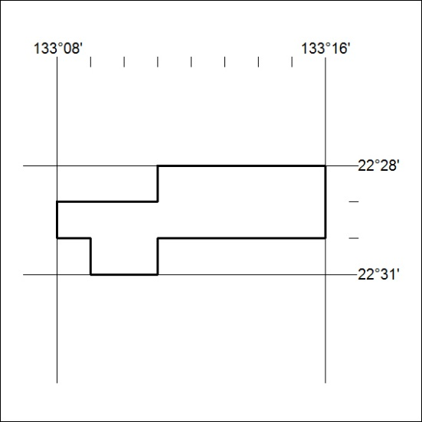

345/18

Mineral Titles Act
NOTICE OF LAND CEASING TO BE A MINERAL TITLE AREA
Title Type and Number: | Exploration Licence 31883
Area Ceased on: | 15 August 2018
Area: | 14 Blocks, 46.71 km²
Locality: | TIPPERARY
Name of Applicant(s)/Holder(s): | 100% NEOTECH METALS PTY LTD [ACN. 625 419 838]
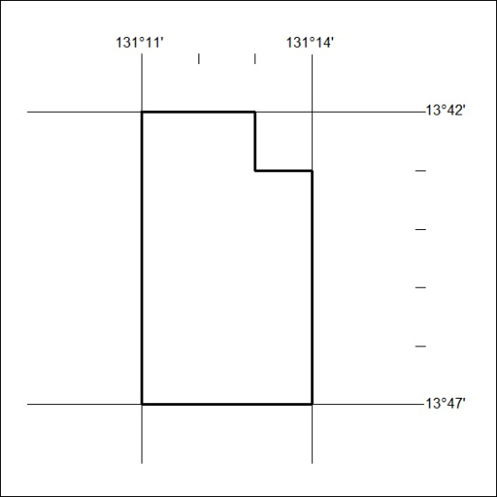

346/18

Mineral Titles Act
NOTICE OF GRANT OF A MINERAL TITLE
Title Type and Number: | Exploration Licence 31793
Granted: | 08 August 2018, for a period of 6 Years
Area: | 7 Blocks, 22.17 km²
Locality: | NAPPERBY
Name of Holder/s: | 100% MIOXIDE AUSTRALIA PTY LTD [ACN. 052 522 111]
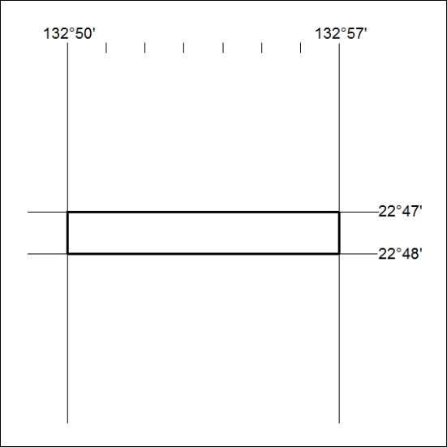
Area granted is indicated above. The titleholder is not permitted to exercise occupational rights on any land that is subject to a development title, or an application for a development title. Any land the subject of a Reserved Land gazettal under the Mineral Titles Act and all land vested in the Commonwealth of Australia is also excluded by description but not excised from the grant area.

347/18

